**2022**

**Technical Proposal**

**Learning Management System for Banglalink Educational Platform**

|  |  |
| --- | --- |
| **Submitted To:** | Banglalink Head Office  SW(H), Plot # 04, Gulshan-1, Dhaka. |
| **Submitted By:** | 95, Khawaja Tower, Bir Uttam AK Khandakar Road, Mohakhali, Dhaka 1212, Bangladesh. |



**Table of Contents**

1.0 Sheba Technologies Ltd. (STL) 2

1.1 Company Background 2

1.2 Our Services 2

1.3 STL’s History 3

1.4 Management Profile 3

1.5 Key Point of Contact 3

2.0 Project Summary 4

2.1 Background 4

2.2 Key Objectives 4

3.0 Scope of Work 5

3.1 Functional Requirements 5

3.1.1 Website Requirements 5

3.1.2 Mobile Application Requirements 13

3.2 Non-Functional Requirements 21

4.0 Development Environment 22

5.0 Workflow Diagram 23

6.0 System Architecture Diagram 24

7.0 Hardware Sizing 25

8.0 Proposed Work Plan and Methodology 26

8.1 Project Development Plan 26

8.1.1 Project Initiation 26

8.1.2 Project Planning 26

8.1.3 Project Execution 27

8.1.4 Project Monitor and Control 27

8.1.5 Project Closure 28

8.1.6 User Roles Accessibility & Authorization 29

8.1.7 Data Privacy Plan 30

8.1.8 Common vulnerabilities considered for their prevention 32

8.1.9 Input Validation Control 32

8.1.10 Requirement Analysis 34

8.1.11 Agile Scrum Methodology 35

8.2 System Requirement Analysis Plan 37

8.2.1 Business Analysis 38

8.2.2 Requirements Elicitation Techniques: 38

8.2.3 Technical Requirements 38

8.2.4 Logical Design 39

8.2.5 Deployment Design 39

8.3 System Design Plan 40

8.3.1 Stage 1: Planning 40

8.3.2 System and Requirement Analysis 40

8.3.3 System design 40

8.3.4 Coding 41

8.3.5 Integration & Testing 41

8.3.6 Implementation 41

8.3.7 Operation & Maintenance 41

8.3.8 System Design 42

8.4 Application Development Methodology 43

8.4.1 Software Development Methodology 43

8.4.2 Agile Methodology 45

8.4.3 Features of Agile Model 46

8.4.4 The Agile Approach 46

8.4.5 Agile Scrum Methodology 47

8.5 Deployment and Implementation Plan 49

8.6 Project Implementation Plan 50

8.7 Business Continuity plan 54

8.8 Risk Management Plan 55

8.8.1 Risk Management 55

8.9 UX Planning 56

8.9.1 Approach and Methodology of UX/UI Design 57

8.10 Release Management 60

8.11 Incident Management 61

8.12 Problem Management 61

8.13 SLA (Service Level Agreement) 62

9.0 Configuration Management 63

9.1 Change Management 63

9.2 Service Layers for Support 63

10.0 Testing 65

10.1 Testing Requirements of BRAC 65

10.2 Testing Plan of Sheba Technologies Limited 65

10.3 Various Testing Methodologies 66

10.3.1 Usability Testing 66

10.3.2 Functional Testing 66

10.3.3 Unit testing 66

10.3.4 Integration Testing 66

10.3.5 System Testing 67

10.3.6 User Acceptance Testing 67

10.3.7 Load Testing 67

10.3.8 Recovery Testing 68

10.3.9 Security Testing 68

10.3.10 Compatibility Testing: 68

10.3.11 Testing Plan Details 68

10.3.12 Performance Monitor 69

10.4 Training 69

10.5 Training Plan 69

10.5.1 Draft Training Plan 70

10.5.2 Training Type 70

10.6 Error Handling, Bug Fixing & Fine Tuning 71

10.6.1 Error Handling 71

10.6.2 Bug Fixing 71

10.6.3 Fine Tuning 71

10.6.4 Help Desk Support 72

11.0 Project WBS 73

12.0 Annexure A: STL Legal Documents 74

13.0 Annexure B: STL Organogram 86

14.0 Annexure C: Sheba Technologies Limited Brochure 87

15.0 Annexure D: Financial Capacity of the Firm 107

16.0 Annexure E: STL Work Experience 135

17.0 Annexure F: Technical Experts for Performing the Assignment 144

# Sheba Technologies Ltd. (STL)

## Company Background

Sheba Technologies Limited (STL) is part of the Sheba Group conglomerate which has been in Tech business for almost quarter of a century. We are always keen on listening to our customers and are constantly learning from their experiences while rendering Telecom and IT services. This has made us recognize the importance of evolving into the new ‘normal’ which is ‘Data is everything’. With this aspiration, STL is fully committed to bring world class technologically advanced Business Process Automation by delivering architecturally superior software solution, off-the-shelf customizable software, digital identity platform for citizens, smart city initiatives, artificial intelligence and machine learning to our esteemed clients. Please see Annexure for legal documents and attached STL full portfolio for details.

## Our Services

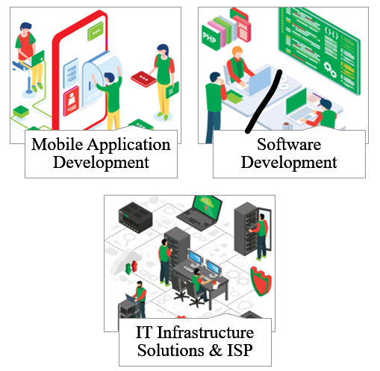

## STL’s History

## Management Profile

**Afzal H. Choudhury** is the Founder & Group Chairman. He started his career at BTTB and later started his own business. He has a B.S. degree in Electrical Engineering and has obtained advanced training on Satellite Telecommunications in 1973 from the USA.

**Asif H. Choudhury** is the Group Managing Director. He has been involved with Sheba Group since 2002. Prior to joining Sheba Group, he worked for Credit Agricolebank in their project finance unit and also worked at CDIC as an analyst. He has an undergraduate degree in Economics and Political Science from Rutgers University and an MBA from McGill University.

**Reaz U. Ahmed** is the Chief Executive Officer, responsible for Group’s Telecom and ICT business development and operations. He has worked for high tech companies for more than 10 years in the heart of Silicon Valley, California. He has a B.S. degree in Electrical Engineering from Rutgers University.

**Mohammad Somael Kabir** is the Chief Technology Officer for the Group’s Telecom and ICT Planning, Implementation and Operations. He has 16 years of experience in Telecom and ICT infrastructure planning, capacity analysis, business plan development and system implementation. His certifications include: CEH, CICISO, RHCVA, RHCEv5.

## Key Point of Contact

Name: **Farhan Islam**

Designation: **Chief Operating Officer**

Phone: **+8801711547804**

Email: [**farhan.islam@shebatech.com.bd**](mailto:farhan.islam@shebatech.com.bd)

# Project Summary

## Background

Digital Education sector has emerged as one of the fastest-growing sectors in the recent time with the booming of ed-tech startups. Globally and locally, both are gaining momentum and successfully attracting multi-million-dollar investments due to it’s potential.

In line with that, with assistance of Sheba Technologies Limited, Banglalink is on its way to create an individual education platform to offer skill development courses mostly targeted towards the youth

## Key Objectives

* Education platform both App and web
* Easy sign-in with MSISDN OTP verification for end users.
* Both Free and paid options for users to access the platform under Freemium model.
* Paid subscribed users will get premium and full-length contents, without any interruption of ad.
* Free users can access demo of contents for shorter period. Also, the ad will be shown randomly, and users need to purchase in-app items separately.

# Scope of Work

## Functional Requirements

### Website Requirements

| **Website Requirements** | | | |
| --- | --- | --- | --- |
| **#** | **Module** | **Activity /Features** | **Requirements** |
| 1 | Access Control | Login | * Log into the system with SSO authentication * Log into the system with PIN and password. * Create an account with MSISDN OTP verification * Without proper authorization user will not be able to access the system |
| 2 | Subscription Management | Subscribed Users | * Paid subscribed users will get full access to premium contents without any interruption of ad * Customer can earn BL Loyalty points subscribing to the education segment |
| Unsubscribed Users | * Free plan subscribed user will get limited access to premium contents. Also, the ad will be shown randomly * User will be able to select the tutorial or watch “demo” without any subscription |
| Payment | * Clicking on the Pay/Buy Subscription will redirect user to the payment page. * Different modes of payment (Banglalink MA Balance, MFS, Debit/Credit Cards) will be offered for customer convenience. |
| 3 | Role Management Module | Create Role | * Admin will have the capability to add role name. * With permission checkbox admin can state the accessibility of the role. * Status will be included to state the activity and inactivity of the |
| Role Landing Page | * Admin will view the role details in list order, where Name, Permission, Action will be displayed accordingly. * Edit Role button is provided under action table, to redirect the user to edit page. * Export Option will also be included for the table, where admin can export role file in Excel and PDF format. * Create Role button is contributed, to redirect the user to create |
| Edit Role | * Selected Role ID will be considered for changes * Admin will have the capability to change role name. * With permission checkbox admin can modify the accessibility of the role. * Status will be included to state the activity and inactivity of the role |
| 4 | User Management Module | Create User | * Admin will have the competence to state User Name, Email ID, Designation, Phone number, Password and Confirm Password, where Password and Confirm Password will match with each other * Admin needs to assign role for the user to state the permission according to the given role. * Status will be included to state the activity and inactivity of the user |
| User Landing Page | * Representation of the user details will be shown in list order, where Full Name, Designation, Email Address, Phone Number, Role, Status, Action will be displayed accordingly. * Edit User button is provided under action table, to redirect admin to edit user page. * Export Option will also be included for the table, where admin can export user file in Excel and PDF format. * Create User button is contributed, to redirect admin to create user page |
| Edit User | * Specified User ID will be considered for changes * Admin will have the accessibility to change User Name, Email ID, Designation, Phone number, Password * Admin can change the assigned role for the user to update the permission according to the given role. * Status will be included to state the activity and inactivity of the user |
| User Profile | * User Name, Email ID, Designation, Phone number, Password and Confirm Password will be presented according to the specified logged user * User will have the accessibility to change password, where password and confirm password needs to match. * User photo can be updated when the user wants, where user have to browse files to upload it. |
| 5 | Course Management | Create Category | * Admin will have the capability to add category name. * Status will be included to define the active and inactive state of the Category. |
| Category Landing Page | * Admin will view the category details in list order, where Category Name and Action will be displayed accordingly. * Edit Category button is provided under action table, to redirect the user to edit page. * Export Option will also be included for the table, where admin can export Category file in Excel and PDF format. * Create Category button is contributed, to redirect the user to create category page. |
| Edit Category | * Selected Category ID will be presented. * Admin will have the accessibility to change category name. * Status will be included to define the active and inactive state of the Category. |
| Create Sub Category | * Admin needs to select category from the dropdown list, where list will contribute the category data. * Admin will have the capability to add sub category name. * Status will be included to define the active and inactive state of the Sub Category. |
| Sub Category Landing Page | * Admin will view the sub category details in list order, where Category Name, Sub Category Name and Action will be displayed accordingly. * Edit Sub Category button is provided under action table, to redirect the user to edit page. * Export Option will also be included for the table, where admin can export Sub Category file in Excel and PDF format. * Create Sub Category button is contributed, to redirect the user to create sub category page. |
| Edit Sub Category | * Designated Sub Category ID will be generated. * Admin have the access to change the selected category from the dropdown list, where list will contribute the category data. * Admin will have the accessibility to change sub category name. * Status will be included to define the active and inactive state of the Sub Category. |
| Create Course | * User needs to select category from the dropdown list, where list will contribute the category data. * User needs to select sub category from the dropdown list, where list will contribute the sub category data based on the selected category. * User will have the capability to add Course name, Training Overview and Training Details * User can upload resources. * Moreover, the user also can conduct live class. * Status will be included to define the active and inactive state of the Course. |
| Course Landing Page | * User will view the Course details, where Category Name, Sub Category Name, Course Details and Action will be displayed accordingly. * Edit Course button is provided under action table, to redirect the user to edit page. * Export Option will also be included for the table, where admin can export course details in Excel and PDF format. * Create Course button is contributed, to redirect the user to create Course page |
| Edit Course | * Specific Course ID will be generated. * User have the access to change the selected category from the dropdown list, where list will contribute the category data. * User have the access to change the selected sub category from the dropdown list, where list will contribute the sub category data. * User will have the accessibility to change Course name, Training Overview and Training Details * User can Modify and update resources and videos. * Status will be included to define the active and inactive state of the course. |
| Course Approval | * Authorized user will view the Course Details and Information and will give approval decision, where status will be updated according to the given decision. |
| Course Status | * User should be able to see completed courses. * User should be able to see pending courses. * Users should be able to see courses yet to start. |
| 6 | Customer | Account/ Portfolio | * The Customers will be able to conduct the courses using his personal profile at the website. * The Customers must be able to subscribe for training courses. * The Customers will also give information about their educational qualifications including the upload of the documents |
| 7 | Streaming Platform | Live Videos | * The system should be able to facilitate weekly live session, which will be facilitated by the trainers answering the key questions or confusions of the trainees regarding skills training or related topics. * An option for live streaming of videos will also be available on the website. So that the experts in relevant professions can share their insights regarding the course with the learners and relevant audiences. |
| 8 | Advertisement | Manage ad | * Without any interruption of ad paid customer can view contents. * Ad will be shown randomly for free customers. |
| 9 | Referral System | Share Status | * Customer can share their learning status, hours of learning, completed courses etc. score on different social media to invite other users |
| Invitation | * Customer invites other users from his contact list to download/ visit the education platform. An invitation SMS with the URL to be sent within 10 minutes. |
| 10 | Notification |  | * Send them emails/notification if they are remained absent from courses for a longer time as well as inform the administrators of the customers information, their progress and notify them of any important information which will be useful to get back the customers engaged with the platform. |
| 11 | Reporting & Analytics |  | * Will give insight into areas of success and opportunities * The platform will have a sophisticated system design at the backend to monitor customers progresses, |

### Mobile Application Requirements

| **Mobile Application Requirements** | | | |
| --- | --- | --- | --- |
| **#** | **Module** | **Activity /Features** | **Requirements** |
| 1 | Access Control | Login | * Log into the system with SSO authentication * Log into the system with PIN and password. * Create an account with MSISDN OTP verification * Without proper authorization user will not be able to access the system |
| 2 | Subscription Management | Subscribed Users | * Paid subscribed users will get full access to premium contents without any interruption of ad * Customer can earn BL Loyalty points subscribing to the education segment |
| Unsubscribed Users | * Free plan subscribed user will get limited access to premium contents. Also, the ad will be shown randomly * User will be able to select the tutorial or watch “demo” without any subscription |
| Payment | * Clicking on the Pay/Buy Subscription will redirect user to the payment page. * Different modes of payment (Banglalink MA Balance, MFS, Debit/Credit Cards) will be offered for customer convenience. |
| 3 | Role Management Module | Create Role | * Admin will have the capability to add role name. * With permission checkbox admin can state the accessibility of the role. * Status will be included to state the activity and inactivity of the |
| Role Landing Page | * Admin will view the role details in list order, where Name, Permission, Action will be displayed accordingly. * Edit Role button is provided under action table, to redirect the user to edit page. * Export Option will also be included for the table, where admin can export role file in Excel and PDF format. * Create Role button is contributed, to redirect the user to create |
| Edit Role | * Selected Role ID will be considered for changes * Admin will have the capability to change role name. * With permission checkbox admin can modify the accessibility of the role. * Status will be included to state the activity and inactivity of the role |
| 4 | User Management Module | Create User | * Admin will have the competence to state User Name, Email ID, Designation, Phone number, Password and Confirm Password, where Password and Confirm Password will match with each other * Admin needs to assign role for the user to state the permission according to the given role. * Status will be included to state the activity and inactivity of the user |
| User Landing Page | * Representation of the user details will be shown in list order, where Full Name, Designation, Email Address, Phone Number, Role, Status, Action will be displayed accordingly. * Edit User button is provided under action table, to redirect admin to edit user page. * Export Option will also be included for the table, where admin can export user file in Excel and PDF format. * Create User button is contributed, to redirect admin to create user page |
| Edit User | * Specified User ID will be considered for changes * Admin will have the accessibility to change User Name, Email ID, Designation, Phone number, Password * Admin can change the assigned role for the user to update the permission according to the given role. * Status will be included to state the activity and inactivity of the user |
| User Profile | * User Name, Email ID, Designation, Phone number, Password and Confirm Password will be presented according to the specified logged user * User will have the accessibility to change password, where password and confirm password needs to match. * User photo can be updated when the user wants, where user have to browse files to upload it. |
| 5 | Course Management | Create Category | * Admin will have the capability to add category name. * Status will be included to define the active and inactive state of the Category. |
| Category Landing Page | * Admin will view the category details in list order, where Category Name and Action will be displayed accordingly. * Edit Category button is provided under action table, to redirect the user to edit page. * Export Option will also be included for the table, where admin can export Category file in Excel and PDF format. * Create Category button is contributed, to redirect the user to create category page. |
| Edit Category | * Selected Category ID will be presented. * Admin will have the accessibility to change category name. * Status will be included to define the active and inactive state of the Category. |
| Create Sub Category | * Admin needs to select category from the dropdown list, where list will contribute the category data. * Admin will have the capability to add sub category name. * Status will be included to define the active and inactive state of the Sub Category. |
| Sub Category Landing Page | * Admin will view the sub category details in list order, where Category Name, Sub Category Name and Action will be displayed accordingly. * Edit Sub Category button is provided under action table, to redirect the user to edit page. * Export Option will also be included for the table, where admin can export Sub Category file in Excel and PDF format. * Create Sub Category button is contributed, to redirect the user to create sub category page. |
| Edit Sub Category | * Designated Sub Category ID will be generated. * Admin have the access to change the selected category from the dropdown list, where list will contribute the category data. * Admin will have the accessibility to change sub category name. * Status will be included to define the active and inactive state of the Sub Category. |
| Create Course | * User needs to select category from the dropdown list, where list will contribute the category data. * User needs to select sub category from the dropdown list, where list will contribute the sub category data based on the selected category. * User will have the capability to add Course name, Training Overview and Training Details * User can upload resources. * Moreover, the user also can conduct live class. * Status will be included to define the active and inactive state of the Course. |
| Course Landing Page | * User will view the Course details, where Category Name, Sub Category Name, Course Details and Action will be displayed accordingly. * Edit Course button is provided under action table, to redirect the user to edit page. * Export Option will also be included for the table, where admin can export course details in Excel and PDF format. * Create Course button is contributed, to redirect the user to create Course page |
| Edit Course | * Specific Course ID will be generated. * User have the access to change the selected category from the dropdown list, where list will contribute the category data. * User have the access to change the selected sub category from the dropdown list, where list will contribute the sub category data. * User will have the accessibility to change Course name, Training Overview and Training Details * User can Modify and update resources and videos. * Status will be included to define the active and inactive state of the course. |
| Course Approval | * Authorized user will view the Course Details and Information and will give approval decision, where status will be updated according to the given decision. |
| Course Status | * User should be able to see completed courses. * User should be able to see pending courses. * Users should be able to see courses yet to start. |
| 6 | Customer | Account/ Portfolio | * The Customers will be able to conduct the courses using his personal profile at the website. * The Customers must be able to subscribe for training courses. * The Customers will also give information about their educational qualifications including the upload of the documents |
| 7 | Streaming Platform | Live Videos | * The system should be able to facilitate weekly live session, which will be facilitated by the trainers answering the key questions or confusions of the trainees regarding skills training or related topics. * An option for live streaming of videos will also be available on the website. So that the experts in relevant professions can share their insights regarding the course with the learners and relevant audiences. |
| 8 | Advertisement | Manage ad | * Without any interruption of ad paid customer can view contents. * Ad will be shown randomly for free customers. |
| 9 | Referral System | Share Status | * Customer can share their learning status, hours of learning, completed courses etc. score on different social media to invite other users |
| Invitation | * Customer invites other users from his contact list to download/ visit the education platform. An invitation SMS with the URL to be sent within 10 minutes. |
| 10 | Notification |  | * Send them emails/notification if they are remained absent from courses for a longer time as well as inform the administrators of the customers information, their progress and notify them of any important information which will be useful to get back the customers engaged with the platform. |
| 11 | Reporting & Analytics |  | * Will give insight into areas of success and opportunities * The platform will have a sophisticated system design at the backend to monitor customers progresses, |

## Non-Functional Requirements

| **Particulars** | **Requirements** |
| --- | --- |
| Security | * System will grant access using unique user id and password; * System will log user access and track date last used, unsuccessful attempts; * Allow subscription-based and permission-based access; |
| Usability Requirements | * User friendly Graphical User Interface (GUI); * Easy navigation; * Sends push notifications to learners on delay completion of course |
| Performance Requirements | * Quick report generation facility; * Predictive data analysis by AI; * Process time will be optimum; * Large number of concurrent process handling capability will be there; * Appropriate messaging will be there |
| Design/Technical Requirements | * High compatibility with themes and plugins * RDBMS will be decided after getting approval from authority; |
| Backup/Recovery Requirements | * Store detail data generated by each user; * Recovery mechanism will be from the backed-up data files in case of any disaster; |
| Flexibility | * Option for further modification of the source code. |

# Development Environment

|  |  |
| --- | --- |
| Middleware: | Laravel |
| Front- End: | ReactJS |
| DB: | MariaDB |

# Workflow Diagram

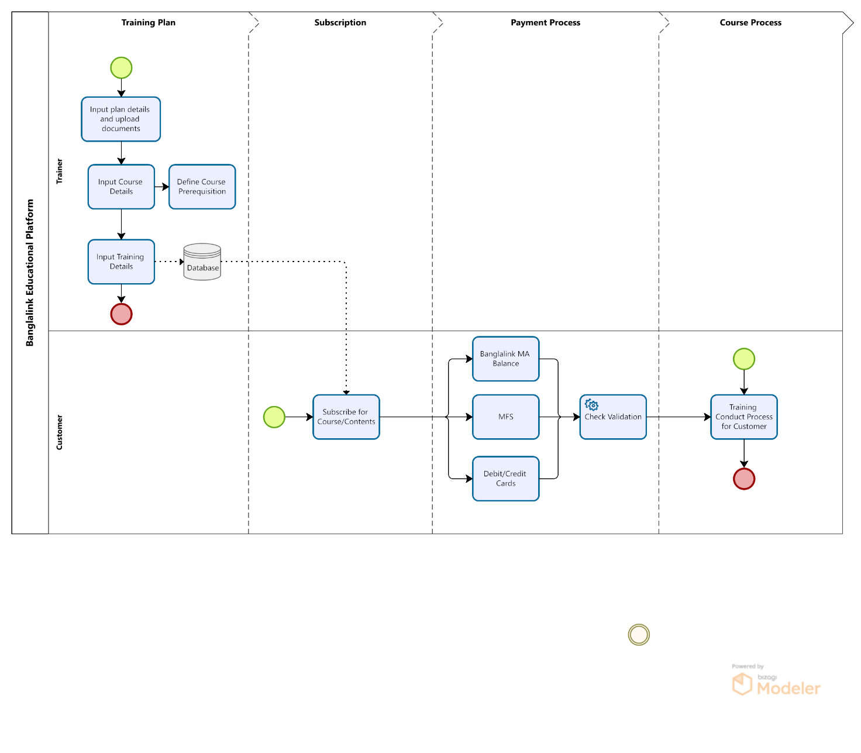

# System Architecture Diagram

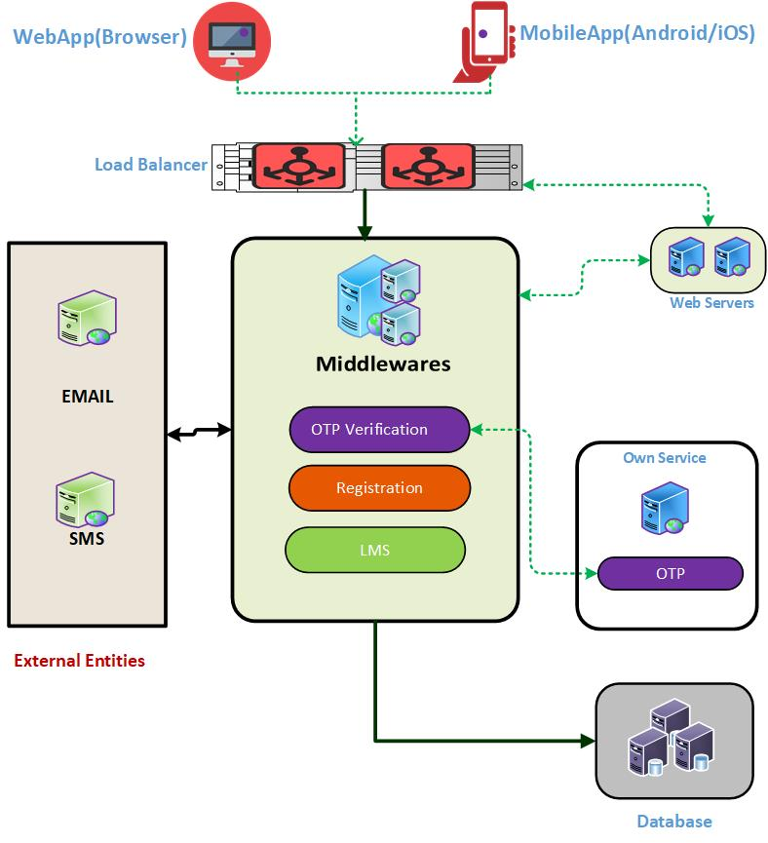

# Hardware Sizing

* **Streaming and Video on-Demand Application and Server needs to be provided by Banglalink.**

* **Hardware Sizing will be provided after Streaming and Video on-Demand requirements along with Capacity requirements are provided.**

# Proposed Work Plan and Methodology

## Project Development Plan

### Project Initiation

The primary challenge of project management is to achieve all of the project goals and objectives while honoring the preconceived project constraints. Typical constraints are scope, time, and budget. The secondary and more ambitious challenge is to optimize the allocation and integration of inputs necessary to meet pre-defined objectives. The phases followed by us for Project Management are:

 **Value Proposition:** Build foundation for success with a good plan: A structured planning process for the project helps companies reach their targets in an efficient way. We help to improve our clients’ planning methodologies and competencies by creating solid plans, securing the commitment of participants, ensuring sufficient resources and producing a workable schedule to ensure project execution.

 **Develop efficient teams:** Building a high-performing team and putting the right people in the right place at the right time is one important factor for success. We assist our clients to build winning teams, while leading individuals and handling conflicts effectively. We help design projects with relevant coordination and communication mechanisms to integrate and align project activities vis-à-vis other projects and operations.

 **Retain control by robust decision-making**: Understanding and knowing the project’s risks and taking charge of the project’s direction is probably the single most important task of managing any project. We can help to build these capabilities, or we can assist directly through regular analyses of project risks and assistant in necessary decision-making.

 **Communication and Reporting:** An analysis of stakeholder interest is a necessary foundation for successful communication about the project. We can either assist clients in designing the entire project communication systems or just communicate effectively with key stakeholders – in a well-timed appropriate way to ensure a smooth transition.

### Project Planning

Project planning is done to increase the likelihood that a project will be implemented efficiently, effectively and successfully. Project planning covers the first three stages of "the project management cycle." This cycle, illustrated below, describes the various stages for conceptualizing, planning, implementing and evaluating a project and recognizes that even when a project is finished; it may provide the starting point for a new on.

### Project Execution

During the Project Execution phase the project team produces the deliverable while the project manager will monitor and control the project delivery by undertaking:

**Time Management:** tracking and recording time spent on tasks against the Project Plan

**Cost Management:** identifying and recording costs against the project budget

**Quality Management:** reviewing the quality of the deliverable and management processes

**Change Management:** reviewing and implementing requests for changes to the project

**Risk Management:** assessing the level of project risk and taking action to minimize it

**Issue Management:** identifying and resolving project issues

**Acceptance Management:** identifying the completion of deliverable and gaining the customers’ acceptance

**Communications Management:** keeping stakeholders informed of project progress, risks and issues

### Project Monitor and Control

Only through constant monitoring and employing control operations can the project be implemented and maintained. The process is thus described below

As the monitoring and controlling process is always being executed every time any process is being initiated, thus the list of processes to monitor and control are varied. These processes have been described briefly below:

**Schedule progress:**

* The status of the activities that have been scheduled for the ongoing week/month.
* Measuring progress of activities. i.e., Ahead, behind or on-schedule.
* Change/ Correct in particulars of the progress.

**Budget:**

* Analysis of Budgetary Correlation.

**Scope:**

* Revised estimate to complete the work.
* Team working on activities that are in-scope or out-of-scope.
* Changes occurred that requires an additional scope.

There are additional things, such as Key Performance Indicators, that we want to monitor throughout the project but the ones mentioned above are the bare minimum. It is very important to monitor the progress on the project to ensure it does not get too far off the original plan.

Controlling the project refers to the actions that we will take as the project manager to ensure the project progresses according to the plan and actions. A change control procedure, where changes are identified, formally documented in a change order and then approved by BRAC is highly recommended.

### Project Closure

The final phase of any project is the Project Closure where the project’s success will be reported to BRAC and the project is formally closed.

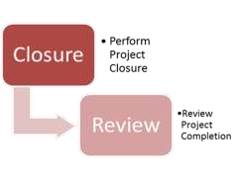

**Figure: Project Closure Steps**

**Project Closure-** The project closure relies on identifying the completion criteria and fulfilling any outstanding deliverable or activities that are essential for implementation. Furthermore, any withstanding agreements that were required for implementation must be closed and the project resources will be released to the business while maintaining effective communication.

**Project Completion Review-** By performing a post project review, BRAC Shall identify the project successes, deliverable, achievements and lessons learned. The post project review is the last critical step in the project life cycle, as it allows an independent party to validate the success of the project and give confidence to the stakeholders that it has met the objectives it set out to achieve. This would technically involve the following:

* Measuring the benefits and objectives
* Deciding whether the project was within scope
* Assessing the final deliverable produced
* Reviewing the project against schedule
* Comparing the expenditure against budget
* Stating the final outcome of the project
* Communicate its success to stakeholders

### User Roles Accessibility & Authorization

A proper user management is essential for a system that allows the administrators to manage user accounts by controlling access level, account setting rights, user roles etc. User management also provides the administrators/ authority to monitor the frequency in which a user logs on to, and also monitor what data and software users can see, how much of it they can see, and whether they have full rights within the software or to edit any data. This helps to increase the overall security as it focuses on the ‘need to know’ basis, and it can help simplify deployment processes for new software or technologies.

System will design and customize according to the user types to manage respective features designated to a user type. There will four types of users will have whose access level and roles will be subjective to their purposes in the software system.

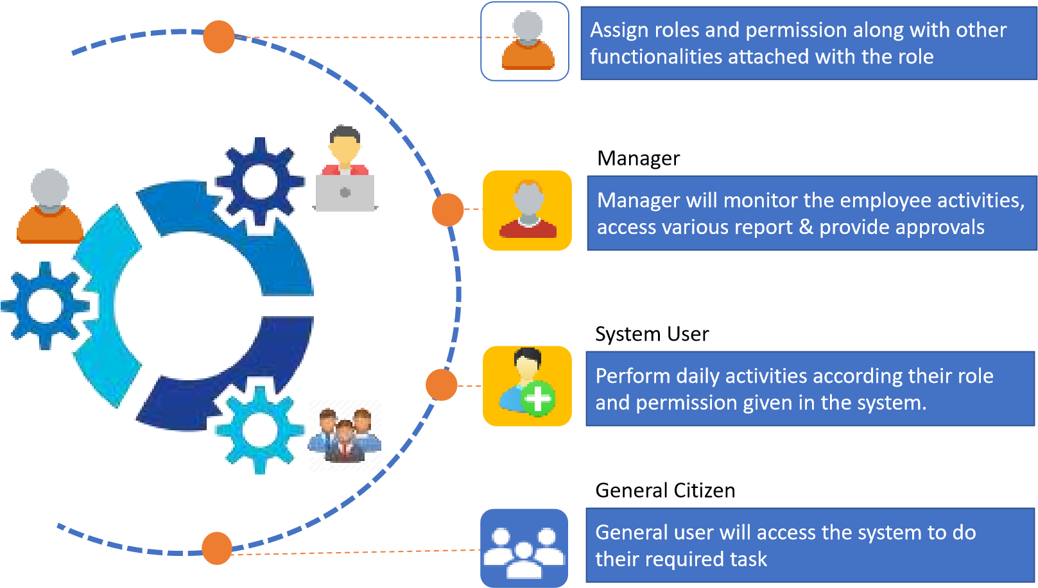

### Data Privacy Plan

Security and data privacy plan is an outlines how an organization will protect the personal information of its customers and clients. A data privacy plan for an IT system depends on how an organization collects, processes and uses data. For data privacy, Sheba Technologies Limited includes the following activities in different phases of software development which starts from the planning stages and continues throughout the journey of a software lifecycle. Several steps of data privacy are described below.



* **Identify the Types of Information Collected and Processed**

Sheba Technologies Limited will identify and takes extra care for certain types of commonly collected information which require special handling and protection.

* **Gather and Examine Internal Policies**

Sheba Technologies Limited will collect data retention and destruction policies of client’s organization, privacy policies, data security procedures, and internal auditing and monitoring processes. All of these materials will be gathered and considered in the data security plan.

* **Assemble and Evaluate Risks**

As a precursor to developing (or revising) a data security plan, Sheba Technologies Limited will generate a list of the risks associated mishandling of data and data breaches. Once this risk analysis is complete, one or more methods for mitigating each risk will be prepared. Sheba Technologies Limited will also define the user roles that will be responsible for ensuring information security, privacy compliance and data protection.

* **Security Design for a Data Life Cycle**

Sheba Technologies Limited will consider customer privacy, legal compliance and data protection throughout the data lifecycle; i.e., collection, processing, storage and destruction.

* **Monitoring and Tracking Network Access**

To mitigating breaches or other types of security incidents Sheba Technologies Limited will continually coordinate with IT professionals to ensure that network access is adequately monitored such that suspicious activity on network can be detected prior to breach.

* **User Access Control & Role wise Access Permission**

As it has been observed that Employees can be a common cause of data breaches, data loss and data misappropriation if appropriate safeguards are not instituted and enforced in a system. To mitigate these risks, Sheba Technologies Limited will develop comprehensive policies and procedures that dictate which employees have access to particular data; establish how confidential and proprietary information must be handled through various roles and access controls.

* **Develop a Breach Response Plan**

A critical part of data security plan is the breach-response plan, which governs how to respond to a suspected or actual breach. Sheba Technologies Limited’s breach response plan will have clear instruction and will be easy to follow and scenario based.

* **Conduct Regular Audits**

Sheba Technologies Limited will regularly measure the effectiveness of the designed solution, including by revisiting and reevaluating all of the factors that went into developing them. Regular audits will also evaluate the current information-security practices.

After defining all the roles and plans; and after modeling the data security and privacy the following activities are performed by Sheba Technologies Limited during different phases of the software development life cycle to ensure data privacy.

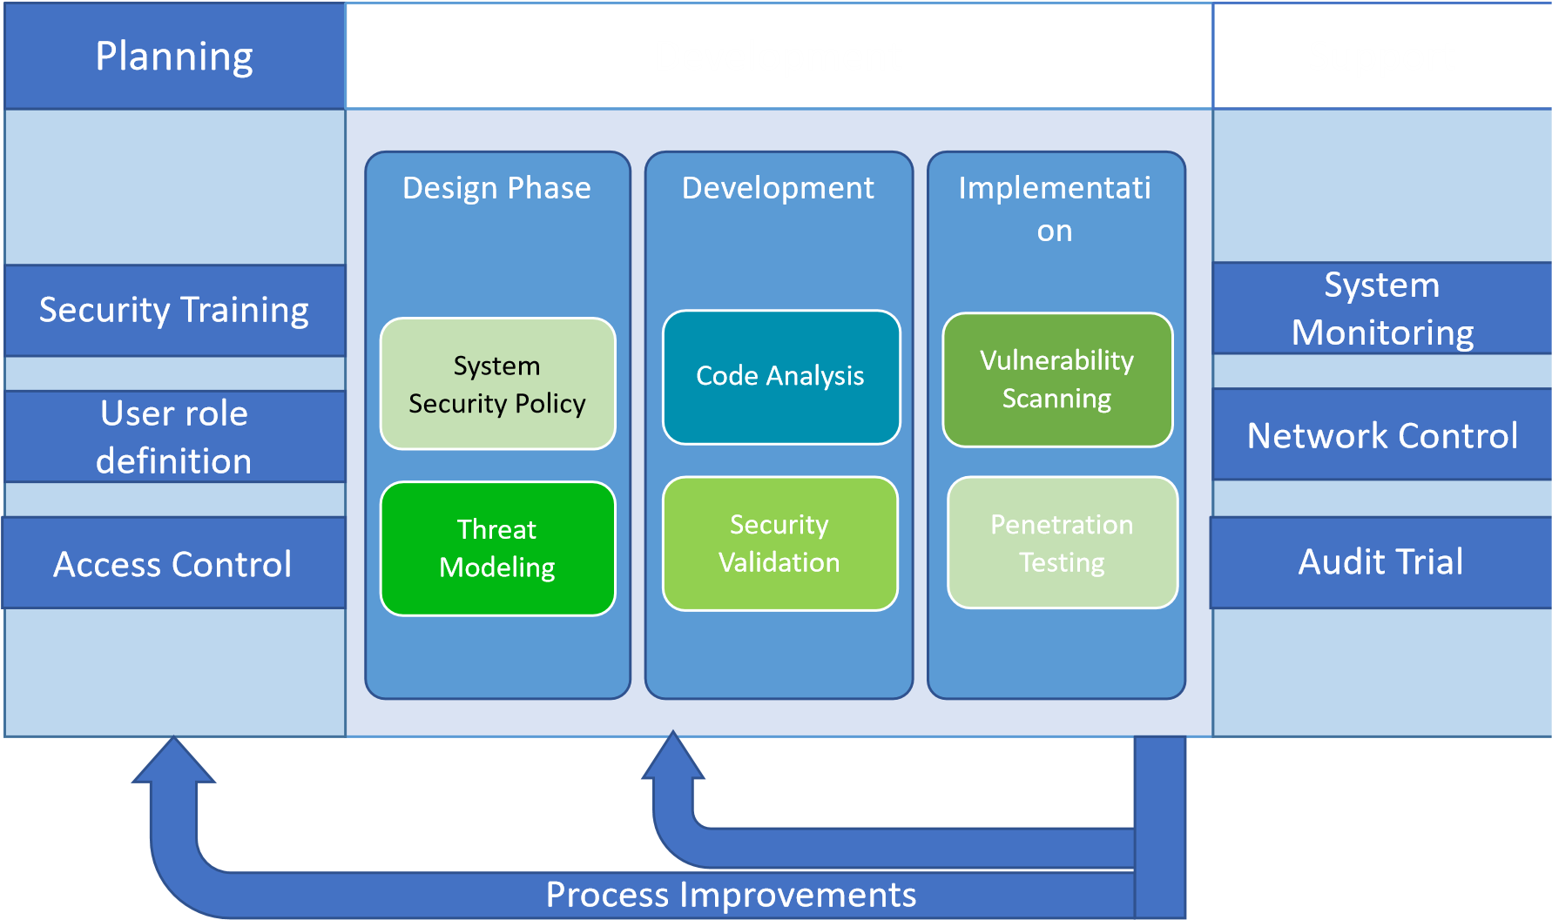

### Common vulnerabilities considered for their prevention

Sheba Technologies Limited will check and prevent the following vulnerabilities during development, implementation and maintenance:

**Vulnerabilities considered for Web-based applications**

* Cross-site scripting (XSS) vulnerabilities
* SQL injection vulnerabilities **Database applications**
* SQL injection vulnerabilities

**System Vulnerabilities considered**

* Input validation
* Language-specific issues (PHP, Java)

***Cryptographic code***

* Common cryptographic errors

### Input Validation Control

Input validation is essential for any software that deals with input from its external environment. As a number of users will access the system, Sheba Technologies Limited Ltd. will take responsibility for Input Validation Controls by the following process:

* **Verifying User and Host Identity:** Developed system will go through the user authentication, authorization, and account provisioning.
* **Specify variable types:** Type of variable will be specified in the system to prevent any input validation attack.
* **Data validity check:** This will allow only valid data to be entered into the system.
* **Logic check:** Illogical combinations of input will not be accepted.
* **Limit input size:** Input size will be limited for each field.
* **Log of validation:** Validations that were conducted will be logged. This will help to identify any missing data validation checks and improve the validation.

**User Access, authorization and Authentication Control**

To provide secure access to the system and preventing any fraudulence each access permission will go through several permission phases in the system.

• **Single sign on (SSO) (Authorization)**: the system will provide a single login entry point enabling users to login, authenticate and get authorization to all permitted functions in one step.

• **Common profiles (Authentication)**: the system will provides common standard and customer customization profiles according to the most typical operational tasks.

• **User activity logging (Accountability)**: Actions performed by any user are registered including information like unique user identification, timestamp and event will be recorded in the system through audit trial.

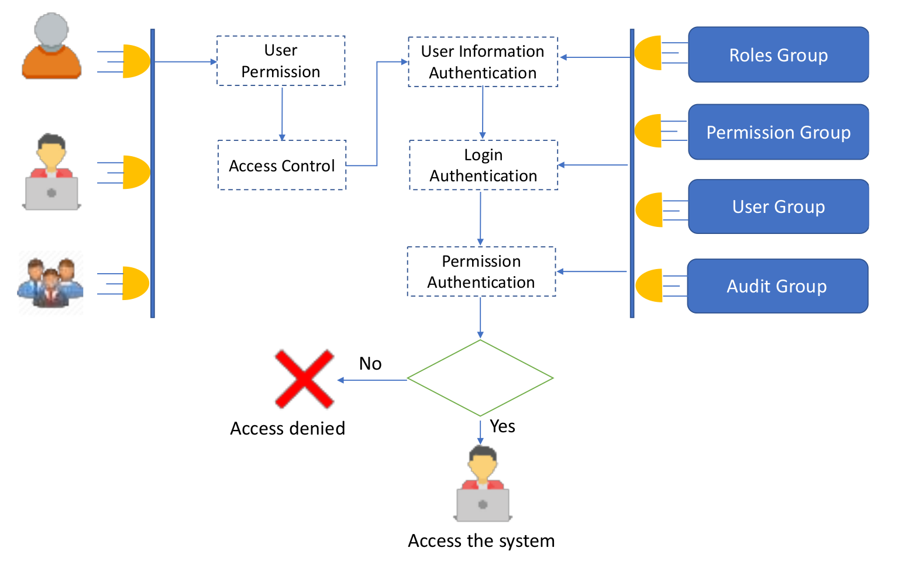

### Requirement Analysis

**Wire-framing**

* Wire-framing of complete project along with analysis is carried out
* Interactive client communication to achieve successful results
* Elegant design of the project in accordance with user interface depiction with click-able prototype

**System Architecture**

* Decision about Framework design and duration of project by our experts
* Brief layout of work procedure with targeted milestone within stipulated time
* Architectural enhancement by technical teams combining all aspects of project

**Project Implementation**

* The existing prototypes during previous phases are coded, programmed and modified during this phase.
* Successive execution of technical coding steps according to set milestones.
* Collaboration of technical aspects to deliver efficient product.

**Testing and Debugging**

* The existing prototypes during previous phases are coded, programmed and
* Modified during this phase.
* Successive execution of technical coding steps according to set milestones.
* Collaboration of technical aspects to deliver efficient product.

### Agile Scrum Methodology

Scrum is the most commonly used agile framework for system/ customized software development. Scrum uses “flexible” strategy where customer has more transparency on the current progress of the project and customer can even change the project execution plan in the middle of the project according to the business values which is not possible with traditional/sequential approach. Scrum makes progress in a series of sprints which are time boxed for a month or less than a month. At the end of every sprint, a sprint review is conducted during which the team demonstrates the new functionality to the product Owner, stakeholders and to the customer.

Scrum framework provides “Change Anytime Strategy” so that, the solution might provide latest technology and support systems integration such as integration with accounting system of the existing procedure used by BRAC.

**Figure: Agile Scrum Methodology**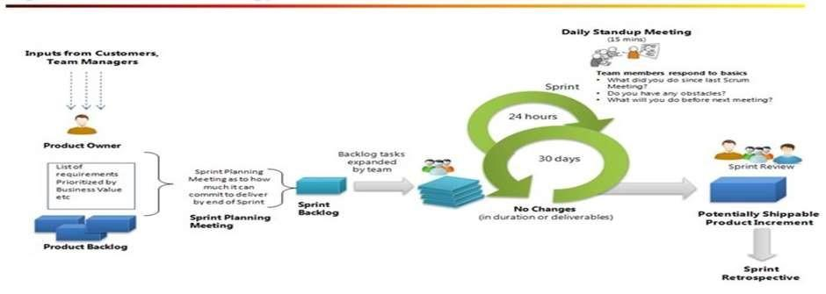

**Scrum Roles**

**Product Owner:** The Product Owner is responsible for managing the Product Backlog, writing user stories and is the voice of the customer. Product Owner is accountable for maximizing the value of the product and work of development team. Product owner ensures that Product Backlog is visible to all and confirms what Scrum team will do in the next sprint.

**Development Team:** Development team is responsible for delivering a potentially releasable “Increment of Done Product” at the end of each sprint. The work done by Development team is self-organizing, cross functional (analyses, design, develop, test, technical communication, document, etc.).

**Scrum Master:** Scrum Master is responsible for ensuring that Scrum is understood by the entire team and for removing any hurdles which might affect sprint goal/deadlines. Scrum Master helps in coaching agility to the Product Owner and to the development team.

**Scrum Meetings**

**Sprint Planning Meeting:** Sprint Planning Meeting is time boxed to eight hours for one month sprint and the meeting duration will be shorter for the shorter sprint. In the meeting we discuss what work to be done in this sprint and how we can get this work done.

**Daily Stand-up Meeting:** Daily Stand-up Meeting is time boxed to 15-20 mins for the Development team to create a plan for the next 24 hours.

**Sprint Review Meeting:** The Product Owner is responsible for managing the Product Backlog, writing user stories and is the voice of the customer. Product Owner is accountable for maximizing the value of the product and work of development team. Product owner ensures that Product Backlog is visible to all and confirms what Scrum team will do in the next sprint.

**Sprint Retrospective Meeting:** Sprint Retrospective Meeting is time boxed to 3 hours for one-month sprint and will be shorter for the shorter sprint. Sprint Review Meeting held after the Sprint Review meeting and prior to the next Sprint Planning Meeting.

**Product Backlog:** Product Backlog in a list of user stories (requirements) which are maintained for the development. Product Backlog is dynamic and constantly changes to identify what the app needs to be appropriate, competitive and useful. Product Backlog is often ordered by value, risk, priority and necessity, and high priority items gets immediate development activities over lower priority items.

**Sprint Backlog:** Sprint Backlog is a list of selected items from the Product Backlog for the Sprint. Sprint Backlog makes visible all of the work that Development identifies as necessary to meet the Sprint goal. Once sprint tasks estimation is done and team is committed on sprint backlog items then we can’t add additional user story in the sprint.

## System Requirement Analysis Plan

Requirements finalization is a very important part in development methodology. Sheba Technologies Limited will carry out detailed requirement study and analysis on the each and every scope of enhancement and maintenance. Under this scope of work, Sheba Technologies Limited will analyze the detail functions, processes and get it signed off from concerned stake holder.

Technical requirements analysis begins with the business requirements documents created during the business analysis phase. Using the business requirements as a basis, you perform the following steps:

* Perform a usage analysis to aid in determining expected load on the deployment
* Create a set of use cases that model typical user interaction with the deployment
* Create a set of system requirements that are derived from the business requirements, use cases, and usage analysis

The following figure shows the technical requirements phase in relation to the business analysis, logical design, and deployment design phases.

|  |  |  |  |
| --- | --- | --- | --- |
| Business Analysis | Technical Requirements | Logical Design | Deployment Design |

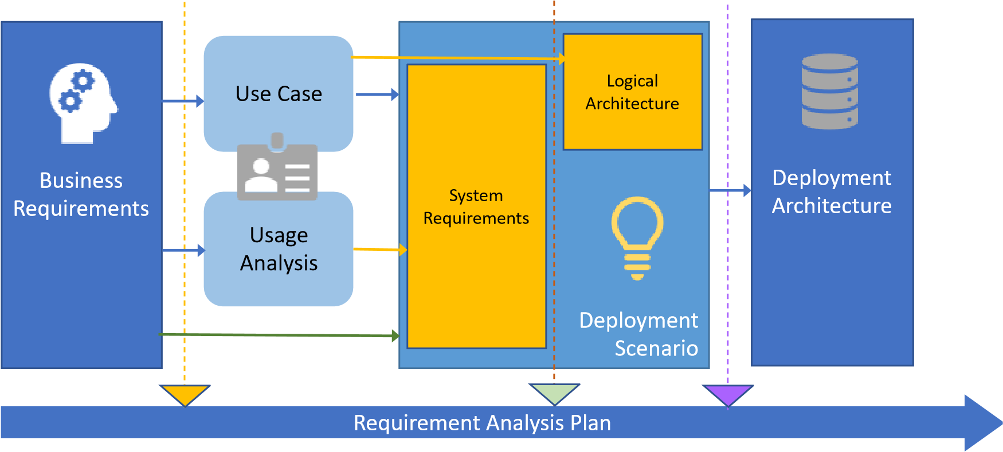

**Figure: Technical Requirements Phase and Other Deployment Planning Phases**

### Business Analysis

In this Sheba Technologies Limited try to understand many components, such as:

* The data needed to accomplish the desired business objective
* Individual work tasks that manipulate, review, or act upon the data in some way
* Decisions that affect the data in the process or the manner in which the process is conducted
* The movement of data between tasks in the process
* Individuals and groups which perform tasks

In this stage to understand the nature of business requirements, Sheba Technologies Limited focuses on the requirements elicitation techniques as discussed below:

### Requirements Elicitation Techniques:

Requirements elicitation (also known as Requirements Gathering or Capture) is the process of generating a list of requirements (functional, system, technical, etc.) from the various stakeholders (customers, users, vendors, IT staff, etc.) that will be used as the basis for the our formalRequirements collection.Depending on the need and situation we will use the techniques mentioned below to correctly elicit requirements:

* Interviews
* Questionnaires
* User Observation
* Workshops
* Brainstorming
* Role Playing
* Use Cases & Scenarios
* Prototyping

### Technical Requirements

Technical requirements, in the context of software development and systems engineering, are the factors required to deliver a desired function or behavior from a system to satisfy a user’s standards and needs. There are aspects such as performance, reliability, and availability those are recorded in this phase. To collect technical requirements Sheba Technologies Limited performs the following tasks:

* **Use Case Analysis:**

Sheba Technologies Limited uses Use case analysis for technical requirements collection as Use cases capture user requirements for a system by describing how a system will be used and to what ends in a way that the end user can understand. Use cases provide many benefits beyond defining user requirements and help us to

* + Illuminate and document current or goal-stated methods, systems and stakeholders
  + Identify business-domain classes and their associates
  + Drive detailed application analysis and design
  + Develop scripts for testing
  + Suggest prototyping activity to Clarify architecture requirements of Highlight risks and needs for risk management
* **System Requirements Analysis:**

Software requirement is a functional or non-functional need to be implemented in the system. Functional means providing particular service to the user. Software requirement can also be a non-functional; it can be a performance requirement. In system requirements analysis phase Sheba Technologies Limited performs the following

* 1. **Business requirements:** They are high-level requirements that are taken from the business case from the projects.
  2. **Architectural and Design requirements:** These requirements are more detailed than business requirements. It determines the overall design required to implement the business requirement.
  3. **System and Integration requirements:** At the lowest level, we have system and integration requirements. It is detailed description of each and every requirement. It can be in form of user stories which describes everyday business language.

### Logical Design

Logical Design or Logical Process Modeling is the representation of a business process, detailing all the activities in the process from gathering the initial data to reaching the desired outcome. A sound logical design therefore helps to ensure a successful implementation. And a complete and accurate logical design for a database helps to ensure us:

* Data independence
* Physical database flexibility
* Integrity
* User satisfaction

Based on logical design, Sheba Technologies Limited then moves on to Logical Architecture Design and Deployment design:

* **Logical Architecture Design:**  To demonstrate the concept applicability, in Sheba Technologies Limited we apply our ideas to a logical architecture design where the metadata is represented as an aspectual, crosscutting view. With the advantages of aspect-oriented specification approach we apply it to design such as data warehousing architecture design and so on.

### Deployment Design

During the deployment design phase of the solution life cycle, Sheba Technologies Limited designs a high-level deployment architecture and a low-level implementation specification and prepares a series of plans and specifications necessary to implement the solution.

## System Design Plan

### Stage 1: Planning

The purpose of this 1st phase is to find out the scope of the problem determine solutions. Resources, costs, time, benefits and other items should be considered here.

### System and Requirement Analysis

The 2nd phase is where teams consider the functional requirements of the project or solution. It’s also where system analysis takes place or analyzing the needs of the end users to ensure the new system can meet their expectations.

### System design

The 3rd phase describes in detail, the necessary specifications, features and operations that will satisfy the functional requirements of the proposal system which will be in place. Basically, at this phase the detail functional scope defining and designing as per the standard of software engineering approach is required. This is very vital and important phase of any SDLC (Software Development Life Cycle).

Considering the existing system is running on stable architecture design, Sheba Technologies Limited Ltd. will undergo the existing system design with required redesign approach for robust, scalable, user friendly system when and if applicable.

At this system designing phase Sheba Technologies Limited will perform different following designing related tasks when new requirement for feature/module development comes up. Some may be listed as:

* Identifying module, components, tasks, I/O and functional features.
* Specifying technical and functional requirements.
* User Interface design.
* Description of UI and requirements.
* Preparing the use cases.
* Determine process and data flow.
* Database design.
* API Design.

### Coding

Now the real work begins! The Coding phase marks the end of the initial section of the process. Additionally this phase signifies the start of production. The Coding stage is also characterized by installation & change.

### Integration & Testing

This phase involves system integration and system testing- normally carried out by a Quality Assurance professional to determine if the proposed design meets the initial set of business goals.

### Implementation

The 6th phase is when the majority of the code for the program is written and when the project is put into production by moving the data and components from the old system and placing them in the new system via direct cutover.

### Operation & Maintenance

The last phase is when end users can fine tune the system if they wish to boost performance, add new capabilities or meet additional user requirements.

At this system designing phase the following design related tasks will be performed and will produce various standard System Designing Document (SDD):

* Identifying module, components, tasks, I/O and functional features
* Specify technical and functional requirements
* User Interface design
* Description of UI and requirements
* Preparing the use cases
* Defining Integration and Interoperability scope
* Designing system architecture
* Determine process and data flow
* Database design
* API design
* Finalized tools, technologies and frameworks to be used

### System Design

|  |  |  |  |  |
| --- | --- | --- | --- | --- |
| **SL** | **Tasks/Elements** | **Responsibility** | **Outcome** | **Remarks** |
| **1** | Designing system architecture | System Analyst & team | Component of SDD |  |
| **2** | Identifying Module,  Components | System Analyst & team | Component of SDD |  |
| **3** | Specify technical and functional requirements | System Analyst & team | Component of SDD |  |
| **4** | User Interface Design | UI/UX | Wireframing | Wireframing is used to easy visualization of upcoming software for user |
| **5** | Use Case Preparation | System Analyst & team | Use cases &  Diagram(Component of SDD) |  |
| **6** | Determine process and data flow | System Analyst & team | * Process flow diagram(Component of SDD) * Data Flow Diagram   (Component of SDD) |  |
| **7** | Defining class & API Design | System Analyst & team | * Class Diagram   (Component of SDD)   * API Documentation |  |
| **8** | Database Design | System Analyst & team | * Data Dictionary   (Component of SDD)   * Database design document |  |
| **9** | Defining Integration and Interoperability scope | System Analyst & team | Component of SDD |  |
| **10** | Finalized tools, technologies and frameworks | System Analyst | Component of SDD | Depending on functional, Non Functional & User requirements the tools, technologies  and frameworks will be finalized |

## Application Development Methodology

### Software Development Methodology

Sheba Technologies Limited will develop a significant project within short time with fixed requirements, so we would like to follow the **Agile Scrum Methodology** for Development. The lifecycle of this model is as follows:

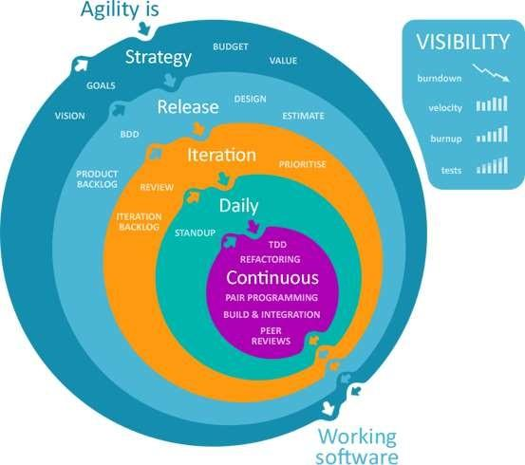

The overall development model can be explained as follows:

* **Requirement Gathering and Analysis:** All possible requirements of the system to be developed are captured in this phase and documented in a requirement specification doc.
* **System Design:** The requirement specifications from first phase are studied in this phase and system design is prepared. System Design helps in specifying hardware and system requirements and also helps in defining overall system architecture.
* **Implementation:** With inputs from system design, the system is first developed in small programs called units, which are integrated in the next phase. Each unit is developed and tested for its functionality which is referred to as Unit Testing.
* **Integration and Testing:** All the units developed in the implementation phase are integrated into a system after testing of each unit. Post integration the entire system is tested for any faults and failures.
* **Deployment of System**: Once the functional and non-functional testing is done, the product is deployed in the customer environment or released into the market.
* **Maintenance:** There are some issues which come up in the client environment. To fix those issues patches are released. Also to enhance the product some better versions are released. Maintenance is done to deliver these changes in the customer environment.

Sheba Technologies Limited will be maintaining the MVC architecture for developing the online based systems:

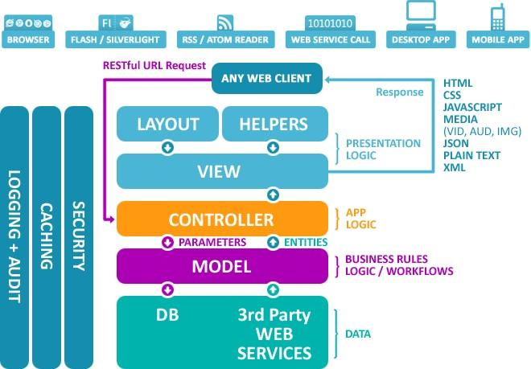

**Figure: MVC Architecture**

**Model**

The model represents enterprise data and the business rules, logic and workflows that govern access to (and updates of) this data. Model has no governance over the presentation of the data, or how that data will be displayed at the receiving front-end client (typically a browser).

**View**

The view represents the presentation of the application. The view accepts and returns data and instructions to and from the Controller and these are molded with presentation logic into a user interface. The view has no knowledge of where the data comes from or what it means - only owning an expectation of the data's structure.

**Controller**

Whenever a user sends a request (e.g. get this, save this, delete this) the application routes it to the Controller. The Controller is responsible for intercepting the requests manifesting from View and wiring it to the business functions that exist in Model. After the action has been taken on the data, the controller is responsible for creating an appropriate response to the user, typically via the generation of a new View.

**API**

API (Application Programming Interface) is a set of instructions, standards or requirements that enables a software or app employ features/services of another app, platform or device for better services. In short, it’s something that let apps communicate with each other. Standard API will be developed as per BRAC guideline, API will be RESTful that covers all the basic communication model of BRAC and third parties.

**API Terminology**

a) **API Key**: When an API request through a header or parameter to recognize the requester, the authorized code passed into the request is said to be an API Key.

b) **Endpoint**: When an API interacts with another system, one end of the communication channel is termed as Endpoint.

c) **JSON**: JavaScript Object Notion or JSON is said to be a data format used for APIs request parameters and response body.

d) **GET**: The RESTful API’s HTTP method of obtaining resources is called GET.

e) **POST**: It is the RESTful API’s HTTP method for building resources.

f) **OAuth**: It is basically an Open standard authorization framework that renders access from the user’s side without directly sharing the credentials.

g) **REST:** REST (Representational State Transfer) is a kind of programming architectural implementation meant to enhance the efficiency of communication between the two devices/systems. It is light-weighted and based on the idea of making a particular data available only when requested by sharing references to the data instead of the entire copy of the data itself. The systems enforced on this architecture are said to be ‘RESTful’ systems, and the most overwhelming example of RESTful systems is the World Wide Web.

h) **SOAP**: SOAP or Simple Object Access Protocol is a messaging protocol for sharing structured information in the execution of web services in computer networks. It works with XML information set and application layer protocols (like HTTP and SMTP) for message format and message negotiation & transmission, respectively.

i) **Latency**: Latency is defined as the total time taken by an API in the process from the request to the response.

j) **Rate-Limiting**: The term API Rate-limiting refers to the process of defining the rate at which an end user can access the APIs. In other words, it means restricting the number of requests a user can hit to an API per time.

k) **API Throttling**: The process of regulating the usage of APIs by users during a particular time period is called Throttling. This can be used for API limiting. For example, you set the limit of 1000 API requests per day. When the user hit the 1001 request, the server will send 429 messages as HTTP status to the end user along with the message, “Too many Requests”.

### Agile Methodology

Agile is a time boxed, iterative approach to software delivery that builds software incrementally from the start of the project, instead of trying to deliver it all at once near the end.

It works by breaking projects down into little bits of user functionality called [user stories](http://www.agilenutshell.com/user_stories), prioritizing them, and then continuously delivering them in short two week cycles called [iterations.](http://www.agilenutshell.com/iterations)

**AGILE methodology** is a practice that promotes **continuous iteration** of development and testing throughout the software development lifecycle of the project. Both development and testing activities are concurrent unlike the Waterfall model.

The agile software development emphasizes on four core values.

### Features of Agile Model

1. Agile method proposes incremental and iterative approach to software design

2. The agile process is broken into individual models that designers work on

3. The customer has early and frequent opportunities to look at the product and make decision and changes to the project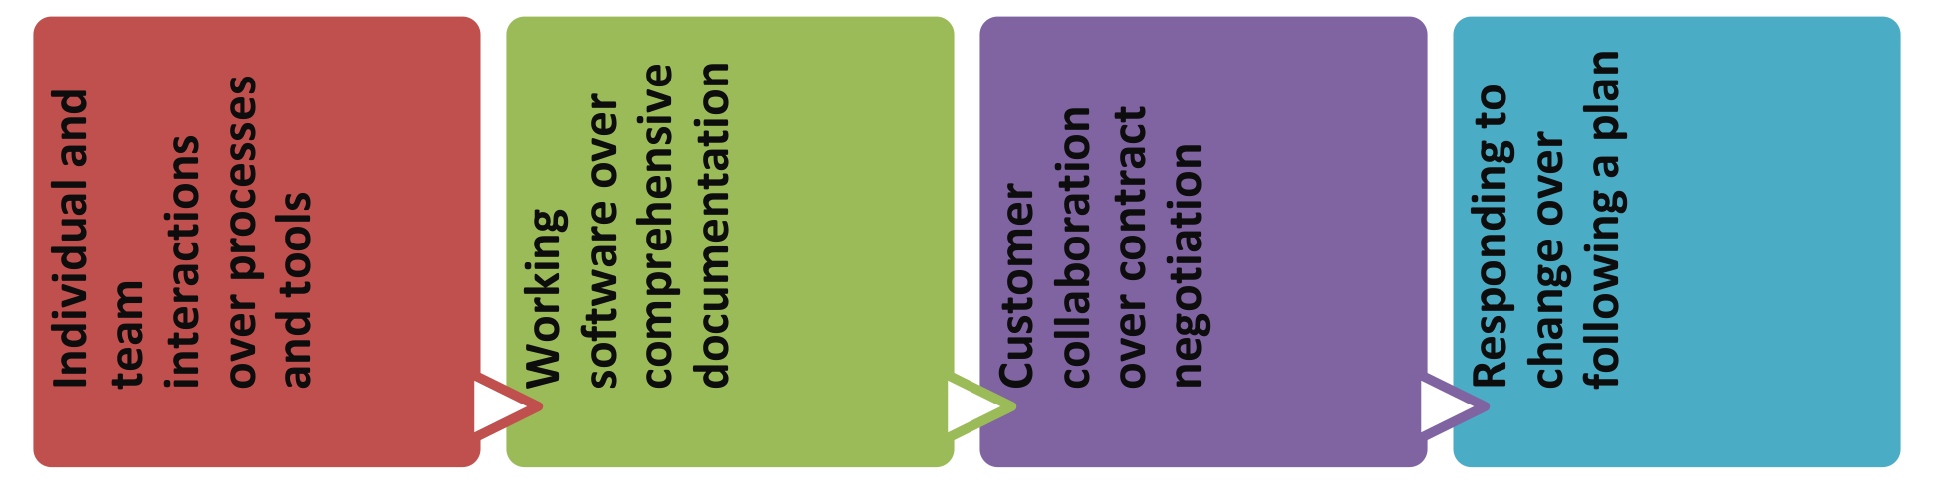

4. Agile model is considered unstructured compared to the waterfall model

5. Small projects can be implemented very quickly. For large projects, it is difficult to estimate the development time.

6. Error can be fixed in the middle of the project.

7. Development process is iterative, and the project is executed in short (2-4) weeks iterations. Planning is very less.

8. Documentation attends less priority than software development

9. Every iteration has its own testing phase. It allows implementing regression testing every time new functions or logic are released.

10. In agile testing when an iteration end, shippable features of the product is delivered to the customer. New features are usable right after shipment. It is useful when you have good contact with customers.

11. Testers and developers work together

12. At the end of every sprint, user acceptance is performed

13. It requires close communication with developers and together analyzes requirements and planning.

### The Agile Approach

Instead of treating these fixed stages Agilest believe these are continuous activities. By doing them continuously:

• Quality improves because testing starts from day one.

• Visibility improves because you are 1/2 way through the project when you have built 1/2 the features.

• Risk is reduced because you are getting feedback early, and

• Customers are happy because they can make changes without paying exorbitant costs.

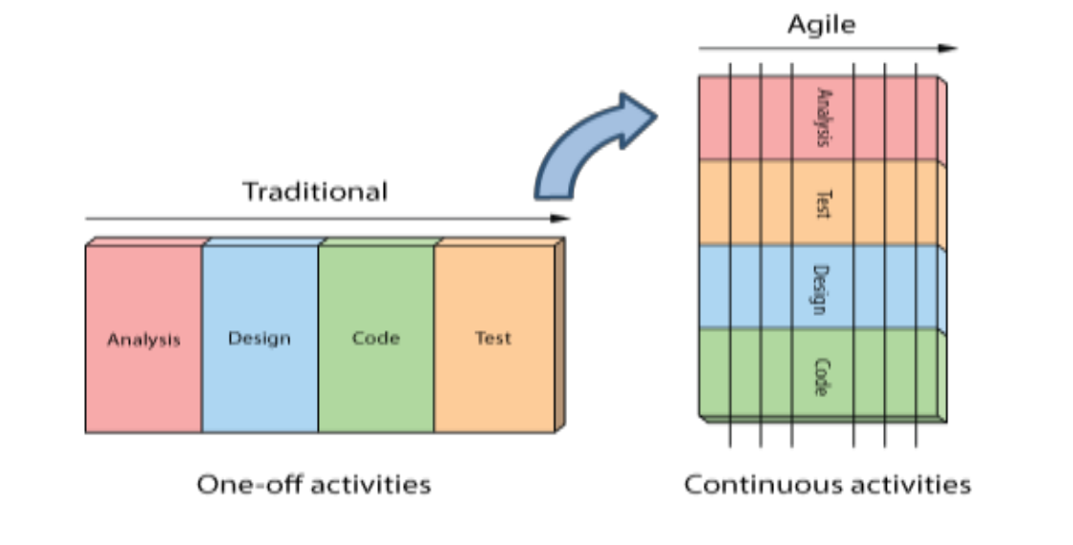

**Agile Testing Methodology**

There are various methods present in agile testing, but we will follow the Scrum method for testing.

### Agile Scrum Methodology

**Scrum** is a lightweight agile project management framework with broad applicability for managing and controlling iterative and incremental projects of all types. Ken Schwaber, Mike Beedle, Jeff Sutherland and others have contributed significantly to the evolution of Scrum over the last decade. Scrum has garnered increasing popularity in the agile software development community due to its simplicity, proven productivity, and ability to act as a wrapper for various engineering practices promoted by other agile methodologies. With Scrum methodology, the “Product Owner” works closely with the team to identify and prioritize system functionality in form of a “Product Backlog”. The Product Backlog consists of features, bug fixes, nonfunctional requirements, etc. – whatever needs to be done in order to successfully deliver a working software system.

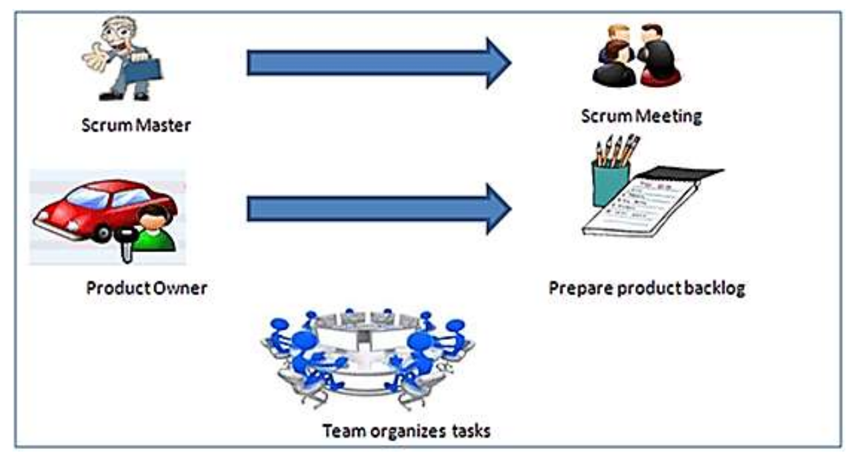

SCRUM is an agile development method which concentrates specifically on how to manage tasks within a team-based development environment. Basically, Scrum is derived from activity that occurs during a rugby match. Scrum believes in empowering the development team and advocates working in small teams (say- 7 to 9 members). It consists of three roles, and their responsibilities are explained

As follows:

• **Scrum Master:**

Master is responsible for setting up the team, sprint meeting and removes obstacles to

Progress.

• **Product owner:**

The Product Owner creates product backlog, prioritizes the backlog and is responsible for

the delivery of the functionality at each iteration.

• **Scrum Team:**

Team manages its own work and organizes the work to complete the sprint or cycle.

• **Scrum Practices:**

Practices are described in detailed:

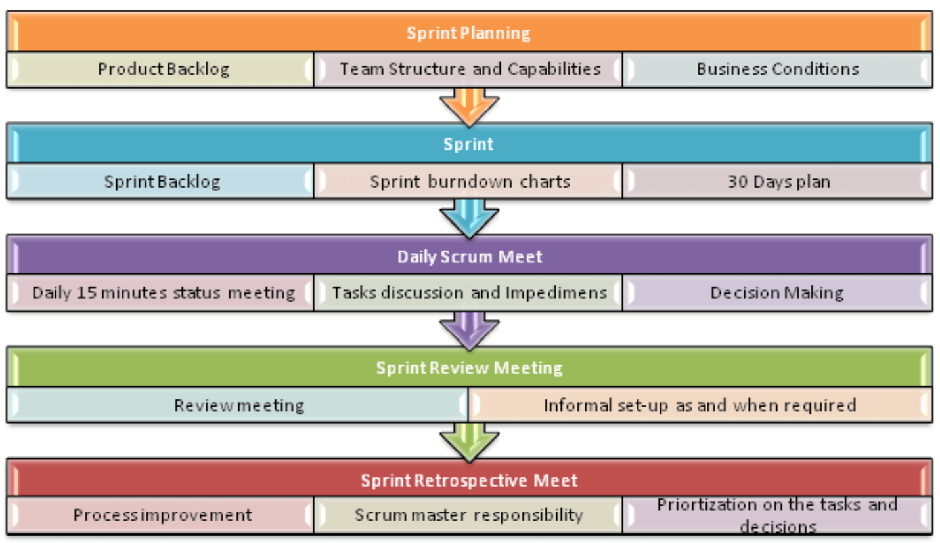

## Deployment and Implementation Plan

This is the phase of SDLC, when the consent is being given to “GO LIVE” of the developed module of existing system after completed all kinds of development integration, testing and hosting. This is very crucial and sensitive stage for a Government application because at this stage the system becomes public and expose to access towards all levels of users. Sheba Technologies Limited will notify concerned stake holders before Deployment and Implementation covering the major activities to be performed, the deliverable to be provided etc.

In Software Development, for Continuous Integration and deployment Github private will be used.

For implementation some of these following mentions should be maintained:

**Implementation Schedule**

This section provides a schedule of activities to be accomplished

**Implementation Support**

This section describes the support hardware, software, facilities, and materials required for

the implementation, as well as the documentation

**Implementation Impact**

This section describes how the system’s implementation is expected to impact the network

Infrastructure, support staff, user community, etc.

**Performance Monitoring**

This part describes the performance monitoring tool, techniques and how it will be used to

Help determine if the implementation is successful

**Configuration Management Interface**

This section describes Configuration Management, such as when versions will be distributed

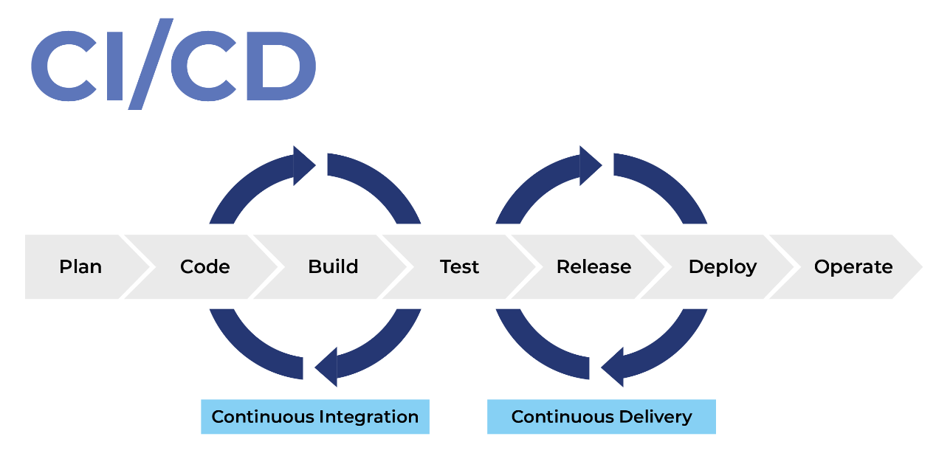

## Project Implementation Plan

**Coding Convention Plan & Approach**

Sheba Technologies Limited will follow the standard coding styles to produce high-quality code for further uses of the code in terms of reusability, refactoring, task automation, language factors etc. Sheba Technologies Limited will submit a standard coding convention approach which may include different conventions like commenting, indent style, naming etc. following the best coding practices. The document “**Code Convention for Programming Language**” is used as guidelines for coding standards.

This is a list of coding practices that will be standardized for each project, and may require additional specification or clarification beyond those detailed in the standards documents.



All code will be written in required language (English).



Good use of descriptive comments for all methods

Relevant variables.



Use automatic tools to generate documentation

1. Select **Clear** and **Meaningful** Names Use and **Avoid Made-Up Acronyms**: Clear, complete and meaningful names make the code more readable and minimize the need for comments. For example; suppose a subroutine called “Process_Input_Line” calls “Push_Input_Character.” If “Push_Input_Character” happens also to echo the input character, then either a different subroutine should be extracted (named “Echo_Input_Character”) and called “Process_Input_Line”, or the name of “Push_Input_Character” should be changed to “Push_And_Echo_Input_Character”

1. **Naming Class** (Noun): Names of class shall consist of a noun and use **Pascal casing**
2. **Naming Interface**(Noun): Names of interfaces shall consist of a noun and use **Pascal casing**
3. **Naming Subroutines/Methods/Functions** (verb and object): Names of procedures/methods/functions shall consist of a verb and (whenever appropriate) an object, such as “Push_Input_Character” and use **Pascal casing.**

1. **Naming Constants, variables** (noun): Names of constants, variables, and functions shall be noun, with or without modifiers (e.g., ''Line ``,''InputLine ``,''NumInputLines ``)
2. **Naming Types:** If allowed by the language, the names of types should have a distinguishable prefix or suffix. It is recommended that all names of types end with the letters “Type”. Further, if the type exists solely to define variable “Xyz”, then the type shall be named “XyzType”.

1. Use of upper/lower case and underscores to differentiate Subroutines, Variables, and Constants.
2. **Naming conventions:** What additional naming conventions should be followed. In particular, systematic prefix conventions for functional grouping of global data and also for names of structures, objects, and other data types may be useful.
3. **Project specific contents** of module and subroutine headers.
4. **File Organization:** What kind of Include file organization is appropriate for the projects data hierarchy, Directory structure, Location of the Make Files (note: “Actions taken before compilation or assembly is performed should be the directory in which the source code resides, unless otherwise specified.)
5. **Specifications for Error Handling:** specifications for detecting and handling of errors, specifications for checking boundary conditions for parameters passed to subroutines.
6. **Revision and Version Control:** configuration of archives, projects, revision numbering, and release guidelines.
7. **Standardization of the development environment** - compiler and linker options and directory structures.
8. **Conditionals and comparisons:** Always test floating-point numbers as <= or >= relational operator, never use exact comparisons (= = or != ). No assumptions should be made about the value of uninitialized variables, unless the language definition makes a clear statement about this.
9. **Program Flow:** Interrupt handlers shall perform minimal processing, and shall be meticulously commented. In high-level languages, multiple exits from a unit are allowed if that avoids excessive control structure nesting. Multiple entries into a unit are not allowed.
10. **Binding time of variables and values**: When data files are accessed in a tree-structured directory environment, the names of the file directories shall not be hardwired in the code; whenever possible, environment variables or some similar mechanism shall be used to provide exact directory names dynamically. The same applies to the names of nodes which are accessed in a network.
11. Engineers should strive to develop code that is both clear, and efficient in its use of CPU time, memory, and other resources. However, when efficiency and clarity conflict, then clarity should take strong precedence over resource stinginess, unless it is proven that using the clear but less efficient method impairs the program critically. Micro-optimizations to small areas of code are especially to be avoided if they impair clarity in any way, since it is generally only the program’s overall algorithms that affect resource utilization significantly.
12. Whenever library routines, graphics packages, compiler/assembler features, or other sorts of utilities are helpful to the program, they should be utilized. The danger of losing access to the utility if the hardware, the compiler/assembler, or the operating system should change is generally overridden by the savings in software creation time. In those cases, in which there is no significant savings of software creation time, it is preferable to use the standard language features, for portability’s sake.
13. Type casting integer and float variables makes code more portable. If the language allows, all integer and floating types which are important in the program should be defined as new types within the program. This will allow for easy correction if the code is ported to a different compiler or machine with different default work sizes. This also often allows for much better type checking, depending on the language.

1. Compiler dependent code should include tests. Whenever the code makes assumptions about how the compiler represents data structures, the code should include a test (if possible) to determine whether the assumption holds true, and display a prominent message and abort the program if the test fails. This will notify future maintainers who may unwittingly spoil the assumption, or who may port the program to a different compiler and/or machine.

1. Use ASCII files for runtime or machine dependent constants and macros. Whenever possible, values which remain static throughout runtime but which can be used to tune or modify the program shall be read from an ASCII file at the start of runtime, to allow for dynamic modification without recompilation or relinking. Note that in some cases, the program design may specify features to support dynamic tuning or modification of some of these values (for example, machine setpoints).
2. Use of prefixes (Hungarian) notations to differentiate the scope and type of a data variable
3. Macros and Constants: Fixed identifiers such as Macros and Constants shall contain underscores between words and use all UPPERcase letters. For example; a constant that defines the maximum of a motor could be named “MAX_MOTOR_RPM”
4. Debugging: Rules for i.e. #define DEBUG_MODULE_NAME
5. Using structures and enumerators is recommended
6. Write Everything Code-Related in English 27. Always Write the Braces Around Single Line Blocks

28. Avoid Hard-Coded Strings and Magic Numbers.

**Variable Scope**

|  |  |  |
| --- | --- | --- |
| Scope | Description | Prefix |
| Global | Variable is valid only within any module in a project | g (or unique prefix identifying the source module) |
| Local | Variable is valid only within the subroutine that it is defined | none |
| Module | Variable is valid only within the module that it is defined | m |
| Public | In Object Oriented languages, useable by all | pb |
| Protected | In Object Oriented languages, useable by members of any class derived from the defining class | prt |
| Private | In Object Oriented languages, useable by members only of the defining class | prv |

**Summary table for Naming Convention:**

|  |  |  |  |  |
| --- | --- | --- | --- | --- |
|  | **Upper/lower case** | **Under -score** | **Prefixes or Suffix** | **Example** |
| Class | Pascal casing | Yes | No | Human |
| Interface | Pascal casing | Yes | No | Human |
| Subroutines/Methods/Functions | Mixed case separated by underscores | yes | Hungarian prefix for the return type | iGet_Color() |
| Constants, Macros, Enum Constants | Upper case | yes | none | COLOR_RED |
| Types and User-type declarations (Structures, Enumerators, Unions) | MixedCase | no | Suffix (Type, Struct,  Enum, and Union) | ColorType,  EmployeeStruct |
| Variables | MixedCase | no | Hungarian prefixes | blStackIsUpdated |

## Business Continuity plan

Business continuity plan (BCP) is the process involved in creating a system of prevention and recovery from potential threats to a company. The plan ensures that personnel and assets are protected and are able to function quickly in the event of a disaster. The BCP is generally conceived in advance and involves input from key stakeholders and personnel.

BCP involves defining any and all risks that can affect the company's operations, making it an important part of the organization's risk management strategy. Risks may include natural disasters— fire, flood, or weather-related events—and cyber-attacks. Once the risks are identified, the plan will also include:

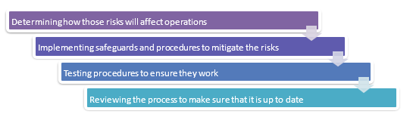

Sheba Technologies Limited Business Continuity plan for this eService application will play a very important role by creating the systems of prevention and recovery to deal with potential threats and risk of the e-Service operation. Regarding business continuity, Sheba Technologies Limited will take in account the followings issues if applicable or suitable for this e-Service Application

* All standard backup facilities will be supported by the system which can be started with disk based backup facility,
* Data and the Operating system core component will be separated. A ghost image of the Operating system will always be available in case of rebuilding the server. All data will be restored in the data drive once the Operating System is restored.
* System will also have an automated Backup mechanism by which users can schedule the backups and the system will take the backups without manual intervention.
* System will check for the media and generate a report on backup with date time and details of backup.
* If a restoration fails for any reason, the system will prompt with proper error messages and suggest what has to be done to rectify the situation via on-screen, logs, email and text messages.
* System will maintain an automated recovery system and all versions of backup will be maintained. At any given point in time, the versions and incremental backup details can be retrieved from the system.

## Risk Management Plan

### Risk Management

As with any project, risks are an essential aspect that must be studied, prevented and controlled. Sheba Technologies Limited stringently follows the principles and guidelines to design, implement and maintain risk management processes throughout the organization. All strategic, management and operational tasks of Sheba Technologies Limited throughout projects, functions, and processes are aligned to a common set of risk management objectives.

The first step in of that methodology is to identify the possible risks (caused by any Internal or External factors) and to assess the consequences (loss of vendor or clients). Once risk assessment is done, a Risk Management Process will be initiated accordingly. Risk Management Process will ensure to mitigate or to take necessary action for upcoming risk of the project.

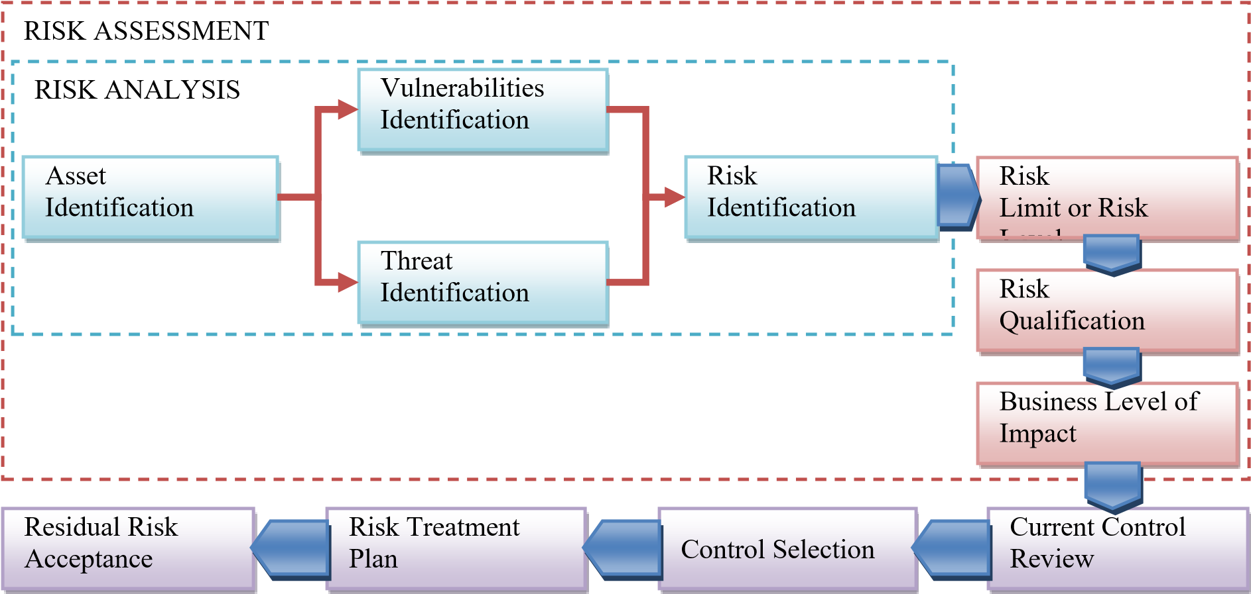

**Figure: Risk Management Process**

Framework for Risk Monitoring and assessment will be maintained throughout project. Sample of the framework is as follows:

|  |  |  |  |  |  |  |
| --- | --- | --- | --- | --- | --- | --- |
| **No** | **Category** | **Risks** | **Probability** | **Impact** | **Risk**  **Exposure** | **Mitigation Plan** |
| **1** | Category 1 | Risk  Description | Numeric  Probability | Impact  Assessment |  | **Mitigation Plan** |
| **2** | Category 2 | Risk  Description | Numeric  Probability | Impact  Assessment |  | **Mitigation Plan** |
| **3** | **Category 3** | **Risk**  **Description** | **Numeric**  **Probability** | **Impact**  **Assessment** |  | **Mitigation Plan** |

## UX Planning

With the technological advancement in the 21st-century, everybody wants to experience the best technology without spending too much of their time and exhausting their busy brains. The same goes for surfing the websites or mobile applications as well where the quick and efficient the website or the mobile application responds, the successful outcomes it obtains. In short, it is about the consumers nowadays! And, when it comes to the mobile application or website user satisfaction, Sheba Technologies Limited turns towards the applications’ User Interface (UI) and User Experience Design (UX). Sheba Technologies Limited always prioritize the user experience and customer satisfaction which ultimately helps increase the number of users of the specific application.

**User Experience (UX)** Development is the procedure of improving the overall experience of the users when they interact with the application or website in order to achieve its objective to provide the maximum customer satisfaction. It keeps customers in mind and creates the basic skeleton of any application. It mainly focuses on wire framing an application and structuring all its components and elements appropriately to create the user flow. The goal of UX design is to create a digital product a user feels comfortable with. This embraces the way a product functions and a user operates it: content hierarchy, clear navigation, and functionality of the visual elements.

The **User Interface (UI)**, on the other hand, is the process of improving the presentation and the interactivity of the web or mobile application. It focuses on the app’s look and interacts with the users. Each screen, page, buttons and other visual elements you see while using an application is the User Interface of that application. UI design makes achieving user goals aesthetically pleasing because of a UX designer’s creativity.

### Approach and Methodology of UX/UI Design

The whole UX design process of Sheba Technologies Limited will be oriented towards creating the best user experience by eliminating the information load. It will consist of two parts:

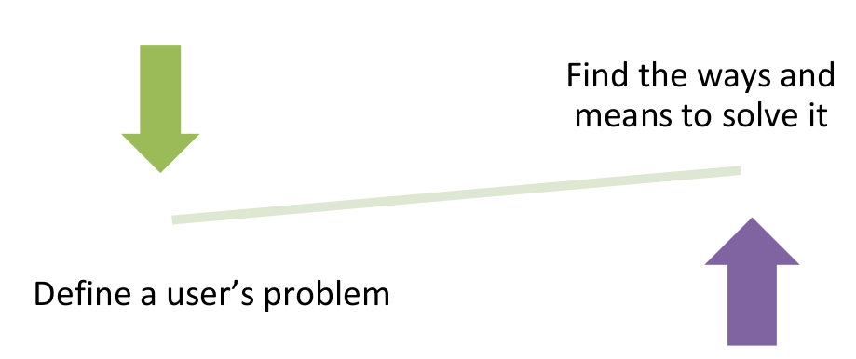

In the first part, our UX designer will be responsible to understand the user and his/her needs considering how to steer someone to achieve particular goals. Sheba Technologies Limited UX designer will serve as a guide for a user. And the UI designer, on the other hand, will pave this path with visual elements and will largely be responsible for the second part.

When designing for web, desktop, or mobile products, Sheba Technologies Limited UX-oriented team always keep in mind why the user needs this or that exact element. The user is the main character of this story, so our UX design will be user-oriented and emotional: a large part of the first stage of a UX design is devoted to exploring a user.

**User Research and Analysis**

At this stage is, Sheba Technologies Limited requirement analysis team will understand the user and his/her pain points. This is when our UX designer works along with a business analyst to do market research, create a competitive analysis, conduct user and stakeholder interviews, record user observations, and define the user journey.

A UX designer will work in cooperation with a business analyst (BA) if needed. As a business analyst gathers requirements from stakeholders and potential users and frames them into software documentation, UX specialist translates it into the product’s information architecture. Main deliverable of this phase are



**Information Architecture (IA)**

As a result of UX research, a designer will create the full structure of a digital product. Information architecture is everything for UX. The main goal of IA will be to classify the content in a way that a user can understand, enabling the user to easily find what he/she needs. As a result of card sorting, our UX designer will structure the content of the website or application.

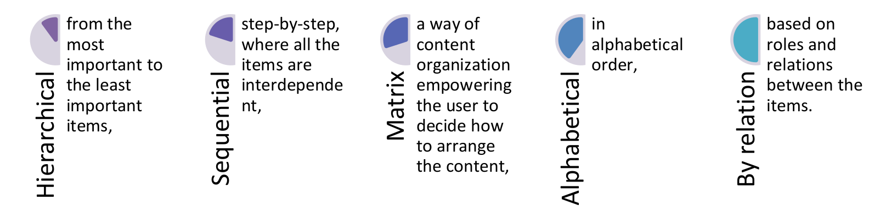

**Prototyping**

This part of UX design will play a significant role in the development because the deliverables will be tested by the users and shown to stakeholders. The designer will create wireframes, mockups, and prototypes. Those artifacts will represent a page layout and look similar but perform different functions: They will represent a product at different stages of development of UX/UI design.

**Main deliverables** of this phase are

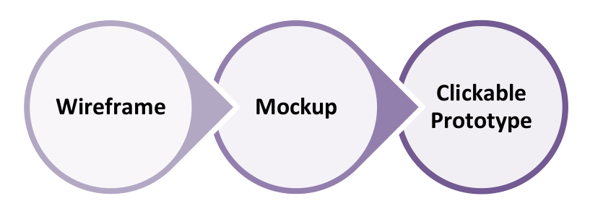

**UI Design System**

Final layout will be prepared in this phase, and designer will work on graphics. Wireframes and mockups are the skeleton, while graphics is the flesh of a digital product. At this stage, UI designer will start developing the graphical interface of the digital product. It entails drawing icons, choosing typography and color palette, as well as setting UI guidelines. Main Deliverables of this phase are Moodboard, UI style guide.

**Usability Testing**

UX designer, front-end development team and UI designer will work together in this phase. As soon as the first prototype is ready, the development team will test its usability. Its main goal will to get feedback from real users of the product to understand how intuitive the interface is, and whether the user can achieve their goal with the product. At this stage, the UX designer will record and analyze the results of testing. There will few different types of usability testing.

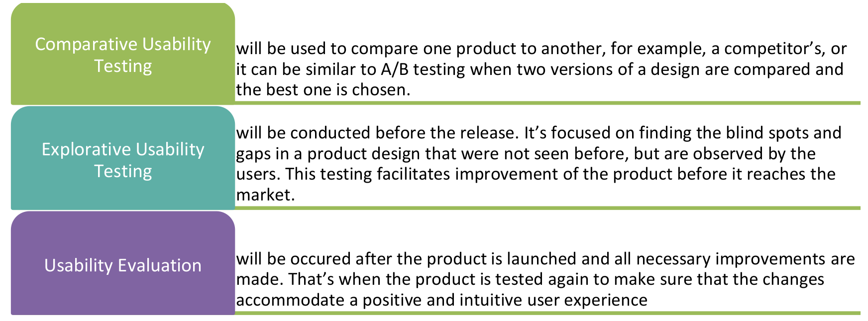

## Release Management

Release management is the process of managing, planning, scheduling and controlling a software build through different stages and environments; including testing and deploying software releases.

• Understands the requirement needs and their priorities, and under what circumstances those priorities can change.

• Works with product owners, IT project teams, and operations staff to ensure every release contains the correct features.

• Release Management has a clear picture of development dependencies, and how changes to one part of a product can affect the stability of the whole.

• Schedules release unit dependencies into release packages.

• Understands the bandwidth and work capacity of each team involved in development.

• Understands the availability of resources and environments for testing.

• Schedules builds and testing according to team and resource bandwidth and availability.

• Create release plans, including governance and approval requirements.

• Ensure compliance of new releases with governance requirements.

• Optimizes value creation at every step, from feature check-in to deployment.

• Schedules seamless release deployments.

## Incident Management

Incident management as a process has a direct bearing on the availability of the customer systems. Incident reports should be used internally to support process improvements as well as externally to illustrate. Incident reporting is ideally driven from the PSA/ticketing solution as this system manages all incidents regardless of the source. Key reporting information includes:

* Number of incidents in the reporting period divided by priority
* Source of those incidents (N-central, phone, email, web)
* Mean time to recovery vs. objective

## Problem Management

If incident management is about resolving customer issues quickly, then problem management is about identifying the underlying cause of one or more incidents and making recommendations to improve the ongoing stability of the infrastructure – by either producing a workaround and/or a solution for the problem. By the very nature of this process problem management is both reactive and proactive at the same time. By solving the problems that are causing a current incident, problem management is contributing to reactively supporting customers. By correcting the underlying problem or weakness within the infrastructure, thus preventing future incidents of a similar type, problem management is contributing to the proactive support of the customer as well.

## SLA (Service Level Agreement)

A service-level agreement (SLA) is required to describe the level of service expected from Sheba Technologies Limited, laying out the metrics by which that service is measured, and the remedies or penalties, if any, should the agreed-upon levels not be achieved.

Sheba Technologies Limited understands the importance of an SLA to pull together information on all of the contracted services and expected reliability into a single document. Clearly stating metrics, responsibilities and expectations, it ensures both sides have the same understanding of requirements.

Sheba Technologies Limited provides an SLA in two areas: services and management:

* Service elements include specifics of services provided, conditions of service availability, and standards such as time window for each level of service, responsibilities of each party, escalation procedures, and cost/service tradeoffs.
* Management elements should include definitions of measurement standards and methods, reporting process, contents and frequency, a dispute resolution process, an indemnification clause protecting the customer from third-party litigation resulting from service level breaches, and a mechanism for updating the agreement as required.

**Availability of the services**

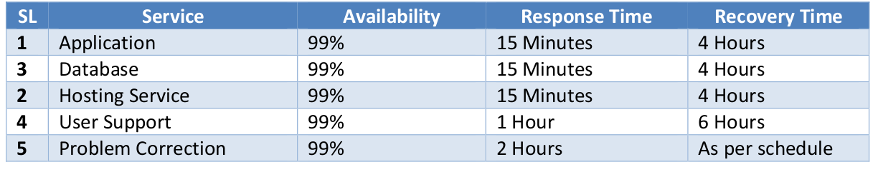

# Configuration Management

Configuration management (CM) is a governance and systems engineering process for ensuring consistency among physical and logical assets in an operational environment. The configuration management process seeks to identify and track individual configuration items (CIs), documenting functional capabilities, and interdependencies. Administrators, technicians, and software developers can use configuration management tools to verify the effect a change to one configuration item has on other systems.

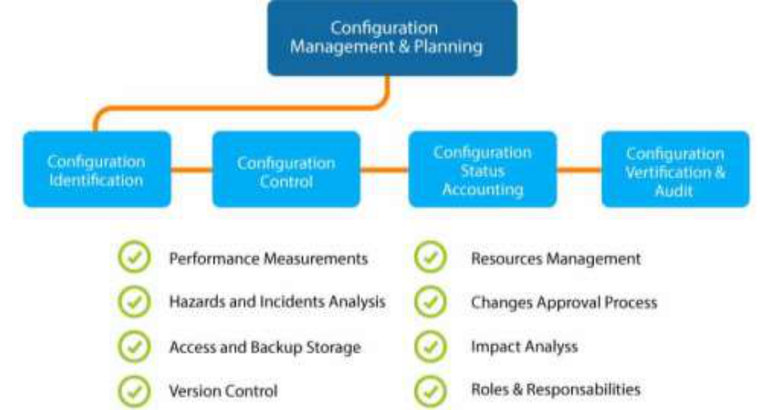

## Change Management

The change management process plays a vital role in maintaining infrastructure and updating the basic configuration management database. Asset management and configuration management provides the information change management needs to assess the risks, costs and impact of change. Sheba Technologies Limited choose to implement change management and configuration management simultaneously in order to give a full strategic control of the infrastructure. To meet this strategic need, asset management, change management and a CMDB are important elements of software applications, which interact and provide added value.

## Service Layers for Support

Users will contact the service desk for any number of reasons; the next task of the service desk engineer performing the incident management function is to define the type of call, which will be one of:

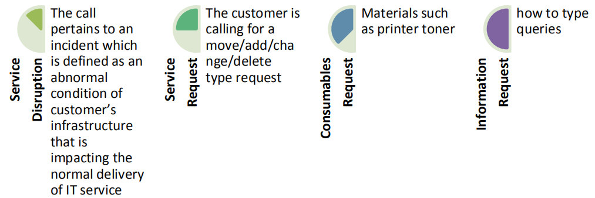

If the nature of the call is about an incident, the service desk engineer must prioritize the case. The purpose of prioritizing the tickets is to allow the efforts to be conducted according to a triage mentality rather than simply first come, first serve. The priority of an incident should be based upon three separate elements:

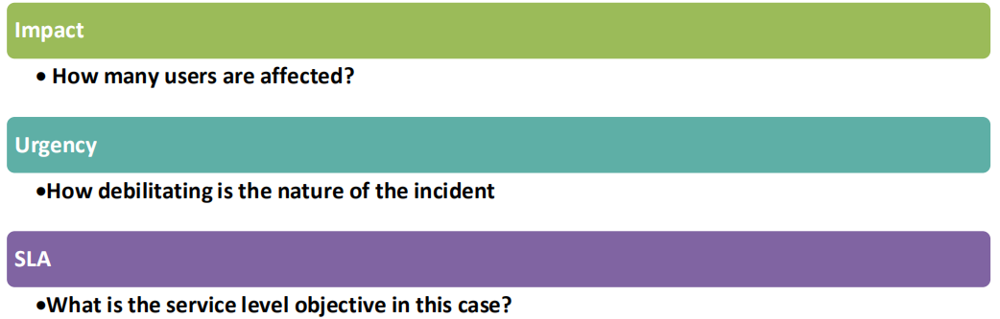

On the basis of these two factors the service desk should be able to assign a priority to the incident. Standard priorities include:

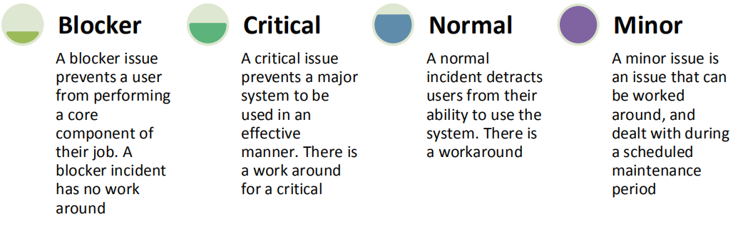

# Testing

## Testing Requirements of BRAC

Details of testing plans and methodologies are given hereafter:

## Testing Plan of Sheba Technologies Limited

This testing plan will cover all the suitable standard approaches for this e-Service application which may include phase wise testing activities like scripting, test cases, testing tools, testing process, test log, result and report formats. For example expected test deliverables based on the application development requirements.

Software testing methodologies are the different approaches and ways of ensuring that a software application in particular is full tested. Software testing methodologies encompass everything from unit testing individual modules, integration testing of an entire system to specialized forms of testing such as security and performance.

Sheba Technologies Limited will perform the following major functions in the testing phase:

• Unit Test

• Integration testing

• System testing

• Functional Test

• Installation testing

• Compatibility testing

• Smoke and sanity testing

• Regression testing

• Stress Testing

• Software performance testing

• Usability testing

• Accessibility testing

• Security testing

## Various Testing Methodologies

As software applications get ever more complex and intertwined and with the large number of different platforms and devices that need to get tested, it is more important than ever to have a robust testing methodology for making sure that software products/ systems being developed have been fully tested to make sure they meet their specified requirements and can successfully operate in all the anticipated environments with the required usability and security.

### Usability Testing

The usability testing part of a testing methodology looks at the end-user usability aspect of the software. The ease with which a user can access the product forms the main testing point. Usability testing looks at five aspects of testing -

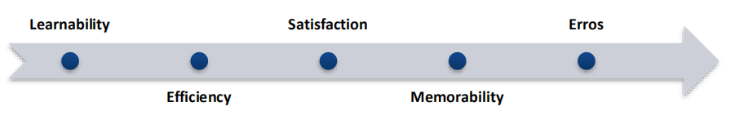

### Functional Testing

In most testing methodologies, functional testing involves testing the application against the business requirements. Functional testing is done using the functional specifications provided by the client or by using the design specifications like use cases provided by the design team.

The functional testing part of a testing methodology is typically broken down into four components.

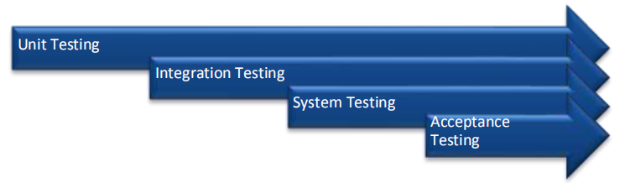

These usually executed in this order. Each of them is described below.

### Unit testing

The unit testing part of a testing methodology is the testing of individual software modules or components that make up an application or system. These tests are usually written by the developers of the module and in a test-driven-development methodology (Such as Agile, Scrum or XP) they are actually written before the module is created as part of the specification. Each module function is tested by a specific unit test fixture written in the same programming language as the module.

### Integration Testing

The integration testing of a testing methodology is the testing of the different modules/ components that have been successfully unit tested when integrated together to perform specific tasks and activities (also known as scenario testing). This testing is usually done with a combination of automated functional tests and manual testing depending on how easy it is to create automated tests for specific integrated components.

### System Testing

The system testing part of a testing methodology involves testing the entire system for errors and bugs. This test is carried out by interfacing the hardware and software components of the entire system (Which have been previously unit tested and integration tests) and then testing it as a whole. This testing is listed under the black-box testing method, where the software is checked for user expected working conditions as well as potential expectation and edge conditions. Automation testing can be performed using

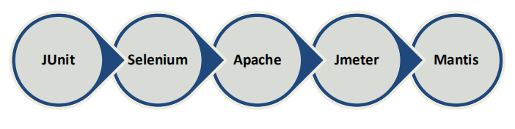

### User Acceptance Testing

The user acceptance testing is the part of a testing methodology which is the final part of functional software testing and involves making sure that all the product/project r requirements have been met and that end-users and customers have tested the system to make sure it operates as expected and meets all their defined requirements.

The UAT plan must consist of the following:

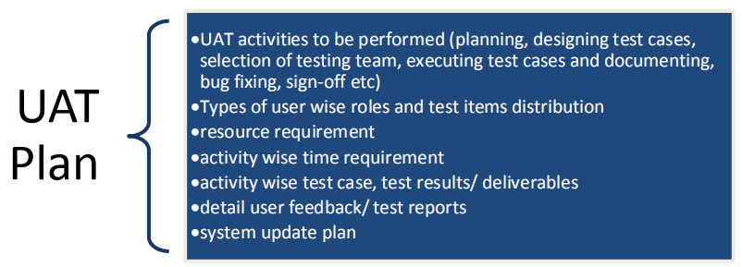

There will be some other testing involves testing the application against the non-functional requirements which typically involve measuring/ testing the application against defined technical qualities (also known as the ‘-ilities’ because they all end in ‘-ility’). For example, vulnerability, scalability, usability. Some of the non-functional testing is described below.

### Load Testing

There are several different types of performance testing in most testing methodologies for example:

performance testing measuring how a system behaves under an increasing load (both numbers of users and data volumes), load testing is verifying that the system can operate at the required response times when subjected to its expected load and stress testing is finding the failure points in the system when the tested load exceeds that wic it can support.

### Recovery Testing

Recovery testing is a type of non-functional testing technique performed in order to determine how quickly the system can recover after it has gone through system crash or hardware failure. Recovery testing is the forced failure of the software to verify if the recovery is successful.

### Security Testing

Previously, security was something that was tested after-the-fact. With the rise in the cyber-crime and the awareness of the risks associated with software vulnerabilities, application security is now something that needs to be designed and developed at the same time as the desired business functionality. Security testing tests software for confidentiality, integrity, authentication, availability and non-repudiation. Individual tests are conducted to prevent any unauthorized access to the software code.

### Compatibility Testing:

The compatibility part of a testing methodology tests that the product or application is compatible with all the specified operating systems, hardware platforms, web browsers, mobile devices and other designed third-party programs (e.g browser plugins). Compatibility tests check that the product works as expected across all different hardware/software combinations and that all functionality is consistently supported.

### Testing Plan Details

|  |  |  |  |
| --- | --- | --- | --- |
| Test | Responsibility | Execution Time | Remarks |
| Unit Test case | Developer/Tester | Before the test execution | Testing requirements will be specified |
| Unit Test case | Developer/Tester | after completing a  unit of task | Test result will be documented in the test report (Pass/Fail, Bug report, bug fixing tool) |
| Integration  Test case | Developer/ Tester | Before the test  execution | testing requirements will be specified |
| Integration  Test | Developer/ Tester | after merging two  units | Test result will be documented in the test report (Pass/Fail, Bug report, bug fixing tool) |
| System Test  case | Tester | Before the test  execution | testing requirements will be specified |
| System Test | Developer/ Tester | after the whole system being developed | Test result will be documented in the  test report (Pass/Fail, Bug report, bug  fixing tool) |
| UAT Test case | QA | After SRS preparation | testing requirements will be specified |
| UAT | User + QA | while user using the  system | Test result will be documented in the test report (Pass/Fail, Bug report, bug fixing tool) |
| Non Functional  Testing | Developer +  Tester | After completing  specific features | Test result will be documented in the  test report (Pass/Fail, Bug report, bug  fixing tool) |

### Performance Monitor

**Performance monitoring:**

In this task the Sheba Technologies Limited will assist BRAC in developing the following capabilities:

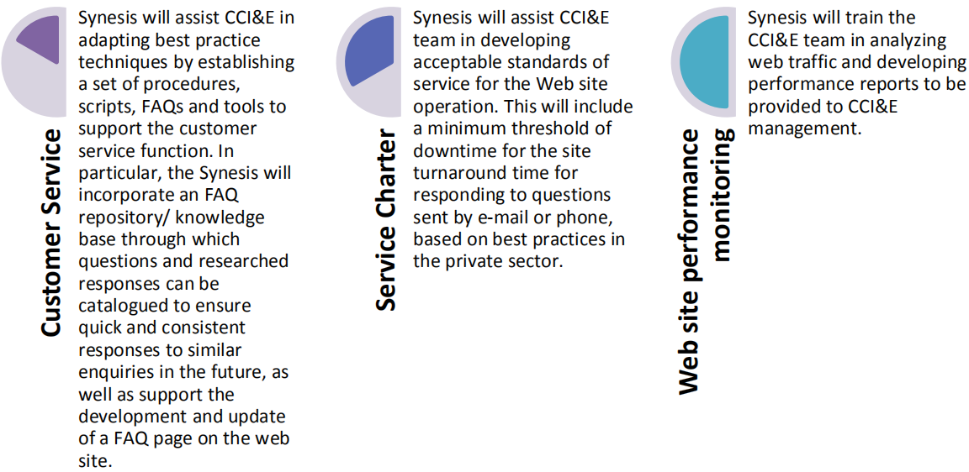

## Training

Sheba Technologies Limited will conduct training sessions for BRAC IT staffs, system administrators and BRAC staffs along with reviewing development proposals and showing different features of the system in order to fully acquaint them with the operation of the features and functionality of the application. Sheba Technologies Limited shall develop training materials to conduct the training . Sheba Technologies Limited will also be responsible to update

(in Bangla and English) system documentation and manuals for users and administrators and fully document any customization and change management made into the system. Detail training plan, scope with methodology is given hereafter:

## Training Plan

Considering the scope of the project and the number of system users, we cannot stress enough the importance of user training in the implementation of this project. To make sure that all the stakeholders involved in the project will be able to use the system independently and in an efficient and error free manner, Sheba Technologies Limited will conduct comprehensive training for process stakeholder .Sheba Technologies Limited will provide the training outlining the below mentioned points.

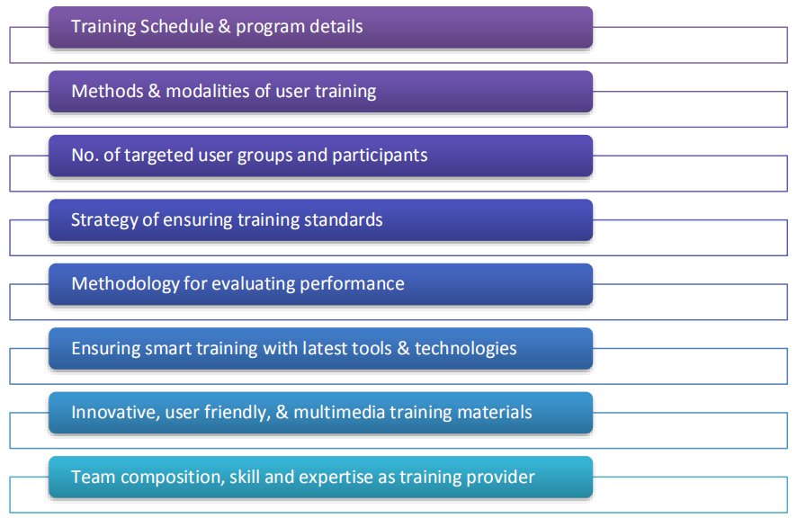

### Draft Training Plan

The training program will be operated by Senior and strong technical training team member of Sheba Technologies Limited for maintaining large system and provide prompt support to the end-user. To upgrade technical personnel; Sheba Technologies Limited will provide technical training separately for assigned technical personnel so that they become confident enough to take responsibility and ownership of software after successful completion of training from us. Sheba Technologies Limited will provide all the instructions and guidelines to run, manage and maintain the software. We will be guiding through:

* Live Training Sessions
* We will be providing the below materials while giving the Trainings:

- User Manual,

- Frequently Asked Questions

### Training Type

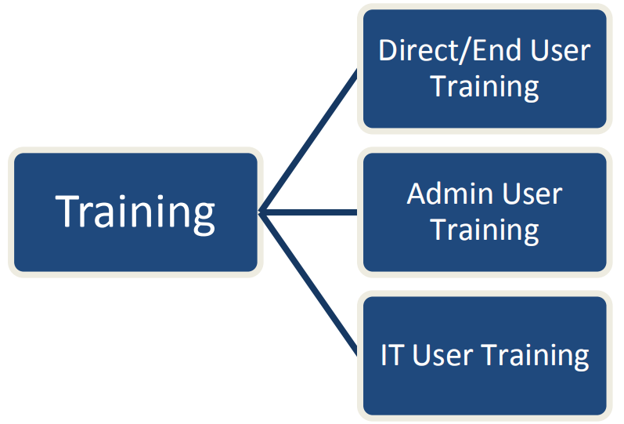

## Error Handling, Bug Fixing & Fine Tuning

### Error Handling

Error handling refers to the anticipation, detection, and resolution of programming, application, and communications errors. Specialized programs, called error handlers, are available for some applications. The best programs of this type forestall errors if possible, recover from them when they occur without terminating the application, or (if all else fails) gracefully terminate an affected application and save the error information to a log file. Error handling is important because it makes it easier for the end users of your code to use it correctly.

Sheba Technologies Limited will perform regular Error handling to the response and recovery procedures. This will comprise of anticipation, detection and resolution of application errors, programming errors or communication errors. Sheba Technologies Limited will look after any sort of Logical errors, Generated errors, Compile-time errors and Runtime errors.

### Bug Fixing

A bug fix is a change to a system or product designed to handle a programming bug/glitch. Many different types of programming bugs that create errors with system implementation may require specific bug fixes that are successfully resolved by a development or other IT team. Sheba Technologies Limited will do corrective changes in software maintenance by fixing bugs, flaws and defects in the software.

### Fine Tuning

Sheba Technologies Limited will also do fine tuning of the system for the functionality and usability of the software by refining, deleting, or adding new features. This will include user interface tweaks, redesigns, or in-system user journey changes etc.

### Help Desk Support

Sheba Technologies Limited will provide auto hunting telephone number for telephone assistance by qualified help desk support engineers between 9:00 am. and 6:00 pm. (Bangladesh time) to provide assistance to the general applicants. BRAC officials will also can get help from the hotline in attempt to correct or bypass defects or errors in the Software that have been brought to the attention.

For helpdesk support, responsible manpower will be present to answer all relevant support services. When general applicants and BRAC officials will be experiencing an issue, whether it’s a network outage, or an inability to perform an action because they might not know how to use the system, they will want an expedient resolution to their problem through the helpdesk support. Restoring System to operational status as quickly as possible, is the main purpose of the helpdesk support and this support service process is called incident management process.

Sheba Technologies Limited IT’s Incident management process defines how and where incidents originate, escalation points and definitions of categorization and prioritization. From the perspective of being responsive to a customer’s needs, incident management is probably the most critical of all IT service support services. Incident management is comprised of the following activities:

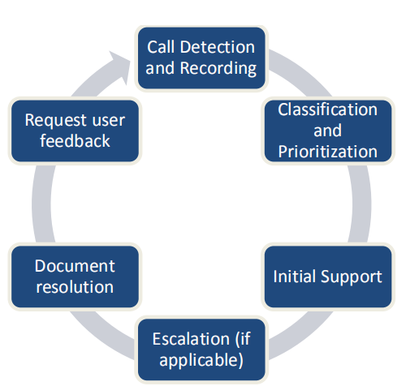

# Project WBS

|  |  |  |  |
| --- | --- | --- | --- |
| **Task Name** | **Duration** | **Start** | **Finish** |
| * **BRAC Service Desk Platform,** * **BRAC Technology Services (Website),** * **Interface changes and dynamic reporting features implementation in PMU dashboard.** |  |  |  |
| **Project Timeline** | **66 days** |  |  |
| **Requirements and Prototyping** | **14 Days** |  |  |
| Req. Elicitation & System Analysis | 4 | S | S+4 |
| XD Prototype Development | 4 | S+4 | S+8 |
| Approval of Prototype | 2 | S+8 | S+10 |
| SRS Development | 2 | S+10 | S+12 |
| Approval on SRS | 2 | S+12 | S+14 |
| **Development:** | **46 Days** |  |  |
| **Planning** | **6 days** |  |  |
| Development Plan | 2 | S+14 | S+16 |
| Development Plan Approval | 1 | S+16 | S+17 |
| Test Cases | 2 | S+17 | S+19 |
| Test Cases Approval | 1 | S+19 | S+20 |
| **Execution** | **40 days** |  |  |
| Application Development | 34 | S+20 | S+54 |
| Testing | 2 | S+54 | S+56 |
| Bug Fixing | 2 | S+56 | S+58 |
| Server Sanity Testing, Fixing & Deployment | 2 | S+58 | S+60 |
| **Closing** | **6 days** |  |  |
| Over all observation and Bug Fixing | 3 | S+60 | S+63 |
| User Manual | 2 | S+63 | S+65 |
| FAC Signoff | 1 | S+65 | S+66 |

# Annexure A: STL Legal Documents

|  |  |
| --- | --- |
| **Name of the Company** | Sheba Technologies Limited |
| **Contact Person:** | Farhan Islam Head of Business Operations Phone: 01711547804 Email: farhan.islam@shebatech.com.bd |
| **Constitution & Year of Establishment:**  Incorporation Year: 2015 |  |
| **Registered Office/Corporate office/Mailing Address:** | Registered Office: H # 55, R # 4/A, Dhanmondi, Dhaka-1209, Bangladesh  Corporate Office: 8th floor, 95, Khaja Tower, Bir Uttam AK Khandakar Road, Mohakhali CA, Dhaka 1212 |
| **Trade License(01)** |  |
| **Trade License(02)** |  |
| **TIN Certificate** | F:\TIN Certificate of STL-1.jpg |
| **Income Tax certificate** |  |
| **VAT registration certificate** | F:\VAT Certificate of STL-1.jpg |
| **BIN Certificate** |  |
| **CMMI Level 3 Certification** |  |
| **ISO 27001:2013 Certification** |  |
| **ISO 9001:2015 Certification** |  |
| **Bank Solvency Certificate** |  |
| **Tax Exemption Certificate** |  |

# Annexure B: STL Organogram

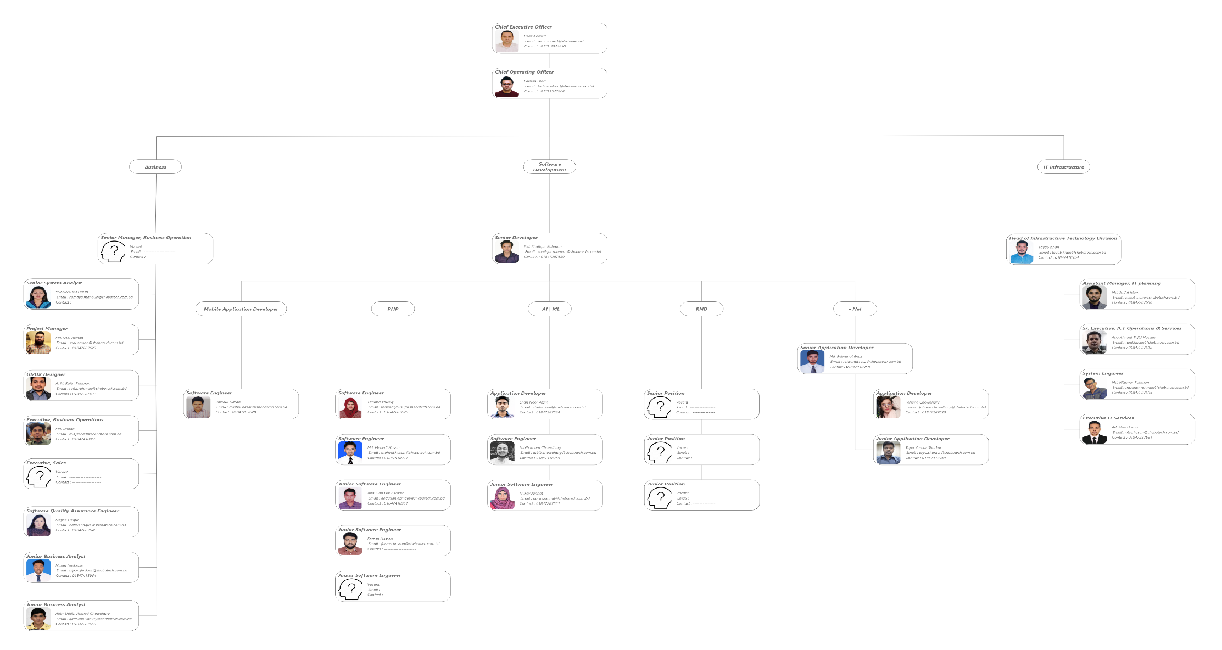

# Annexure C: Sheba Technologies Limited Brochure

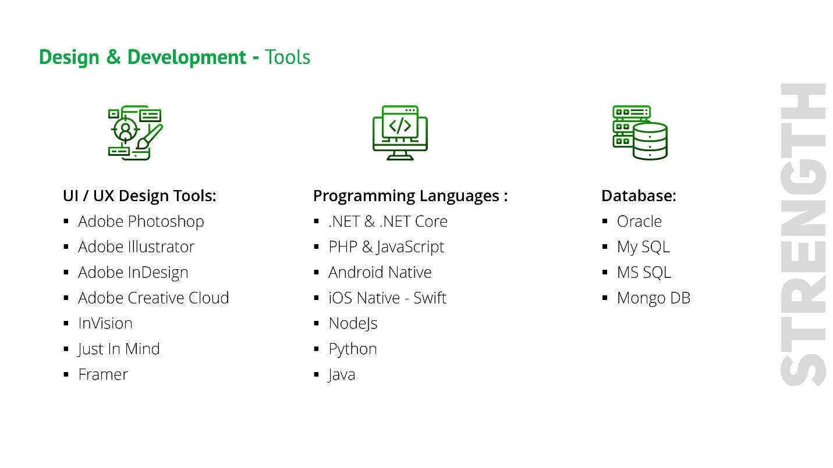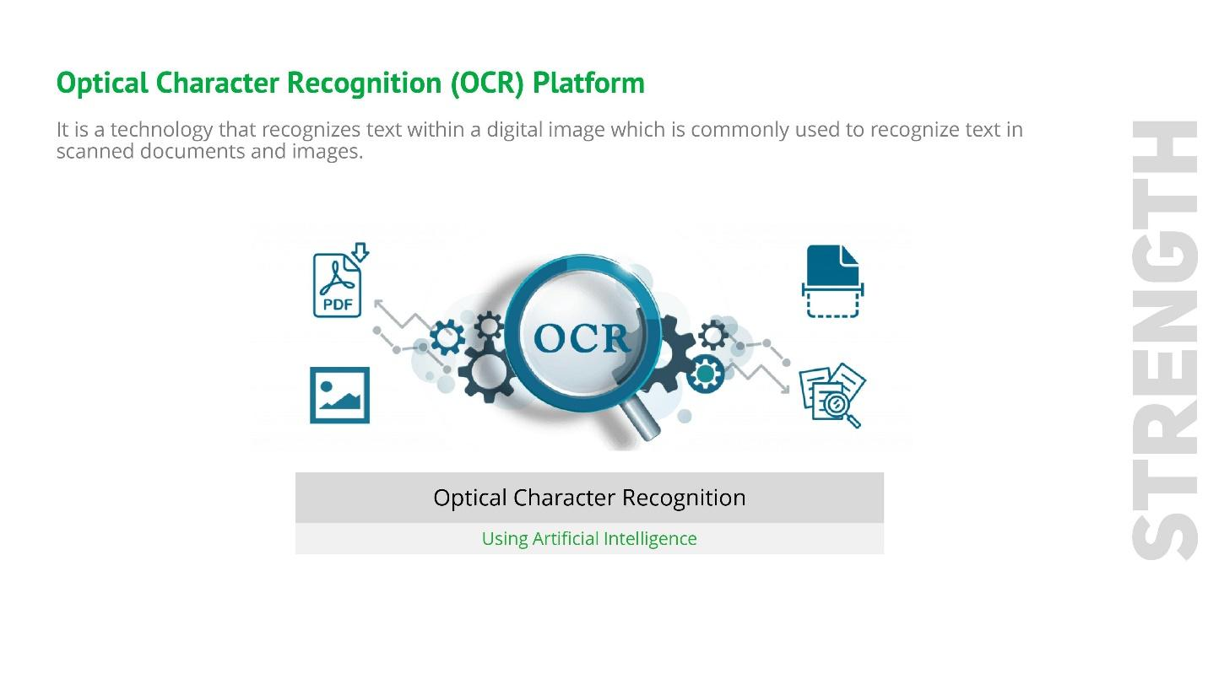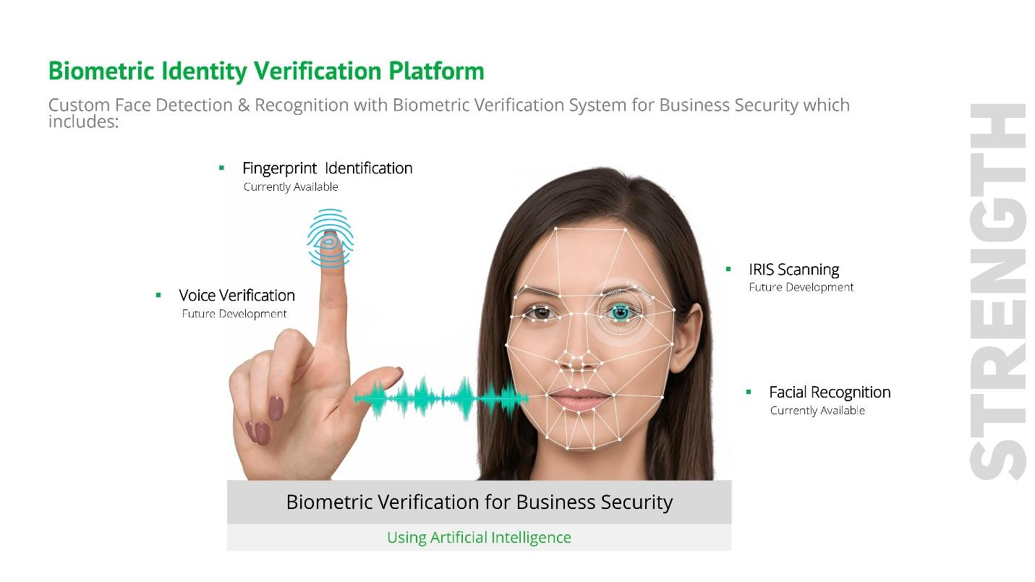

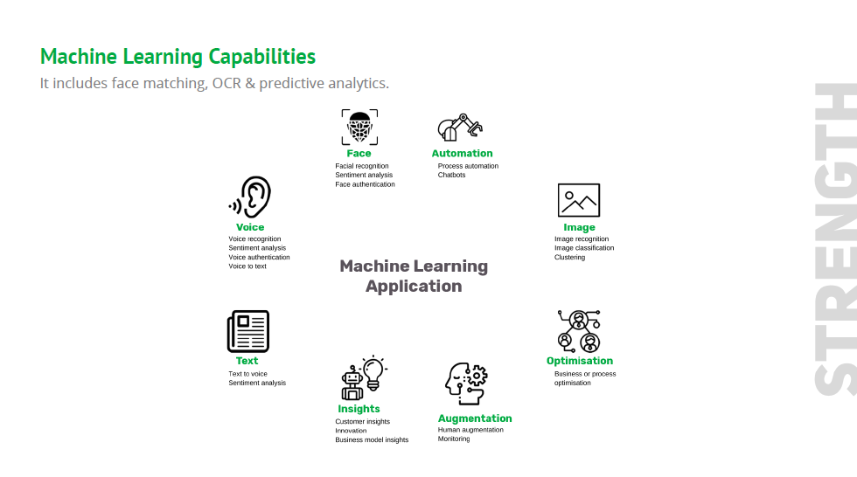

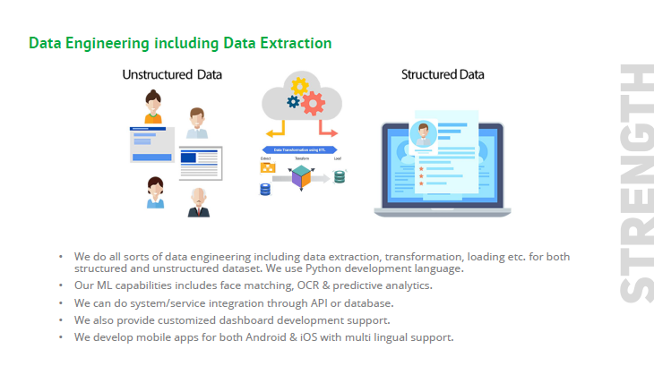

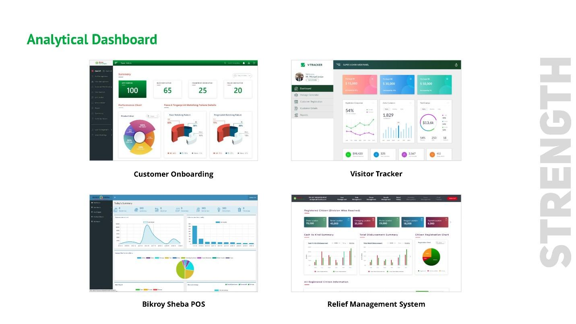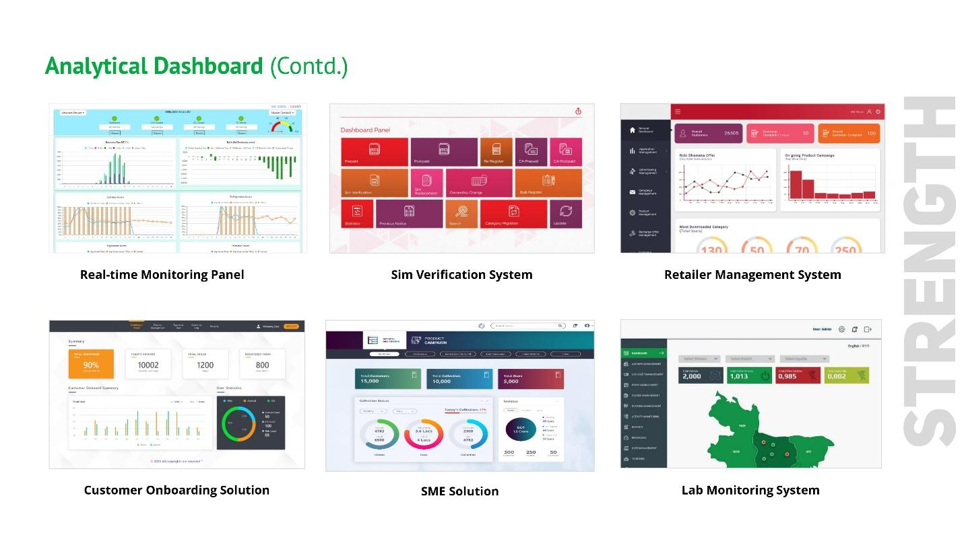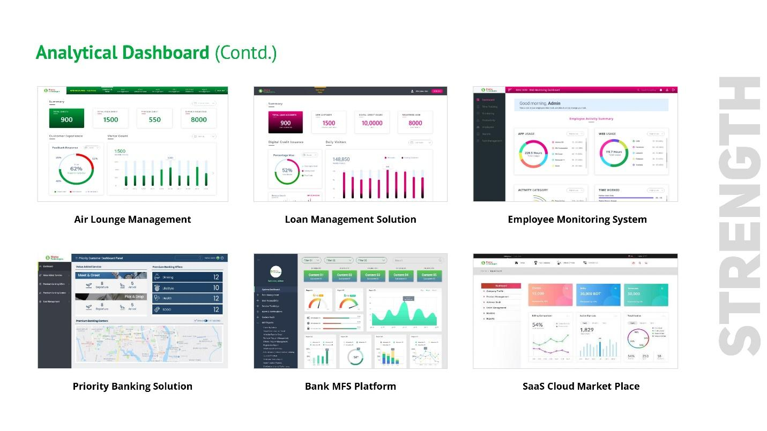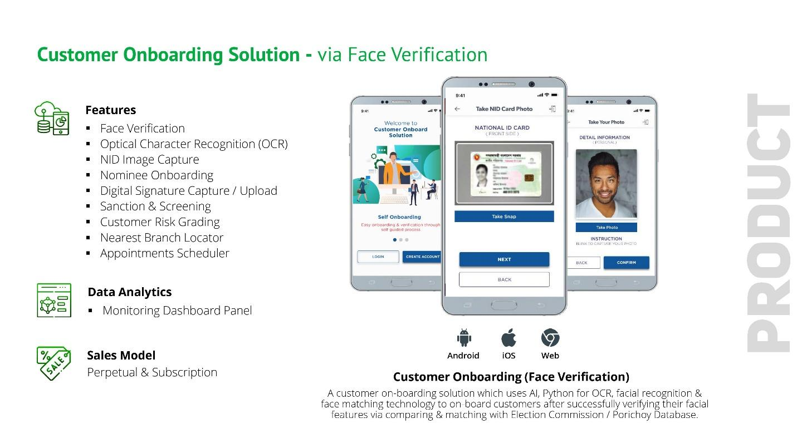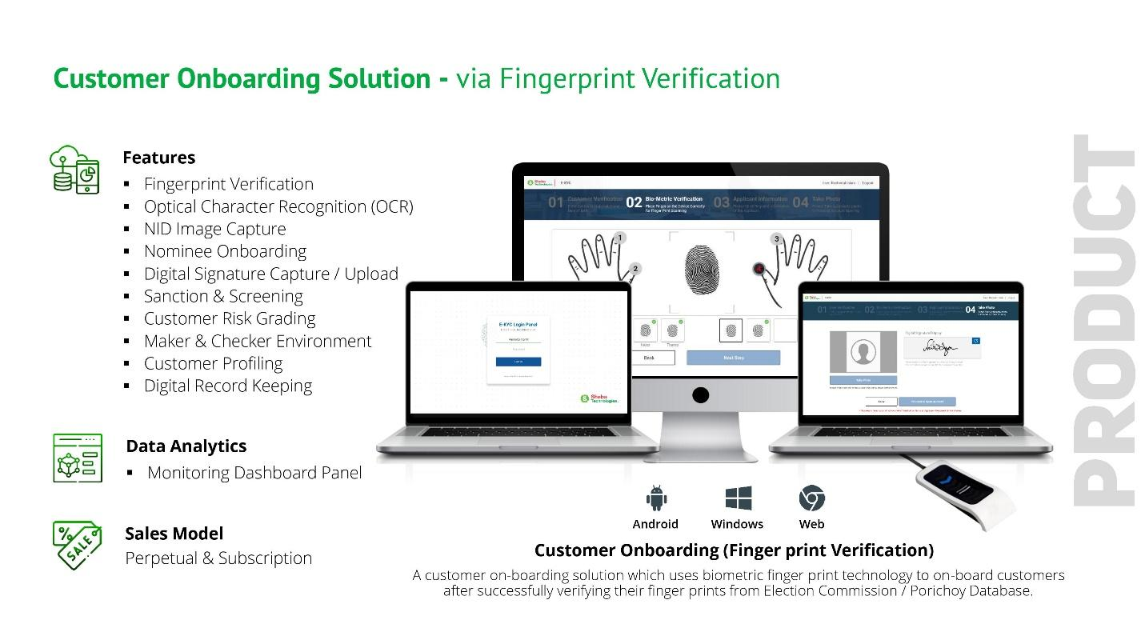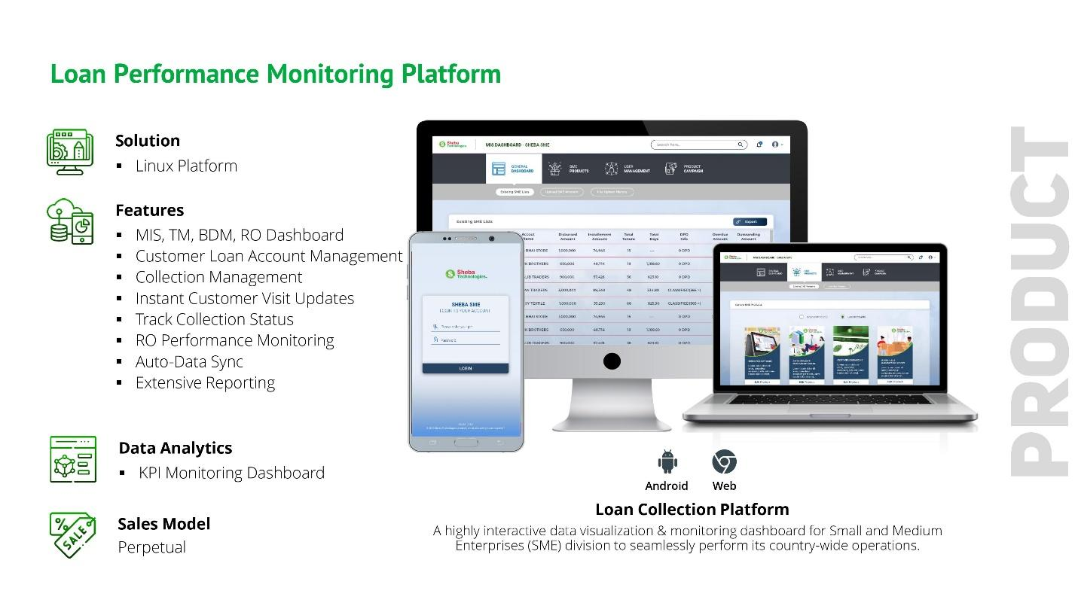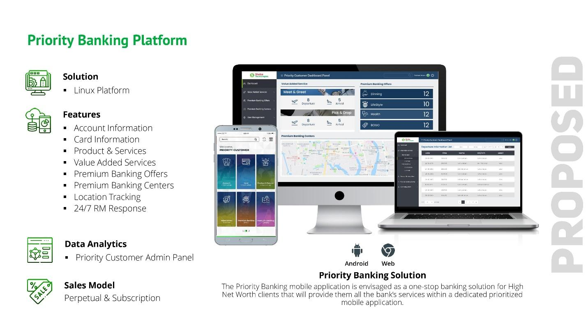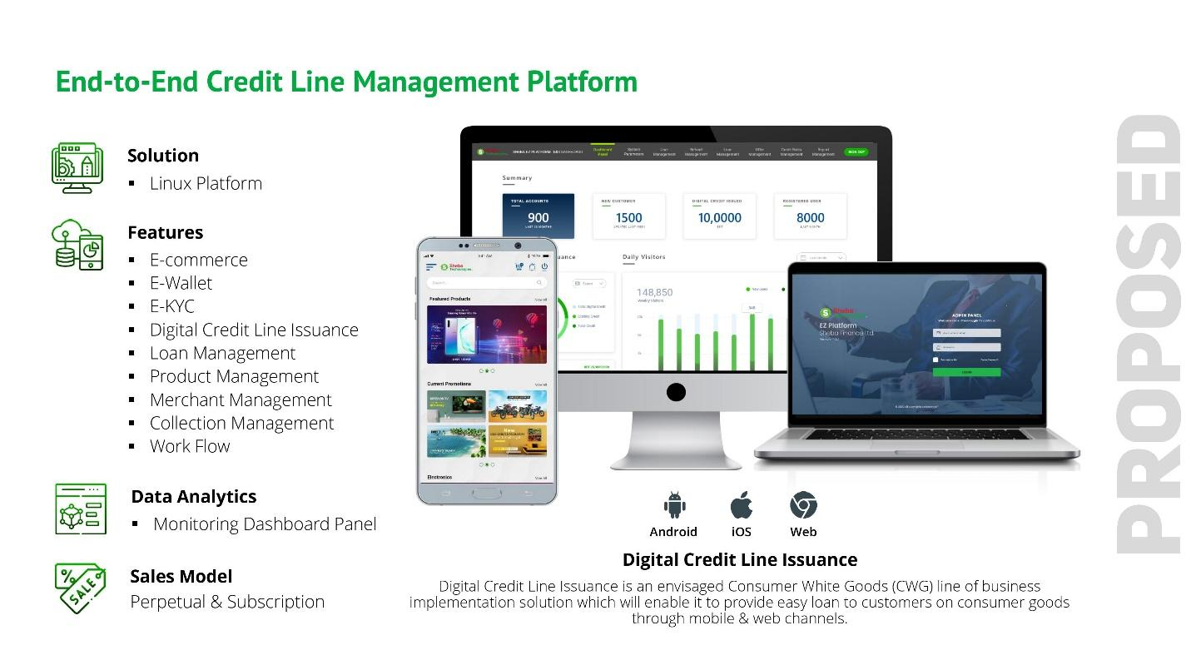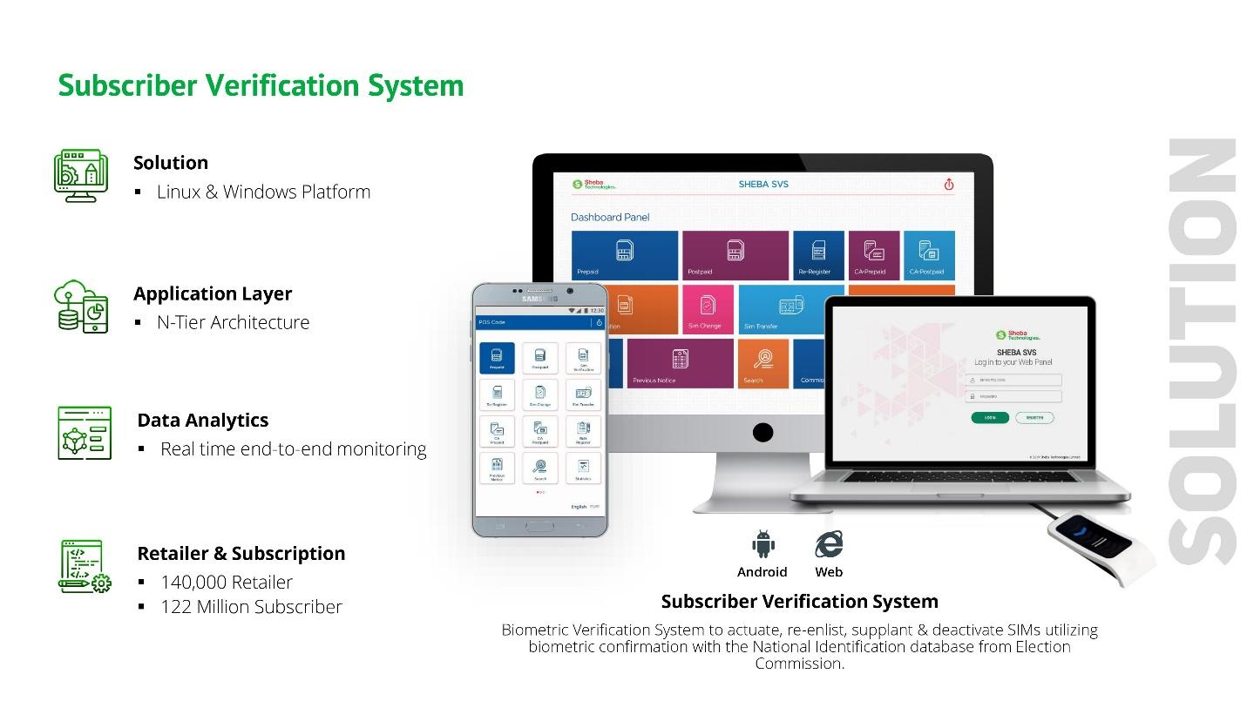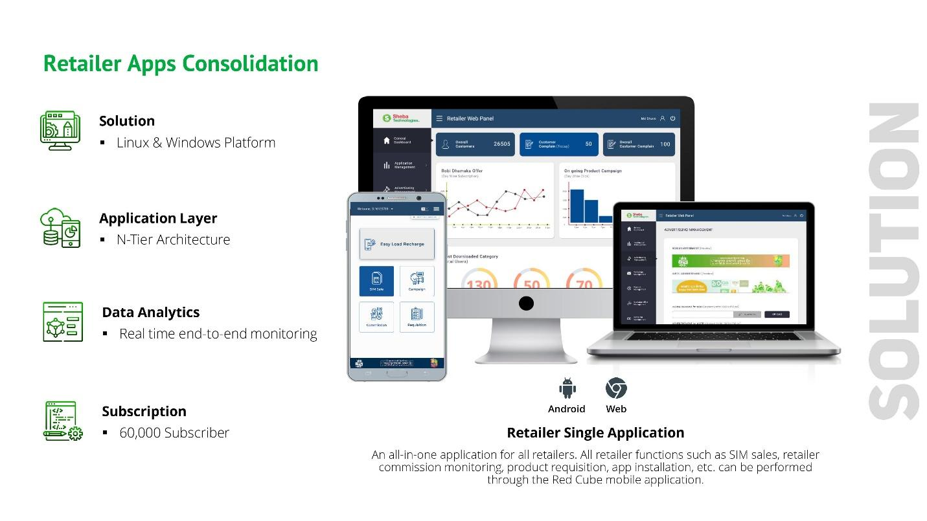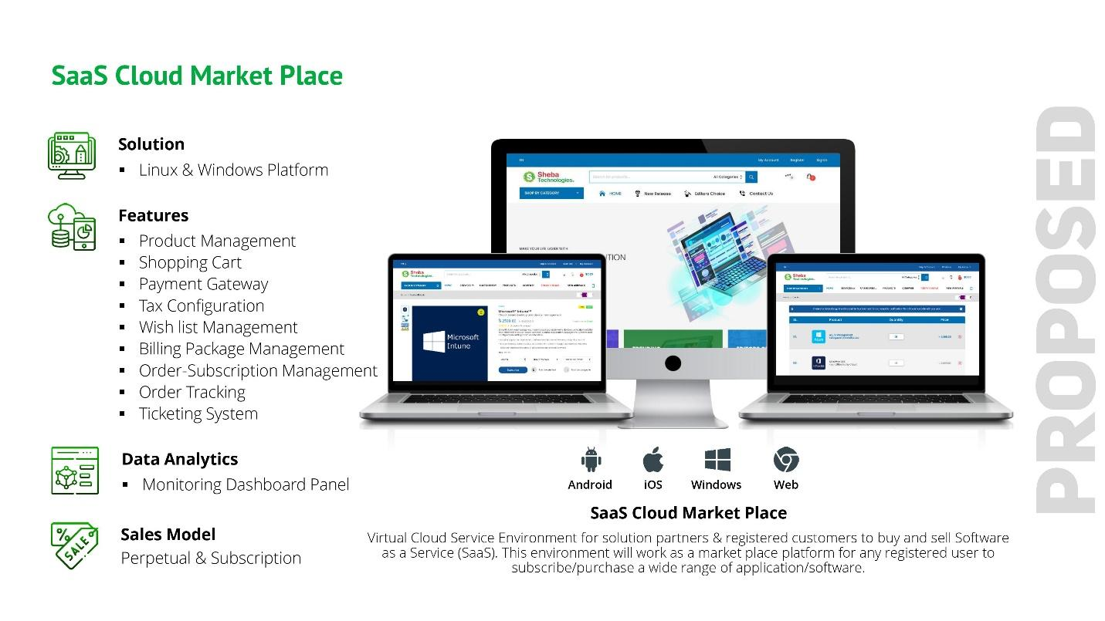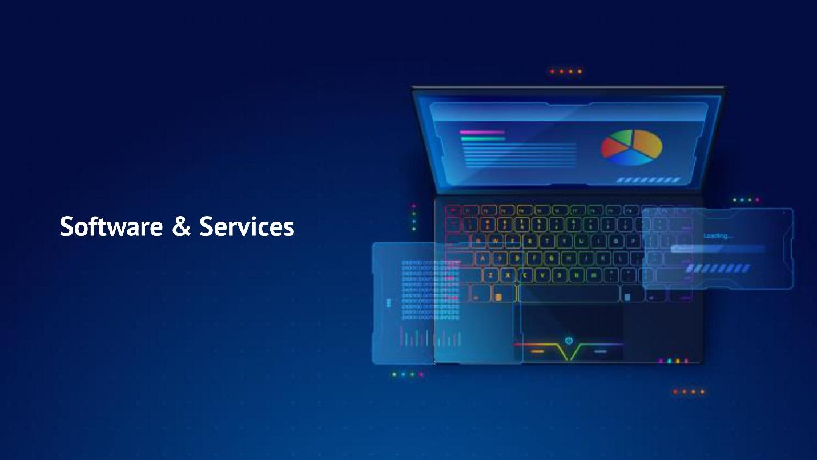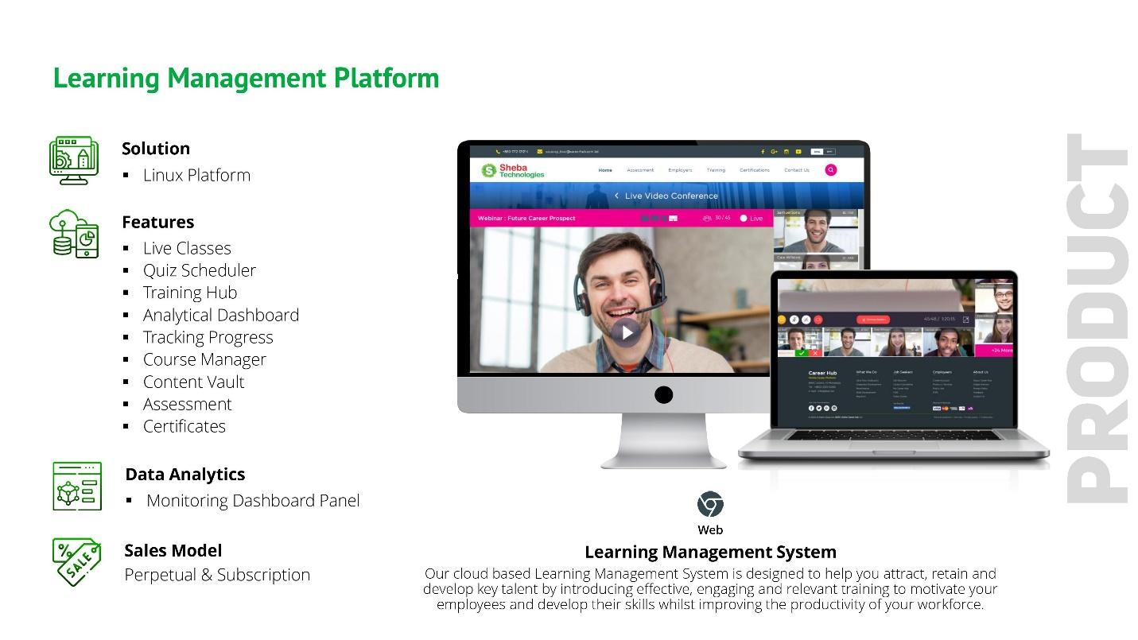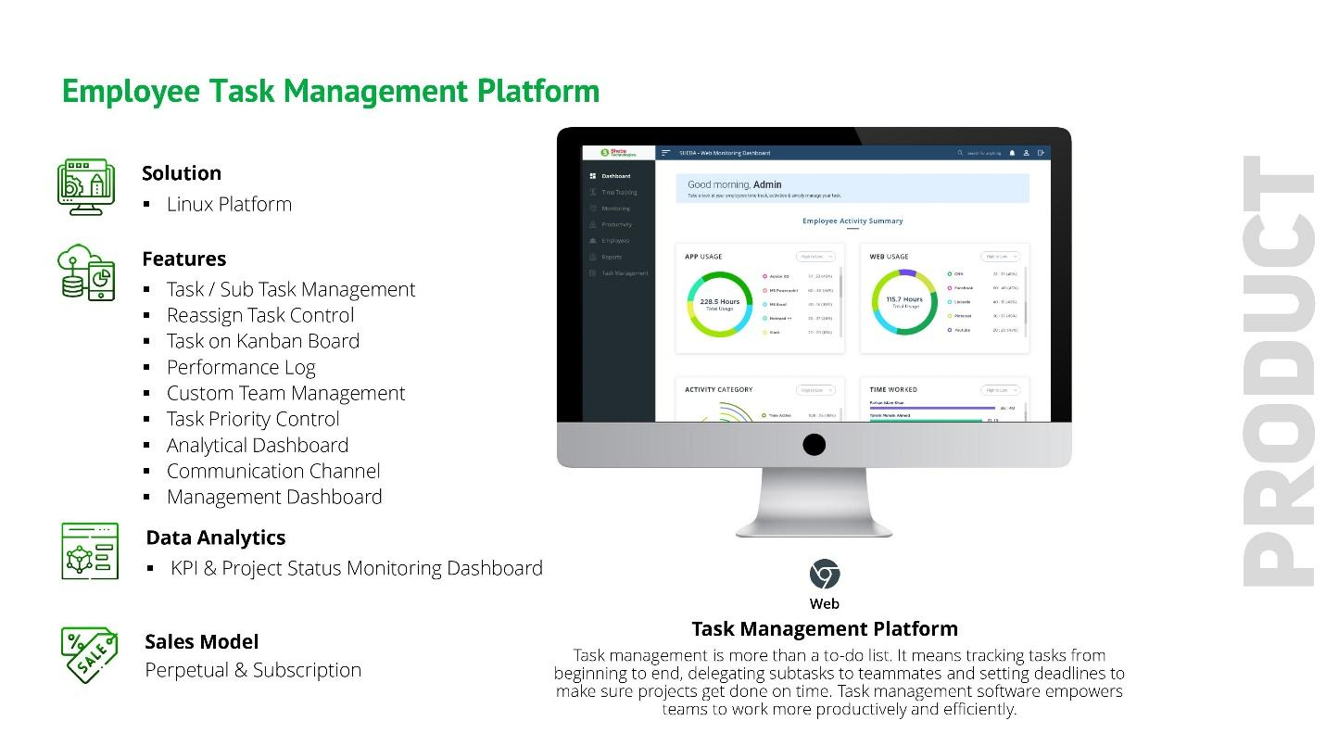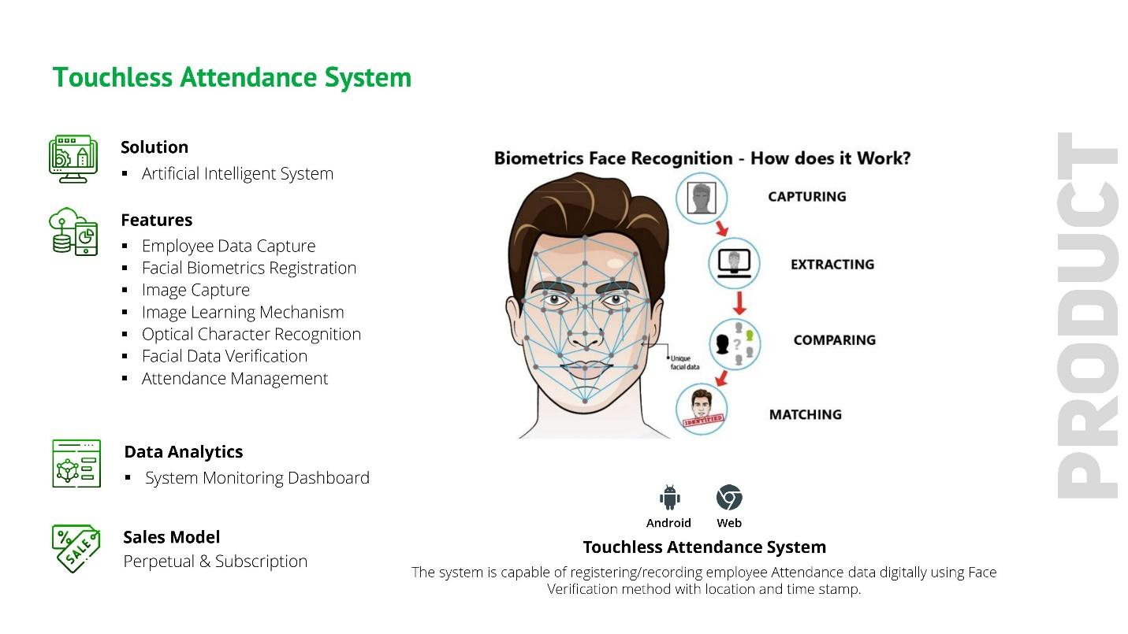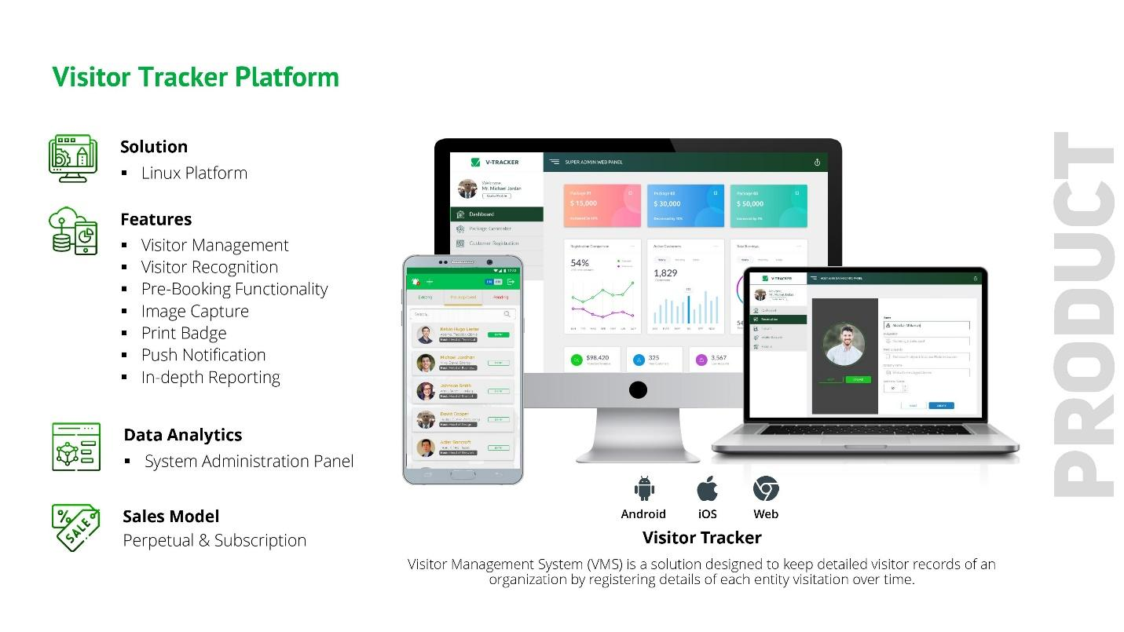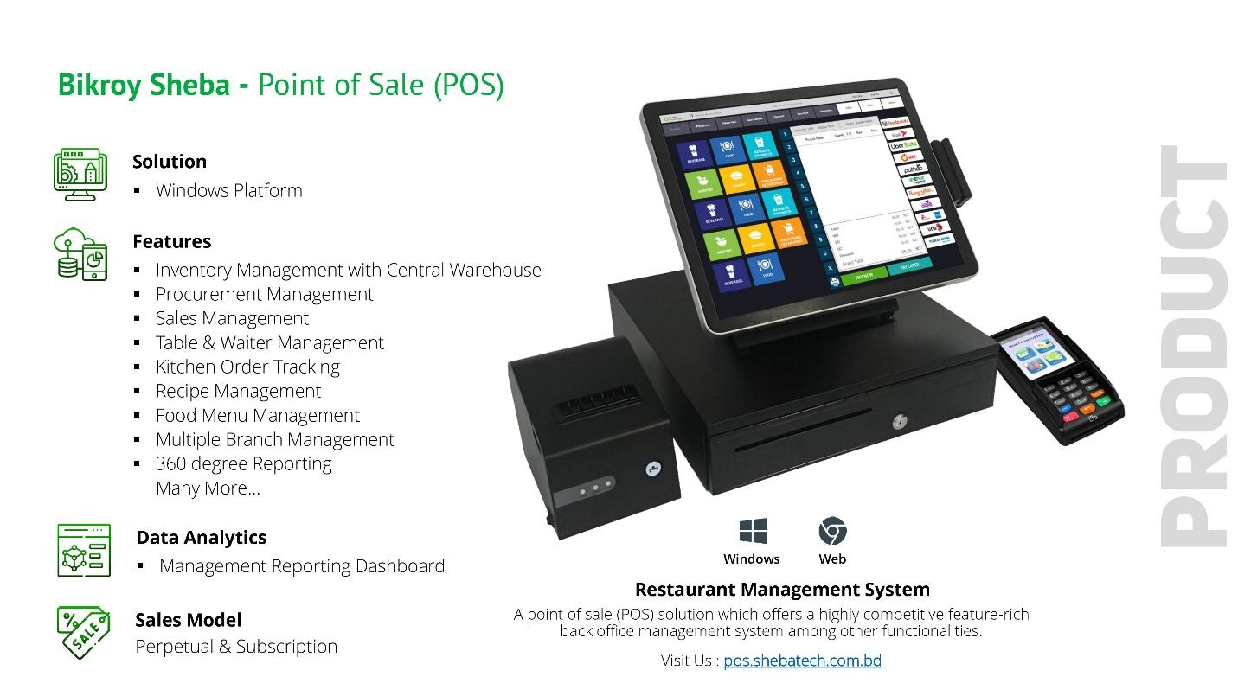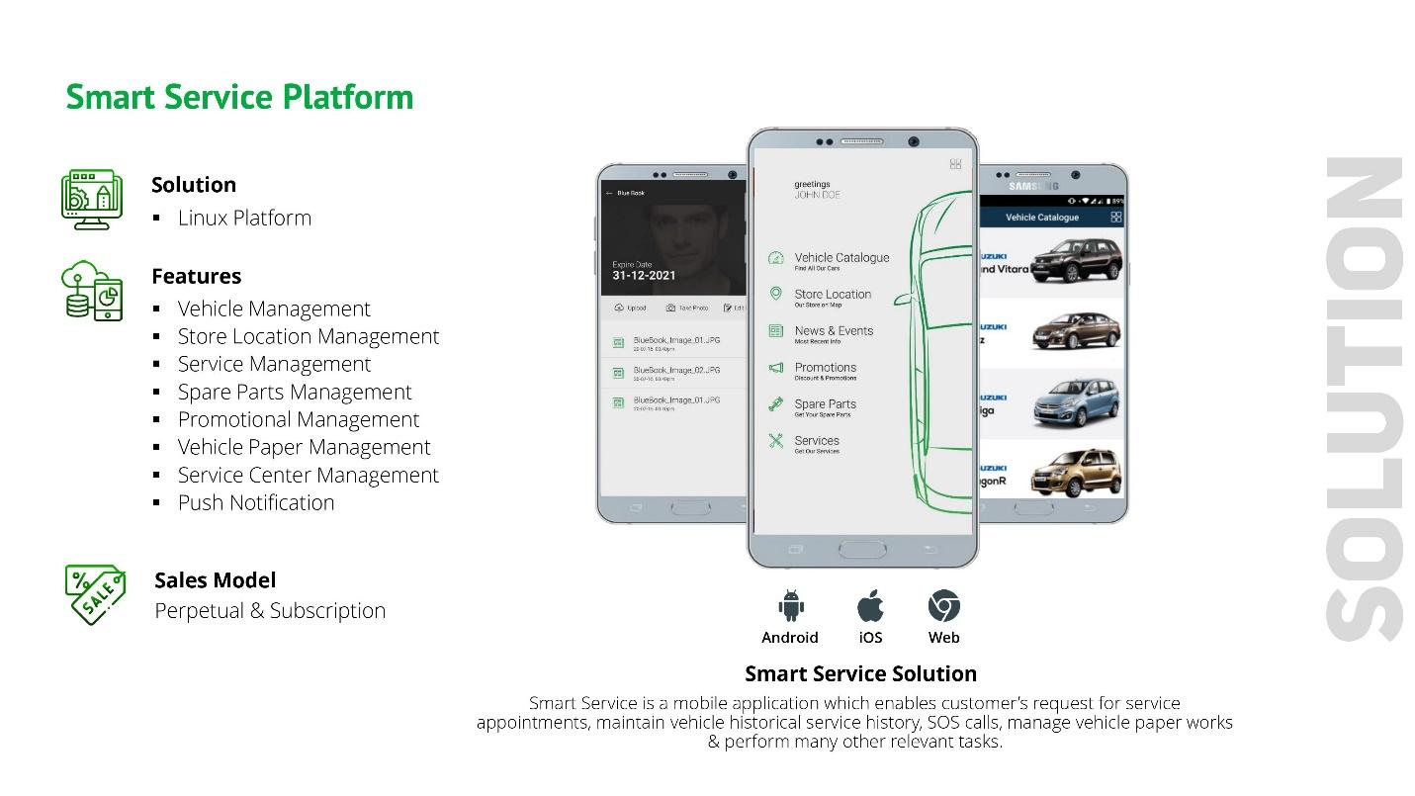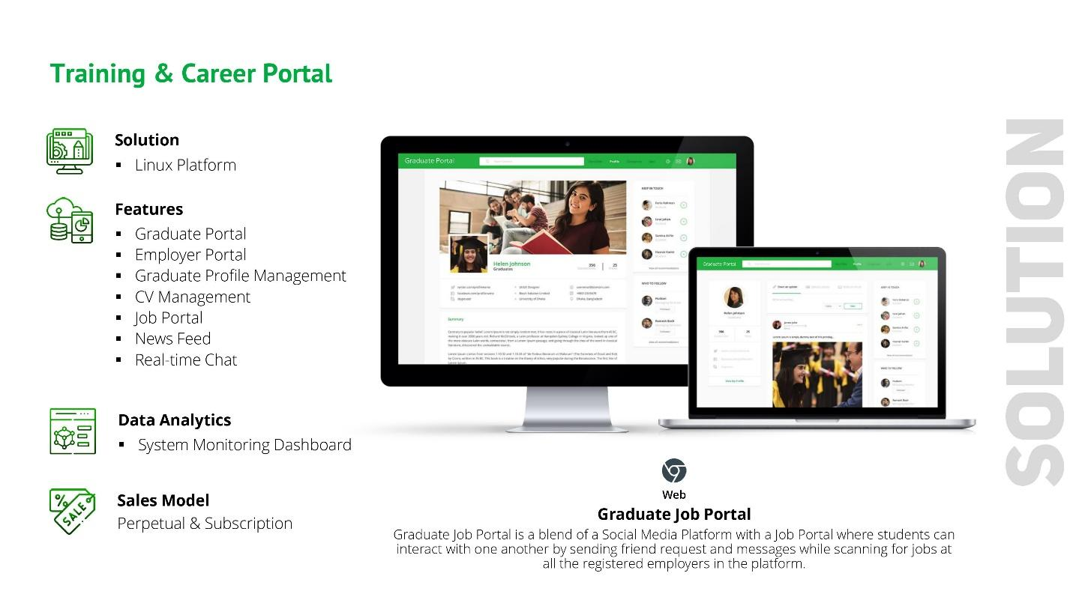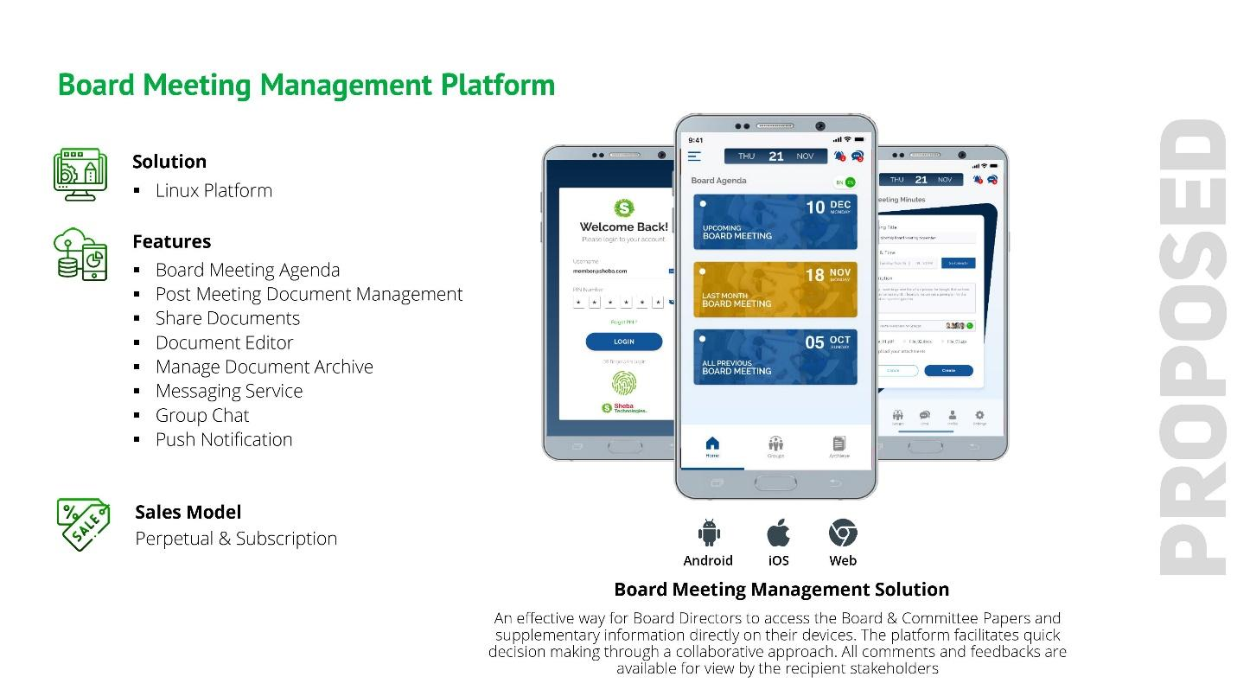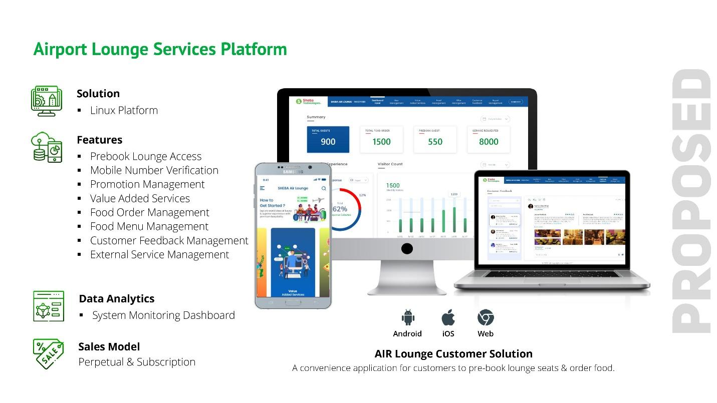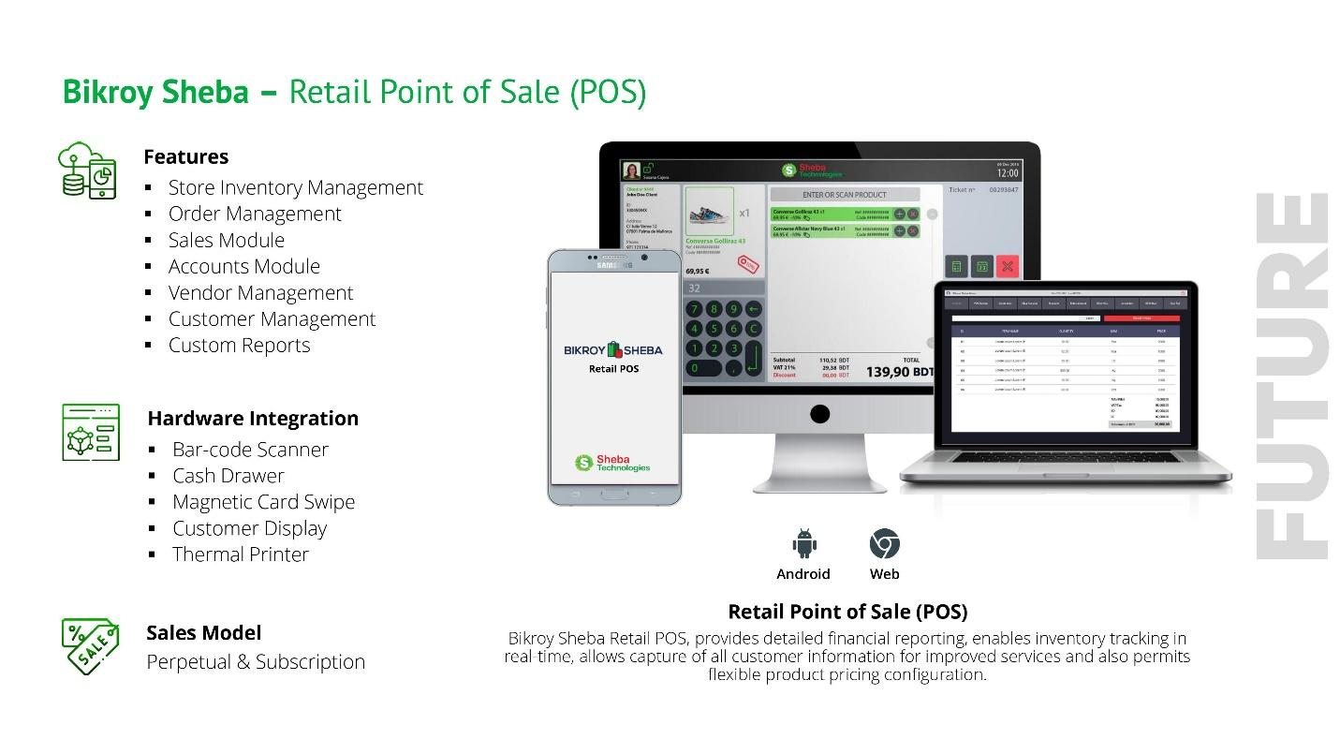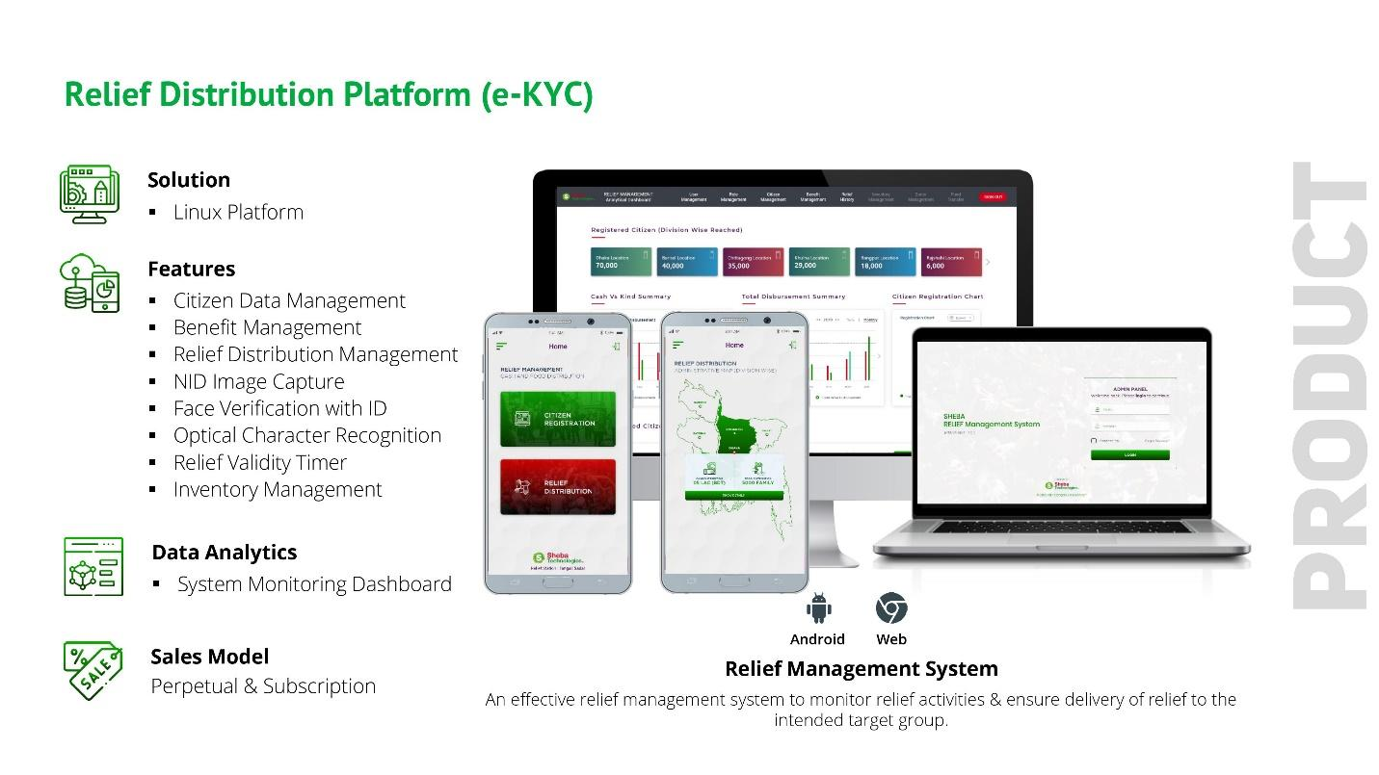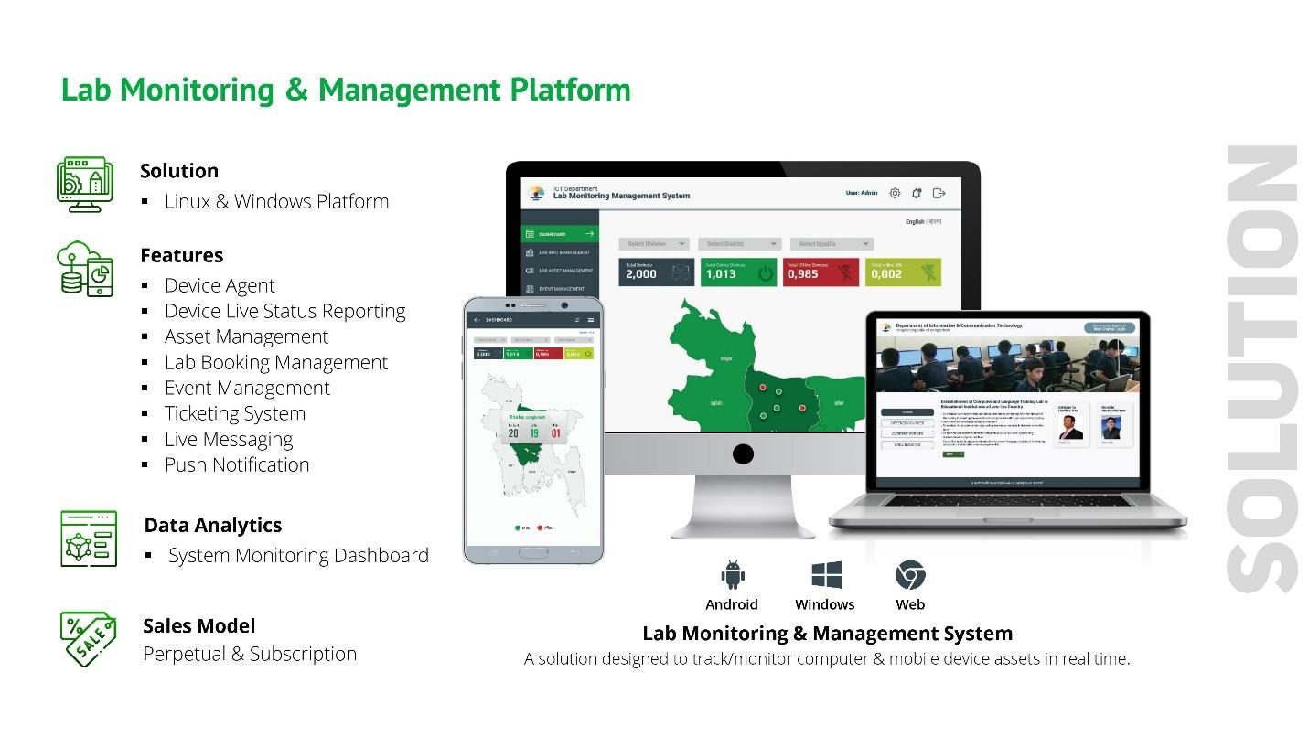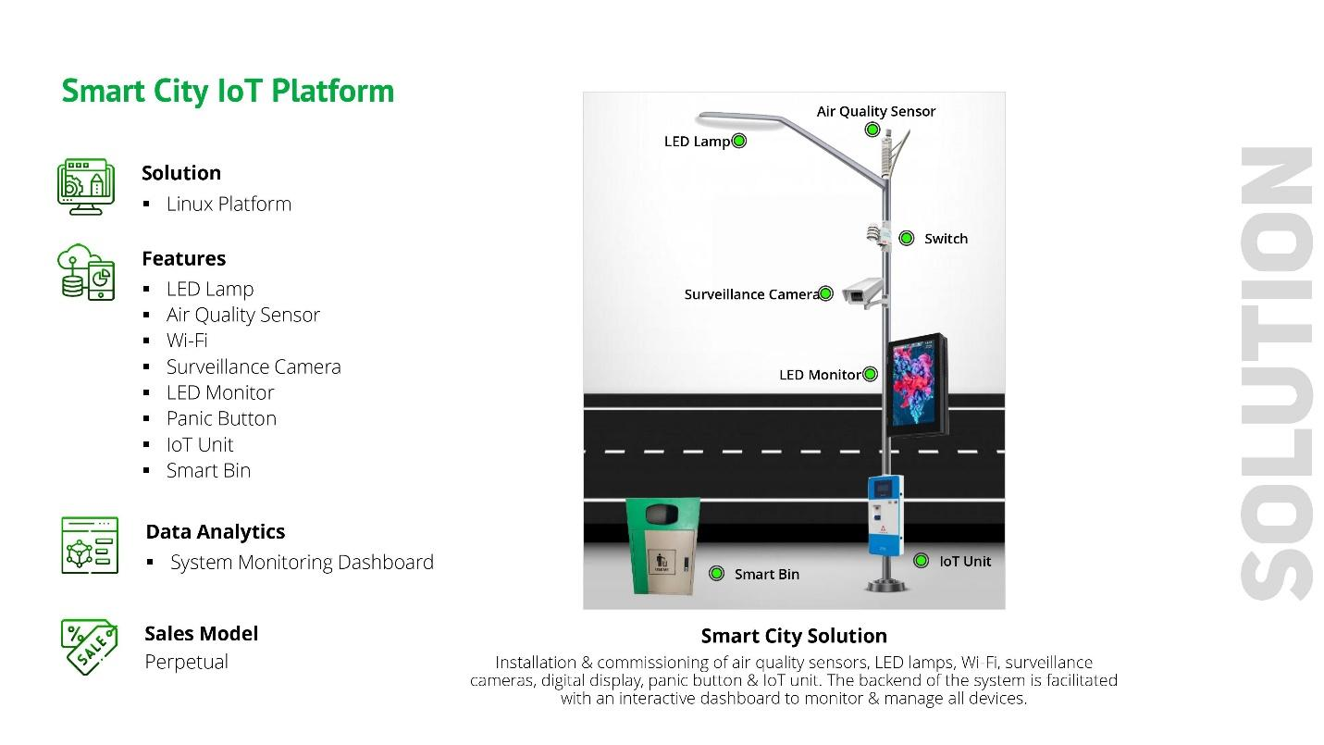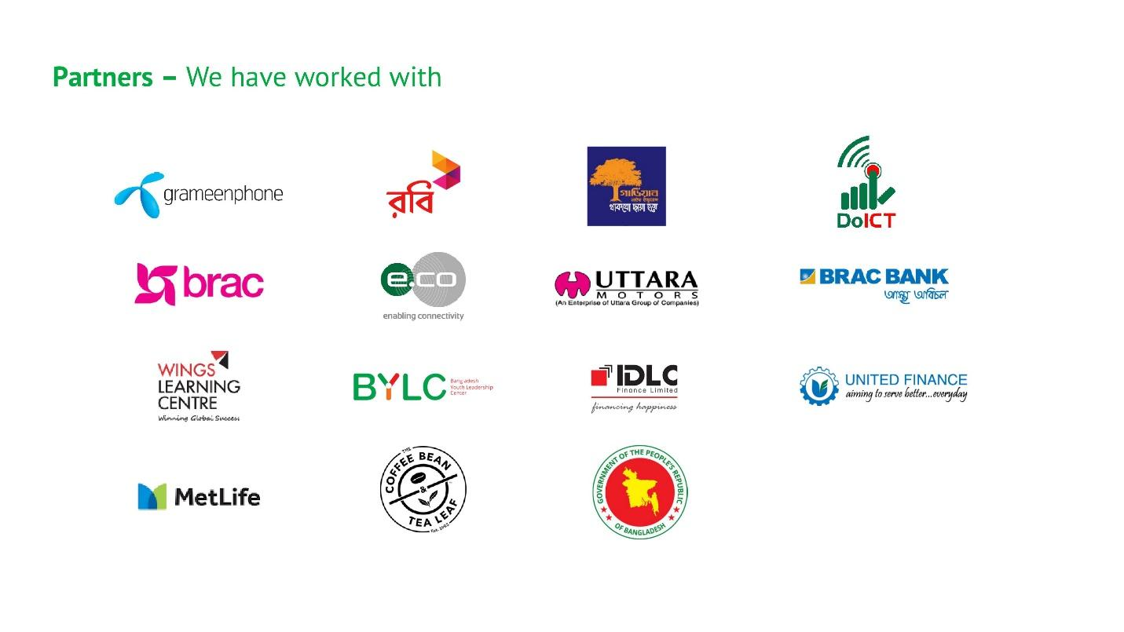

# Annexure D: Financial Capacity of the Firm

**Last 03 Years Audited Financial Report:**

|  |
| --- |
| **2017-2018** |
|  |
|  |
|  |
|  |
|  |
|  |
|  |
|  |
|  |
|  |
| **2018-2019** |
|  |
|  |
|  |
|  |
|  |
|  |
|  |
|  |
|  |
| **2019-2020** |
|  |
|  |
|  |
|  |
|  |
|  |
|  |
|  |
|  |

# Annexure E: STL Work Experience

|  |
| --- |
| **BRAC Online Career Hub**  To address the rising unemployment rate amongst the youth in Bangladesh, SDP wants to propose the development of a web and mobile platform that will serve as a medium for the learners to gain employability skills online to ultimately get employment. The end goal of the platform is to provide its learners necessary skills to get job opportunities/entrepreneurship support within the platform. For this reason, the platform will have features such as career counselling, skills training, and job posting capability.   * Relevant Work Order attached below. |
|  |
| **Grameenphone Mobile Device Management (MDM)**  Sheba Technologies Ltd. has developed the Mobile Device Management (MDM) solution for Grameen Phone.  **Features**  The solution provides full system administrative functionalities, list of which is provided below:   * Web control and usage policies * App whitelisting/blacklisting * Password and encryption enforcement * Remote wipes and locking * Mobile device inventory and tracking * App passwords, and custom application containers * Wi-Fi, Bluetooth and update control * App distribution or volume purchasing * Relevant Work Order attached below. |
|  |
| **Implementation & Development of EKYC Solution for IDLC Finance Ltd.**  Sheba Technologies Limited has provided fully functional EKYC solution to IDLC Finance Limited supported by Web Application and Mobile application both.  Primary Functionalities:   * Client NID verification & Identification; * Administration Dashboard; * Audit Trial; * Application Security; * Relevant Work Order attached below. |
| **United Finance Limited**  The EKYC Solution developed for United Finance will be based on Android and Web-based platforms. The solution will allow both Self verification of Customer along with Assisted Customer verification functionality. For Self-verification of Customer, users can use these two platforms to verify themselves digitally and will receive SMS notification once the verification process has been completed successfully. For Assisted Customer Verification, UFL or its nominated agents will assist the customer to directly get verified using the system. A separate backend web panel will be there for the process admin to maintain settings of the system.   * Relevant Work Order attached below. |
| **Guadian Life Insuarance**  The EKYC Solution developed for GLIL will be based on Android, IOS and Web-based platforms. Customers can use all three platforms to on-board themselves digitally and will receive SMS and Email notification once the onboarding process has been completed successfully. It is essential to note that the on-onboarding parent app is a part of a larger GLIL ‘Parent Application’ which will call for the KYC application and will provide the system with the customer phone number and email ID (optional) through which customers will get on-boarding notification. A separate backend web application will be there for the system admin to monitor the system.   * Relevant Work Order attached below. |
| **Robi Subscriber Verification System**  The solution will comprise of Web Based WIC App, an Android App, Web Portal/Back End for the Web APP, Central Control Management Panel, SVS Middleware, Business Logic Layer, Analytical Dashboard and Management Dashboard.   * Relevant Work Order attached below. |
| **BRAC BANK – SME Collection Dashboard**  SME Dashboard for BRAC Bank is designed to provide a detailed overview of the loan activities for small & medium enterprises**.**   * This application will improve business collection and recovery efforts. * Help RO’s on-the-go to monitor their loan accounts in real time. * Allows RO’s to manage/input key details about their accounts. * Allows BDM to get an overview of the real-time RO performance under them. * Allows TM’s to get an overview of the BDM’s under them as well as an RO’s account details in real-time. * Option to generate various real-time reports as required. * Relevant Work Order attached below. |
| **BRAC Artificial Insemination: ERP SOFTWARE** |
| **Project: Dashboard for Lab Monitoring Activities of Sheikh Russel Digital Labs** |

# Annexure F: Technical Experts for Performing the Assignment

|  |  |  |  |  |  |  |  |  |  |  |  |
| --- | --- | --- | --- | --- | --- | --- | --- | --- | --- | --- | --- |
|  | | Recent Photo of the Individual | |  | | | | | | | |
| 1 | | PROPOSED POSITION FOR  THIS PROJECT | | **Chief Operating Officer** | | | | | | | |
| 2 | | NAME OF PERSON | | **Farhan Islam** | | | | | | | |
| 3 | | DATE OF BIRTH | | 19-11-1982 | | | | | | | |
| 4 | | NATIONALITY | | Bangladeshi | | | | | | | |
| 5 | | MEMBERSHIP IN PROFESSIONALSOCIETIES | | *N/A* | | | | | | | |
| 6 | | EDUCATION: | | *BSc. Computer Science,*  *University of Portsmouth, United Kingdom* | | | | | | | |
| 7 | | OTHER TRAINING | | N/A | | | | | | | |
| 8 | | LANGUAGES & DEGREE OF  PROFICIENCY | | Language | | | Speaking | | Reading | Writing | |
|  | | *English* | | | *Fluent* | | *Excellent* | *Excellent* | |
| 9 | | COUNTRIES OF WORK EXPERIENCE | | Bangladesh | | | | | | | |
| 10 | | | EMPLOYMENT RECORD |  | | | | | | | |
|  | | **EMPLOYER: 1**  **Sheba Technologies Ltd.**  <http://www.shebatech.com.bd/>  8th Floor, Khawaja Tower, 95 Mohakhali C/A, Dhaka-1212.  Position Held: **Head of Business Operations**  **Duties and Responsibilities:**   * Report to CEO on Business Development & Operations; * Collect reports on upcoming project opportunities; * Lead Technical Documentation Team; * Lead Software Quality Assurance & Software Testing Group; * Lead Business Analysts; * Taken Responsibility as Head of Software Engineering Process Group (SEPG); * Provide and support the implementation of business solutions by building relationships and partnerships with key stakeholders; identifying business needs; determining and carrying out necessary processes and practices; monitoring progress and results; recognizing and capitalizing on improvement opportunities; and adapting to competing demands, organizational changes and new responsibilities; * Monitor Project schedules, milestone completions, track all phases of the project lifecycle; * Manage Project team regularly to review project deliverables and deadlines; * Manage existing products and its upcoming feature roadmap; | | | | FROM:  **2020** | | | TO:  **Ongoing** | | |
|  | **EMPLOYER: 2**  **Sheba Technologies Ltd.**  <http://www.shebatech.com.bd/>  8th Floor, Khawaja Tower, 95 Mohakhali C/A, Dhaka-1212.  Position Held: **Senior Business Analyst**  **Duties and Responsibilities:**   * Lead UI/UX Team; * Support and align efforts to meet customer and business needs; * Manage customer relationships and expectations by developing a communication process; * Capture and clearly document business and systems requirements; * Lead or participate in multiple projects by completing and updating project documentation; managing project scope; adjusting schedules when necessary; determining daily priorities; ensuring efficient and on-time delivery of project tasks and milestones; following proper escalation paths; and managing customer and supplier relationships; * Provide project level analysis – producing required project analysis documentation (business requirements, scope matrix, use cases, sequence diagrams, future state proposals, UAT plan); * Analyze Customer Business Requirements and present them with Non-Functional Prototypes to allow them to visualize and experience the solution to be; * Create and maintain issue logs, meeting minutes, meeting schedules, project summaries and updates; * Create and maintain project schedules by developing project plans and specifications, estimating time and resources, monitoring milestone completion, tracking all phases of the project lifecycle, providing timely reporting of issues that impact project progress, coordinating actions and resolving conflicts; * Develop and execute test plans; * Support system conversions, upgrades, enhancements; * Oversee the design of new products, assisting with market trends in order to guide the design team; | | | | FROM:  **2019** | | | TO:  **2020** | | |
|  | **EMPLOYER: 3**  **Sheba Technologies Ltd.**  <http://www.shebatech.com.bd/>  8th Floor, Khawaja Tower, 95 Mohakhali C/A, Dhaka-1212.  Position Held: **Product Manager**  **Duties and Responsibilities:**   * Lead the product development process, including user research, prototyping, and business case generation while working very closely with the Technical Team; * Develop and implement product strategies consistent with company vision; * Collect and analyze feedback from customers, stakeholders and other teams to shape requirements, features and end products; * Work with senior management to create product plans and road maps; * Produce and review product requirement documents (PRD); * Ensure products release as per “Go to Market” (G2M) Strategy; * Managing the product through the delivery process, including managing key vendors / partners and influencing internal stakeholders; * Monitoring product key performance indicators and continuously improving operational delivery to maximize performance; * Preparing and conducting PoC (Proof of Concept), UAT (User Acceptance Test), User Manual, operation and quality control processes; * Continuously communicate with customers and end users to meet their expectation and minimize gap; * Recommending the nature and scope of present and future product lines by reviewing product specifications and requirements; appraising new product ideas and/or product or packaging changes; * Assessing market competition by comparing the company's product to competitors' products; * Providing source data for product line communications by defining product marketing communication objectives; * Obtaining product market share by working with sales to develop product sales strategies; * Providing information for management by preparing short-term and long-term product sales forecasts and special reports and analyses; answering questions and requests; * Facilitating inventory turnover and product availability by reviewing and adjusting inventory levels and production schedules; * Bringing new products to market by analyzing proposed product requirements and product development programs; preparing return-on-investment analyses; establishing time schedules with development; * Introduces and markets new products by developing time-integrated plans with sales, advertising, and production; * Determines product pricing by utilizing market research data; reviewing production and sales costs; anticipating volume; costing special and customized orders;   **EMPLOYER: 4**  FROM To  **2010 2016**  **SkyHigh Communications, HK Limited**  Position Held: **Partner & Chief Business Development Manager**  **Duties and Responsibilities:**   * Reaching out to interconnect with variety of other telecomm carrier’s worldwide; * Negotiating Voice Traffic Wholesale Rates as per destination and caller prefix; * Keeping Local Capacity Suppliers available at all times with numerous **E1** capacity; * Reviewing and Analyzing Call Success Rates along with Average Call durations every hour; * Troubleshooting any issues that might arise while Routing VOIP traffic from Customer To Supplier To Soft switch (VOS3000); * Maintain Monthly Traffic Revenue Accounts and Clearing Payments to all stakeholders.   FROM To **2009 2010**  **EMPLOYER: 5**  **Bangladesh Internet Press Ltd. (BIPL), Bangladesh**.  Position Held: **Manager Key Accounts & Client Relationship**  **Duties and Responsibilities:**   * Use variety of resources to scan through Prospective Tenders & create relationship with the client’s high-end authorities to find & gather in depth project related information; * Schedule & Plan Tender Participation techniques and brief in-house team member to work accordingly; * Actively participate in preparing Technical & Financial Proposal; * Work as a bridge between existing Clients and our Development Team to ensure all Projects related work are well documented & maintained as per CMMI (Level 3) standards; * Assist HR Department to scan through applicants in order to employ consultants for upcoming projects & also for any replacement in the ongoing projects; * Work closely together with the Managing Director & the top-level management officials to identify future prospects of the Company.   FROM To **2004 2005**  **EMPLOYER: 6**  **Apollo Fire detectors Limited, United Kingdom**  Position Held: **Technical Maintenance Engineer**  **Duties and Responsibilities:**   * In charge of providing maintenance support to the shop floor which consists of a wide variety of machines in the production line of fire detectors; * Also engaged partially in charge of Health and Safety from the electrical section, as to perform PAT test to make sure that all the items in use are safe to handle.   FROM To **2002 2003**  **EMPLOYER: 7**  **iCubed Technologies Ltd. United Kingdom**  Position Held: **Industrial Placement Engineer**  **Duties and Responsibilities:**   * iCubed Technologies mainly focuses on providing solutions for real time control systems in commerce and industry; * Involved in Software development, Web Applications development, Embedded Applications Testing, User Interfaces Design and Documentation. | | | | FROM:  **2016** | | | TO:  **2019** | | |

CERTIFICATION

I, the undersigned, certify that (i) I was not a former employee of the Client immediately before the submission of this proposal, and (ii) to the best of my knowledge and belief, this biodata correctly describes myself, my qualifications, and my experience. I understand that any wilful misstatement described herein may lead to my disqualification or dismissal, if engaged.  
I have been employed by **Sheba Technologies Ltd.** continuously for the last Sixty five (65) months as regular full time staff. Indicate “Yes” or “No” in the boxes below:

|  |  |  |  |  |  |  |  |  |  |  |  |  |  |  |  |
| --- | --- | --- | --- | --- | --- | --- | --- | --- | --- | --- | --- | --- | --- | --- | --- |
|  |  |  | **YES** |  |  |  | **NO** |  |  |  |  |  |  |  |  |

|  |  |
| --- | --- |
| Signature |  |
| Date of Signing | **19-12-2021**  Day / Month / Year |

|  |  |  |  |  |  |  |
| --- | --- | --- | --- | --- | --- | --- |
|  | Recent Photo of the Individual |  | | | | |
| 1 | PROPOSED POSITION FOR THIS PROJECT | **Technical Project Manager** | | | | |
| 2 | NAME OF PERSON | **Md. Sadi Arman** | | | | |
| 3 | DATE OF BIRTH | 04-02-1994 | | | | |
| 4 | NATIONALITY | Bangladeshi | | | | |
| 5 | MEMBERSHIP IN PROFESSIONALSOCIETIES | *N/A* | | | | |
| 6 | EDUCATION: | *M.Sc. in IT (2021)* | | | | |
| 7 | OTHER TRAINING | Project Management Professional; | | | | |
| 8 | LANGUAGES & DEGREE OF  PROFICIENCY | Language | Speaking | | Reading | Writing |
|  | *English* | *Native* | | *Native* | *Native* |
| 9 | COUNTRIES OF WORK EXPERIENCE | Bangladesh | | | | |
| 10 | EMPLOYMENT RECORD |  | | | | |
|  | **EMPLOYER: 1**  **Sheba Technologies Ltd.**  <http://www.shebatech.com.bd/>  8th Floor, Khawaja Tower, 95 Mohakhali C/A, Dhaka-1212.  Position Held: **Technical Project Manager**  **Duties and Responsibilities:**   * Establish and implement training processes. * Analyse, plan and develop requirements. * Assign and oversee the daily tasks of technical personnel. * Hold regular technical team meetings. * Determine and define clear deliverables, roles and responsibilities for staff members required, etc. | | | FROM:  **2021** | TO:  **Present** | |
|  | **EMPLOYER: 2**  **Nano Information Technology**  <http://www.nanoit.biz/>  Cha-88/1/B, North Badda (2nd & 3rd Floor), Badda, Dhaka, 1212, Dhaka  Position Held: **IT Project Manager**  **Duties and Responsibilities:**   * Perform Requirement analysis, * Risk Management analysis, * Compile Software Requirement Specification and other essential documents based on relevance, * Design Activity, Wireframe, user story, etc. * Initiate Project (Agile/Waterfall methodologies), * Lead team of developer and tester towards project completion, * SQA when required, * Deliver Projects to stakeholders and many more. | | | FROM:  **2019** | TO:  **2021** | |
|  |  | | |  |  | |

CERTIFICATION

I, the undersigned, certify that (i) I was not a former employee of the Client immediately before the submission of this proposal, and (ii) to the best of my knowledge and belief, this biodata correctly describes myself, my qualifications, and my experience. I understand that any wilful mis-statement described herein may lead to my disqualification or dismissal, if engaged.

I have been employed by **Sheba Technologies Ltd.** continuously for the last Thirty One (31) months as regular full time staff. Indicate “Yes” or “No” in the boxes below:

|  |  |  |  |  |  |  |  |  |  |  |  |  |  |  |  |
| --- | --- | --- | --- | --- | --- | --- | --- | --- | --- | --- | --- | --- | --- | --- | --- |
|  |  |  | **YES** |  |  |  | **NO** |  |  |  |  |  |  |  |  |

|  |  |
| --- | --- |
| Signature |  |
| Date of Signing | **19-12-2021**  Day / Month / Year |

|  |  |  |  |  |  |  |
| --- | --- | --- | --- | --- | --- | --- |
|  | Recent Photo of the Individual |  | | | | |
| 1 | PROPOSED POSITION FOR  THIS PROJECT | Senior System Analyst | | | | |
| 2 | NAME OF PERSON | **SUMAYA MAHBUB** | | | | |
| 3 | DATE OF BIRTH | June 26, 1989 | | | | |
| 4 | NATIONALITY | Bangladeshi | | | | |
| 5 | MEMBERSHIP IN PROFESSIONAL SOCIETIES | *Certified Scrum Master* | | | | |
| 6 | EDUCATION: | *B.Sc. in CSE, East West University* | | | | |
| 7 | OTHER TRAINING | * Work smarter not harder, Coursera * Business Writing, Coursera * Effective Problem Solving and Decision Making, Coursera * Internet of Things (IOT), BRAC IT Services Limited * CBAP, BRAC IT Services Limited * Oracle Procurement Cloud Implementation, BRAC IT Services Limited * Oracle Financial CloudImplementation, , BRAC IT Services Limited | | | | |
| 8 | LANGUAGES & DEGREE OF PROFICIENCY | Language | | Speaking | Reading | Writing |
|  | *English* | | *Fluent* | *Excellent* | *Excellent* |
| 9 | COUNTRIES OF WORK EXPERIENCE | Bangladesh | | | | |
| 10 | EMPLOYMENT RECORD |  | | | | |
|  | **EMPLOYER: 1**  **BRAC IT Services Limited**  Company Location: House 115, Road 5, Block B, Niketon, Gulshan, Dhaka.  Position Held: **Business Analysis**  **Duties and Responsibilities:**  Analyzing applications, find out solution considering the risk of the projects. Prepare flow diagrams,  business analysis documents. Define scope, take vetting by clients. Share user experience, challenges  of using the as is system/process to the cross functional team through documentation, and knowledge  sharing sessions. Work effectively and efficiently to build a quality product through appropriate  software development processes. | | FROM:  **June 15, 2015** | | TO:  **October, 2021** | |
|  | **EMPLOYER: 2**  **Transcom group**  Position Held: **Sadiatec Limited**  Company Location : House 2, Road 3, Sector 7, Uttara, Dhaka  **Duties and Responsibilities:**   * UI Designing, Database maintenance, Software support, marketing | | FROM:  **September 1, 2013** | | TO:  **June 10, 2015** | |

CERTIFICATION

I, the undersigned, certify that (i) I was not a former employee of the Client immediately before the submission of this proposal, and (ii) to the best of my knowledge and belief, this bio-data correctly describes myself, my qualifications, and my experience. I understand that any wilful misstatement described herein may lead to my disqualification or dismissal, if engaged.

I have been employed by **Sheba Technologies Ltd.** as regular full time staff. Indicate “Yes” or “No” in the boxes below:

|  |  |  |  |  |  |  |  |  |  |  |  |  |  |  |  |
| --- | --- | --- | --- | --- | --- | --- | --- | --- | --- | --- | --- | --- | --- | --- | --- |
|  |  |  |  |  |  |  |  |  |  |  |  |  |  |  |  |

|  |  |
| --- | --- |
| Signature |  |
| Date of Signing | **19-12-2021**  Day / Month / Year |

|  |  |  |  |  |  |  |
| --- | --- | --- | --- | --- | --- | --- |
|  | Recent Photo of the Individual |  | | | | |
| 1 | PROPOSED POSITION FOR  THIS PROJECT | **Senior Software Architect** | | | | |
| 2 | NAME OF PERSON | **MD. SHAFIQUR RAHMAN** | | | | |
| 3 | DATE OF BIRTH | 01-07-1989 | | | | |
| 4 | NATIONALITY | Bangladeshi | | | | |
| 5 | MEMBERSHIP IN PROFESSIONALSOCIETIES | *N/A* | | | | |
| 6 | EDUCATION: | *Masters in Information Technology, University of Dhaka, 2016.* | | | | |
| 7 | OTHER TRAINING | CCNA  Linux | | | | |
| 8 | LANGUAGES & DEGREE OF  PROFICIENCY | Language | | Speaking | Reading | Writing |
|  | *English* | | *Fluent* | *Excellent* | *Excellent* |
| 9 | COUNTRIES OF WORK EXPERIENCE | Bangladesh | | | | |
| 10 | EMPLOYMENT RECORD |  | | | | |
|  | **EMPLOYER: 1**  **Sheba Technologies Ltd.**  <http://www.shebatech.com.bd/>  8th Floor, Khawaja Tower, 95 Mohakhali C/A, Dhaka-1212.  Position Held: **Senior Developer (Software Development)**  **Duties and Responsibilities:**   * Design / Architect software solutions * Supervise and conduct development activities of a software life cycle | | FROM:  **Nov, 2017** | | TO:  **Present** | |
|  | **EMPLOYER: 2**  **2RA Technologies Ltd**  Position Held: **Assistant Manager (Development)**  **Duties and Responsibilities:**   * Developed online VISA tracking system. * Electricity production and consumption monitoring system. | | FROM:  **April, 2014** | | TO:  **Nov, 2017** | |
|  | **EMPLOYER: 3**  **Noman Group of Industries**  Dhaka, Bangladesh.  Position Held: **Senior Programmer**  **Duties and Responsibilities:**   * Developed HR & Payroll Software. * Developed Inventory Management Software. * Developed Production Management Software. * Developed Requisition to Procurement Management Software. * Developed Ticketing Software. | | FROM:  **Sep, 2009** | | TO:  **April, 2014** | |

CERTIFICATION

I, the undersigned, certify that (i) I was not a former employee of the Client immediately before the submission of this proposal, and (ii) to the best of my knowledge and belief, this biodata correctly describes myself, my qualifications, and my experience. I understand that any wilful misstatement described herein may lead to my disqualification or dismissal, if engaged.

I have been employed by **Sheba Technologies Ltd.** continuously for the last fifty one (51) months as regular full time staff. Indicate “Yes” or “No” in the boxes below:

|  |  |  |  |  |  |  |  |  |  |  |  |  |  |  |  |
| --- | --- | --- | --- | --- | --- | --- | --- | --- | --- | --- | --- | --- | --- | --- | --- |
|  |  |  | **YES** |  |  |  | **NO** |  |  |  |  |  |  |  |  |

|  |  |
| --- | --- |
| Signature |  |
| Date of Signing | **19-12-2021**  Day / Month / Year |

|  |  |  |  |  |  |  |
| --- | --- | --- | --- | --- | --- | --- |
|  | Recent Photo of the Individual |  | | | | |
| 1 | PROPOSED POSITION FOR  THIS PROJECT | **Database Administrator (DBA)** | | | | |
| 2 | NAME OF PERSON | **A.K.M Ariful Islam Shimul** | | | | |
| 3 | DATE OF BIRTH | 07-01-1983 | | | | |
| 4 | NATIONALITY | Bangladeshi | | | | |
| 5 | MEMBERSHIP IN PROFESSIONALSOCIETIES | *N/A* | | | | |
| 6 | EDUCATION: | *M.Sc. in CSE, Jagannath University (2019)* | | | | |
| 7 | OTHER TRAINING | J2EE (ESAD) ​  Computer Operations, Ministry of Social Welfare  Hardware Application, Ministry of Social Welfare | | | | |
| 8 | LANGUAGES & DEGREE OF  PROFICIENCY | Language | | Speaking | Reading | Writing |
|  | *English* | | *Fluent* | *Excellent* | *Excellent* |
| 9 | COUNTRIES OF WORK EXPERIENCE | Bangladesh | | | | |
| 10 | EMPLOYMENT RECORD |  | | | | |
|  | **EMPLOYER: 1**  **Sheba Technologies Ltd.**  <http://www.shebatech.com.bd/>  8th Floor, Khawaja Tower, 95 Mohakhali C/A, Dhaka-1212.  Position Held: **Lead Application Developer**  **Duties and Responsibilities:**   * Directly supervises others. Provide mentoring, coaching, performance feedback for direct reports or others in the application development area. * Develops, modifies and maintains application software that supports internal and external business processes of Greenheck that may be complex or sensitive in nature. * Ensure quality standards are met for all development including internal, offshore and outsourced development initiatives. * Sr. Member of Business Logic Layer team of ​Redon​ Project (Robi) and Lead of the Data Migration Team. | | FROM:  **Feb, 2019** | | TO:  **Present** | |
|  | **EMPLOYER: 2**  **Institute of Information and**  **Communication Technology (IICT), BUET**  Position Held: **Senior Programmer (Project)**  **Duties and Responsibilities:**   * Design & Develop Online Admission System for National University. * Design & Develop Karnaphuli Gas Marketing System * Design & Develop Karnaphuli Gas Online Billing System. * Database Design & Support for CEGIS for Karnaphuli Gas GIS System | | FROM:  **Sept, 2013** | | TO:  **Jan, 2019** | |
|  | **EMPLOYER: 3**  **IBCS-PRIMAX SOFTWARE LTD.**  Dhaka, Bangladesh.  Position Held: **Programmer**  **Duties and Responsibilities:**   * Training for Novice Software Developer. * Development & Reporting for Independent University Accounting System. * Development & Reporting Walton HRMS. * Development & Reporting Excel Enterprise Resource Planning (ERP). | | FROM:  **Oct, 2012** | | TO:  **Sept, 2013** | |

CERTIFICATION

I, the undersigned, certify that (i) I was not a former employee of the Client immediately before the submission of this proposal, and (ii) to the best of my knowledge and belief, this biodata correctly describes myself, my qualifications, and my experience. I understand that any wilful mis-statement described herein may lead to my disqualification or dismissal, if engaged.

I have been employed by **Sheba Technologies Ltd.** continuously for the last forty three () month43

|  |  |  |  |  |  |  |  |  |  |  |  |  |  |  |  |
| --- | --- | --- | --- | --- | --- | --- | --- | --- | --- | --- | --- | --- | --- | --- | --- |
|  |  |  | **YES** |  |  |  | **NO** |  |  |  |  |  |  |  |  |

|  |  |
| --- | --- |
| Signature |  |
| Date of Signing | **19-12-2021**  Day / Month / Year |

|  |  |  |  |  |  |  |
| --- | --- | --- | --- | --- | --- | --- |
|  | Recent Photo of the Individual | *here]* | | | | |
| 1 | PROPOSED POSITION FOR  THIS PROJECT | **Sr. Programmer** | | | | |
| 2 | NAME OF PERSON | **Md. Rejwanul Reaz** | | | | |
| 3 | DATE OF BIRTH | August 22, 1986 | | | | |
| 4 | NATIONALITY | Bangladeshi | | | | |
| 5 | MEMBERSHIP IN PROFESSIONALSOCIETIES | *N/A* | | | | |
| 6 | EDUCATION: | *M.Sc. in CSE, Daffodil International University (Progressing)*  *B.Sc. in CSE, Daffodil International University(2009)* | | | | |
| 7 | OTHER TRAINING | *N/A* | | | | |
| 8 | LANGUAGES & DEGREE OF  PROFICIENCY | Language | | Speaking | Reading | Writing |
|  | *English* | | *Fluent* | *Excellent* | *Excellent* |
| 9 | COUNTRIES OF WORK EXPERIENCE | Bangladesh | | | | |
| 10 | EMPLOYMENT RECORD |  | | | | |
|  | **EMPLOYER: 1**  **Sheba Technologies Ltd.**  <http://www.shebatech.com.bd/>  8th Floor, Khawaja Tower, 95 Mohakhali C/A, Dhaka-1212.  Position Held: **Sr. Application Developer**  **Duties and Responsibilities:**  Software Architecture Design, Process Analysis, Development. Review Code with debug and testing. | | FROM:  **Dec, 2019** | | TO:  **Present** | |
|  | **EMPLOYER: 2**  **Cygnus Innovation Ltd.**  (Financial Software Experts.)  House: C-39,Road:06, Block-c,  Niketon,Gulshan-1,  Dhaka-1212.  www.cygnusinnovation.com  Position Held: **Sr. Software Engineer**  **Duties and Responsibilities:**  Programming & Develop Web Application (Asset Management System Developing, Vehicle Management & Monitoring , ERP, Merchant Banking Back Office Application) software architecture design, review code with debug, testing, prepare test reports, reporting, bugs & errors prevent, Android Application Design & Development etc. | | FROM:  **April, 2012** | | TO:  **Dec, 2019** | |
|  | **EMPLOYER: 3**  **Cluster BD**  HAK Tower (1st floor), 3/C Karwan bazzar, Dhaka.  Position Held: **Junior Programme**  **Duties and Responsibilities:**  User Interface Designing ,Programming & Develop the Application (Desktop Application Development),Review Code with debug and testing. Prepare Test Reports. | | FROM:  **Sep, 2018** | | TO:  **Oct, 2009** | |

CERTIFICATION

I, the undersigned, certify that (i) I was not a former employee of the Client immediately before the submission of this proposal, and iii) to the best of my knowledge and belief, this biodata correctly describes myself, my qualifications, and my experience. I understand that any wilful mis-statement described herein may lead to my disqualification or dismissal, if engaged.

I have been employed by **Sheba Technologies Ltd.** continuously for the last twenty seven (27) months as regular full time staff. Indicate “Yes” or “No” in the boxes below.

|  |  |  |  |  |  |  |  |  |  |  |  |  |  |  |  |
| --- | --- | --- | --- | --- | --- | --- | --- | --- | --- | --- | --- | --- | --- | --- | --- |
|  |  |  | **YES** |  |  |  | **NO** |  |  |  |  |  |  |  |  |

|  |  |
| --- | --- |
| Signature |  |
| Date of Signing | **19-12-2021**  Day / Month / Year |

|  |  |  |  |  |  |  |
| --- | --- | --- | --- | --- | --- | --- |
|  | Recent Photo of the Individual |  | | | | |
| 1 | PROPOSED POSITION FOR  THIS PROJECT | **Software Engineer** | | | | |
| 2 | NAME OF PERSON | **Fahima Chowdhury** | | | | |
| 3 | DATE OF BIRTH | 01-09-1992 | | | | |
| 4 | NATIONALITY | Bangladeshi | | | | |
| 5 | MEMBERSHIP IN PROFESSIONALSOCIETIES | *N/A* | | | | |
| 6 | EDUCATION: | *Masters in Computer Science*  *United International University* | | | | |
| 7 | OTHER TRAINING | Professional Application Development with ASP.NET MVC  Web Development in ASP.Net  Web Programming | | | | |
|  |  |  | | | | |
| 8 | LANGUAGES & DEGREE OF  PROFICIENCY | Language | | Speaking | Reading | Writing |
|  | *English* | | *Fluent* | *Excellent* | *Excellent* |
| 9 | COUNTRIES OF WORK EXPERIENCE | Bangladesh | | | | |
| 10 | EMPLOYMENT RECORD |  | | | | |
|  | **EMPLOYER: 1**  **Sheba Technologies Ltd.**  <http://www.shebatech.com.bd/>  8th Floor, Khawaja Tower, 95 Mohakhali C/A, Dhaka-1212.  Position Held: **Software Engineer**  **Duties and Responsibilities:**   * Software Development | | FROM:  **March, 2016** | | TO:  **Present** | |
|  | **EMPLOYER: 2**  **ICT Alliance**  12 Kawran Bazar C/A, Dhaka-1215, Bangladesh  Position Held: **Software Developer**  **Duties and Responsibilities:**   * Developing the Front End and Back End in ASP.Net Training the end user over Skype or Team Viewer | | FROM:  **2014** | | TO:  **2016** | |

CERTIFICATION

I, the undersigned, certify that (i) I was not a former employee of the Client immediately before the submission of this proposal, and (ii) to the best of my knowledge and belief, this biodata correctly describes myself, my qualifications, and my experience. I understand that any wilful mis-statement described herein may lead to my disqualification or dismissal, if engaged.

I have been employed by **Sheba Technologies Ltd.** continuously for the last fifty nine (59) months as regular full time staff. Indicate “Yes” or “No” in the boxes below:

|  |  |  |  |  |  |  |  |  |  |  |  |  |  |  |  |
| --- | --- | --- | --- | --- | --- | --- | --- | --- | --- | --- | --- | --- | --- | --- | --- |
|  |  |  | **YES** |  |  |  | **NO** |  |  |  |  |  |  |  |  |

|  |  |
| --- | --- |
| Signature |  |
| Date of Signing | **19-12-2021**  Day / Month / Year |

|  |  |  |  |  |  |  |
| --- | --- | --- | --- | --- | --- | --- |
|  | Recent Photo of the Individual |  | | | | |
| 1 | PROPOSED POSITION FOR  THIS PROJECT | **Business Analyst** | | | | |
| 2 | NAME OF PERSON | **Nipun Ferdous** | | | | |
| 3 | DATE OF BIRTH | 10-09-1995 | | | | |
| 4 | NATIONALITY | Bangladeshi | | | | |
| 5 | MEMBERSHIP IN PROFESSIONALSOCIETIES | *N/A* | | | | |
| 6 | EDUCATION: | *B.Sc. in CS, BRAC University (2019)* | | | | |
| 7 | OTHER TRAINING | N/A | | | | |
| 8 | LANGUAGES & DEGREE OF  PROFICIENCY | Language | | Speaking | Reading | Writing |
|  | *English* | | *Fluent* | *Excellent* | *Excellent* |
| 9 | COUNTRIES OF WORK EXPERIENCE | Bangladesh | | | | |
| 10 | EMPLOYMENT RECORD |  | | | | |
|  | **EMPLOYER: 1**  **Sheba Technologies Ltd.**  <http://www.shebatech.com.bd/>  8th Floor, Khawaja Tower, 95 Mohakhali C/A, Dhaka-1212.  Position Held: **Junior Business Analyst**  **Duties and Responsibilities:**   * Project Requirement Elicitation; * Feature Analysis; * Technical Diagramming; * Prepare Technical Documentation; * Software Testing * Maintain Q/A report * Prepare Test cases * Prepare Bug reports | | FROM:  **Jan, 2019** | | TO:  **Present** | |

CERTIFICATION

I, the undersigned, certify that (i) I was not a former employee of the Client immediately before the submission of this proposal, and (ii) to the best of my knowledge and belief, this biodata correctly describes myself, my qualifications, and my experience. I understand that any wilful mis-statement described herein may lead to my disqualification or dismissal, if engaged.

I have been employed by **Sheba Technologies Ltd.** continuously for more than thirty two (32) months as regular full time staff. Indicate “Yes” or “No” in the boxes below:

|  |  |  |  |  |  |  |  |  |  |  |  |  |  |  |  |
| --- | --- | --- | --- | --- | --- | --- | --- | --- | --- | --- | --- | --- | --- | --- | --- |
|  |  |  | **YES** |  |  |  | **NO** |  |  |  |  |  |  |  |  |

|  |  |
| --- | --- |
| Signature |  |
| Date of Signing | **19-12-2021**  Day / Month / Year |

|  |  |  |  |  |  |  |
| --- | --- | --- | --- | --- | --- | --- |
|  | Recent Photo of the Individual |  | | | | |
| 1 | PROPOSED POSITION FOR  THIS PROJECT | **Head of IT Infrastructure** | | | | |
| 2 | NAME OF PERSON | **TAYAB KHAN** | | | | |
| 3 | DATE OF BIRTH | 25-11-1985 | | | | |
| 4 | NATIONALITY | Bangladeshi | | | | |
| 5 | MEMBERSHIP IN PROFESSIONALSOCIETIES | *N/A* | | | | |
| 6 | EDUCATION: | *Masters in Computer Science, Dept of CSE.(2014)*  *Jahangirnagar University* | | | | |
| 7 | OTHER TRAINING | Microsoft Certified Professional(MCP)  CCNA  Linux  Red hat Linux System and Network Administrating  Certified from Department of Youth Development  CCNP Security (Cisco Certified Network Professional Security)  JNCIA-JUNOS (Juniper Network Certified Internet Associate)  CNSS Certified Network Security Specialist | | | | |
| 8 | LANGUAGES & DEGREE OF  PROFICIENCY | Language | | Speaking | Reading | Writing |
|  | *English* | | *Fluent* | *Excellent* | *Excellent* |
| 9 | COUNTRIES OF WORK EXPERIENCE | Bangladesh | | | | |
| 10 | EMPLOYMENT RECORD |  | | | | |
|  | **EMPLOYER: 1**  **Sheba Technologies Ltd.**  <http://www.shebatech.com.bd/>  8th Floor, Khawaja Tower, 95 Mohakhali C/A, Dhaka-1212.  Position Held: **Head of System, Network and Infrastructure**  **Duties and Responsibilities:**   * Plan and design secure IT infrastructure of ISP, IIG and ICX. * Lead overall Sheba Group Technical team especially System, Network and Infrastructure Team * Deploy ICT Policy and Strategic Planning. Check current environment of the latest technology and also adopt those technologies. | | FROM:  **2018** | | TO:  **2020** | |
|  | **EMPLOYER: 2**  **Earth Telecom and Race Online Ltd.**  Position Held: **Head of System and Cloud**  **Duties and Responsibilities:**   * Lead overall system server and cloud implementation team. * Lead IPTSP Team Plan and design secure IT infrastructure * Train Technical team especially System & Network Team of ISP, IPTSP and Cloud Team. * Deploy ICT Policy and Strategic Planning. * Check current environment of the latest technology and also adopt those technologies. | | FROM:  **2015** | | TO:  **2017** | |
|  | **EMPLOYER: 3**  **Paradise Group, Exabyte and P.Tech**  Dhaka, Bangladesh.  Position Held: **CTO (Chief Technical Officer), DGM**  **Duties and Responsibilities:**   * Lead overall Paradise Group Technical team especially System & Network Team of IIG and ISP. * Deploy ICT Policy and Strategic Planning. Check current environment of the latest technology and also adopt those technologies. | | FROM:  **2012** | | TO:  **2014** | |

CERTIFICATION

I, the undersigned, certify that (i) I was not a former employee of the Client immediately before the submission of this proposal, and (ii) to the best of my knowledge and belief, this biodata correctly describes myself, my qualifications, and my experience. I understand that any wilful mis-statement described herein may lead to my disqualification or dismissal, if engaged.

I have been employed by **Sheba Technologies Ltd.** continuously for the last fifty one (51) months as regular full time staff. Indicate “Yes” or “No” in the boxes below:

|  |  |  |  |  |  |  |  |  |  |  |  |  |  |  |  |
| --- | --- | --- | --- | --- | --- | --- | --- | --- | --- | --- | --- | --- | --- | --- | --- |
|  |  |  | **YES** |  |  |  | **NO** |  |  |  |  |  |  |  |  |

|  |  |
| --- | --- |
| Signature |  |
| Date of Signing | **19-12-2021**  Day / Month / Year |

|  |  |  |  |  |  |  |
| --- | --- | --- | --- | --- | --- | --- |
|  | Recent Photo of the Individual |  | | | | |
| 1 | PROPOSED POSITION FOR  THIS PROJECT | **Sr. Engineer, IT Services** | | | | |
| 2 | NAME OF PERSON | **MD. SAIFUL ISLAM** | | | | |
| 3 | DATE OF BIRTH | 28-12-1990 | | | | |
| 4 | NATIONALITY | Bangladeshi | | | | |
| 5 | MEMBERSHIP IN PROFESSIONALSOCIETIES | *N/A* | | | | |
| 6 | EDUCATION: | *B.Sc in Computer Science & Engineering (CSE) University of Liberal Arts Bangladesh* | | | | |
| 7 | OTHER TRAINING | Cyber Security Concepts & Principles  RHCSA and RHCE  CCNA | | | | |
| 8 | LANGUAGES & DEGREE OF  PROFICIENCY | Language | | Speaking | Reading | Writing |
|  | *English* | | *Fluent* | *Excellent* | *Excellent* |
| 9 | COUNTRIES OF WORK EXPERIENCE | Bangladesh | | | | |
| 10 | EMPLOYMENT RECORD |  | | | | |
|  | **EMPLOYER: 1**  **Sheba Technologies Ltd.**  <http://www.shebatech.com.bd/>  8th Floor, Khawaja Tower, 95 Mohakhali C/A, Dhaka-1212.  Position Held: **Sr. Engineer, IT Services**  **Duties and Responsibilities:**   * System Design, Architecture, Capacity Sizing * Python, PHP, .Net Core, JAVA application deployment and Maintenance. * Solution Design and Deployment in various projects like eKYC, BlueBox, Redshift, Data-Hub, DoICT. * System Deployment and Maintenance: Web, Radius, Database, DNS, Rack-Tables, IPLog and WHM/cPanel * Virtualization and Storage with Clustering and High Availability: NFS Storage, Proxmox VE * VMs management-Backup and Restore, Live Migration, Resource Planning. * Load Balancer: Software based Ha-Proxy Load Balancer. * Monitoring System: Nagios (NMS) and Cacti (MRTG) and Ticketing System: OsTicket. * Spam Filter and eMail Gateway: MailScanner and Proxmox Mail Gateway. * Operation Iredmail mail server and ensure security from viruses, spam, phishing, malware, other attacks and security vulnerabilities * SLA, Preparation of RCA for Major Incidents and SSL Implementation. * Infrastructure Hardening in accordance with standards and project/operational requirements. * Security and Firewall: nDPI and pfSense. * IIG and ISP network operations: Link Aggregation, Routing-BGP, OSPF, GGC, Firewall ACL and Policies. * System and Network Services Check, Monitoring and Support 24x7 & SDC management. | | FROM:  **July, 2018** | | TO:  **Present** | |
|  | **EMPLOYER: 2**  **Sheba Technologies Ltd.**  <http://www.shebatech.com.bd/>  8th Floor, Khawaja Tower, 95 Mohakhali C/A, Dhaka-1212.  Position Held: **Engineer, ICT Planning and Development**  **Duties and Responsibilities:**   * Task plan on daily basis and Team Management * Developing and publish management required Group IT policy, SLA, IT Handbook. * Dealing with Top IT Vendors for IT Related Procurement, Price Negotiation & PO Releasing. * L3 Support in various Telecom projects like GP BlueBox, Robi LBS. * Technical handbook modify & update. * RND Systems, Services and Various Processes for new & existing projects. * Infrastructure (System and Network) and hardware planning, architecture, commissioning, deployment, configuration and management. | | FROM:  **2016** | | TO:  **2018** | |
|  | **EMPLOYER: 3**  **Sheba Technologies Ltd.**  [**http://www.shebatech.com.bd/**](http://www.shebatech.com.bd/)  8th Floor, Khawaja Tower, 95 Mohakhali C/A, Dhaka-1212.  Position Held**: Executive, ICT Operations & Support**  **Duties and Responsibilities:**   * Vendor Management. * Administration of LAN/WAN Network, Cabling, Network Sharing & Channeling. * Administration of Access Point, Routers and Switches. * Mikrotik Router Management (Bandwidth, Static, DHCP, IPsec, IPIP & PPTP VPN). * Mikrotik Hotspot setup with radius server and user manager. * Manage end user support to group of Branch Offices on physically or Remote Access. * Linux/Windows systems installation, configuration and troubleshooting * MS office & email client configure and troubleshooting. | | FROM:  **Jan, 2015** | | TO:  **March, 2016** | |

CERTIFICATION

I, the undersigned, certify that (i) I was not a former employee of the Client immediately before the submission of this proposal, and (ii) to the best of my knowledge and belief, this biodata correctly describes myself, my qualifications, and my experience. I understand that any wilful mis-statement described herein may lead to my disqualification or dismissal, if engaged.

I have been employed by **Sheba Technologies Ltd.** continuously for the last more than five (5) years as regular full time staff. Indicate “Yes” or “No” in the boxes below:

|  |  |  |  |  |  |  |  |  |  |  |  |  |  |  |  |
| --- | --- | --- | --- | --- | --- | --- | --- | --- | --- | --- | --- | --- | --- | --- | --- |
|  |  |  | **YES** |  |  |  | **NO** |  |  |  |  |  |  |  |  |

|  |  |
| --- | --- |
| Signature |  |
| Date of Signing | **19-12-2021**  Day / Month / Year |

|  |  |  |  |  |  |  |
| --- | --- | --- | --- | --- | --- | --- |
|  | Recent Photo of the Individual |  | | | | |
| 1 | PROPOSED POSITION FOR  THIS PROJECT | **UI/UX Designer** | | | | |
| 2 | NAME OF PERSON | **A.M. Rafat Rahman** | | | | |
| 3 | DATE OF BIRTH | 07-04-1996 | | | | |
| 4 | NATIONALITY | Bangladeshi | | | | |
| 5 | MEMBERSHIP IN PROFESSIONALSOCIETIES | *N/A* | | | | |
| 6 | EDUCATION: | *Bachelor of Science (B. Sc.) in Computer Science and Engineering (2017)* | | | | |
| 7 | OTHER TRAINING | N/A | | | | |
| 8 | LANGUAGES & DEGREE OF  PROFICIENCY | Language | | Speaking | Reading | Writing |
|  |  | *English* | | *Fluent* | *Excellent* | *Excellent* |
| 9 | COUNTRIES OF WORK EXPERIENCE | Bangladesh | | | | |
| 10 | EMPLOYMENT RECORD |  | | | | |
|  | **EMPLOYER: 1**  **Sheba Technologies Ltd.**  <http://www.shebatech.com.bd/>  8th Floor, Khawaja Tower, 95 Mohakhali C/A, Dhaka-1212.  Position Held: **UI/UX Designer**  **Duties and Responsibilities:**   * *Story Boarding, User Guide, Brand Guide* * *Mobile and Desktop application interface designing* * *Brand Template Guide building, Prototyping,* * *Social Posts create* * *Website & web application QA.* * *Mobile App UI, icons, wireframing* * All Website, web application and Mobile Apps UI create * *Sketch, Wireframing* * *UI template, Prototyping, Interaction Video* * *Realistic view, User Experience Collection* * *User Presentation, Demonstration All Website, web application and Mobile Apps UI create* | | FROM:  **Jul, 2021** | | TO:  **Present** | |
|  | **EMPLOYER: 2**  **Akij Group, IT Department**  [**www.akij.net**](http://www.akij.net)  Position Held: **UI/UX Designer**  **Duties and Responsibilities:**   * *Story Boarding, User Guide, Brand Guide* * *All website re-branding, User Experience check,* * *Mobile and Desktop application interface designing* * *Brand Template Guide building, Prototyping,* * *Social Posts create, IT Newsletter design.* * *Website & web application QA.* * *Mobile App UI, icons, wireframing* * All Website, web application and Mobile Apps UI create * *Content Collection, Sketch, Wireframing* * *UI template, Prototyping, Interaction Video* * *Realistic view, User Experience Collection* * *Website Monitoring, Modification Analysis* * *User Presentation, Demonstration All Website, web application and Mobile Apps UI create* | | FROM:  **Feb, 2018** | | TO:  **Jun, 2021** | |
|  | **EMPLOYER: 3**  **Freelancer**  [**www.freelancer.com**](http://www.freelancer.com)  Remote.  Position Held: **Front End Designer**  **Duties and Responsibilities:**   * *Website template design, Logo, Brochure design* * *HTML, CSS, Bootstrap template development* * *Story Boarding, User Guide, Brand Guide* * *Mobile and Desktop application interface designing* * *Brand Template Guide building, Prototyping,* * *Social Posts create, IT Newsletter design.* | | FROM:  **Feb, 2014** | | TO:  **Feb, 2018** | |

CERTIFICATION

I, the undersigned, certify that (i) I was not a former employee of the Client immediately before the submission of this proposal, and (ii) to the best of my knowledge and belief, this biodata correctly describes myself, my qualifications, and my experience. I understand that any wilful mis-statement described herein may lead to my disqualification or dismissal, if engaged.

I have been employed by **Sheba Technologies Ltd.** continuously for the last four (4) months as regular full time staff. Indicate “Yes” or “No” in the boxes below:

|  |  |  |  |  |  |  |  |  |  |  |  |  |  |  |  |
| --- | --- | --- | --- | --- | --- | --- | --- | --- | --- | --- | --- | --- | --- | --- | --- |
|  |  |  | **YES** |  |  |  | **NO** |  |  |  |  |  |  |  |  |

|  |  |
| --- | --- |
| Signature |  |
| Date of Signing | **19-12-2021**  Day / Month / Year |

|  |  |  |  |  |  |  |
| --- | --- | --- | --- | --- | --- | --- |
|  | Recent Photo of the Individual | *Azfar* | | | | |
| 1 | PROPOSED POSITION FOR  THIS PROJECT | **Technical Documentation Expert** | | | | |
| 2 | NAME OF PERSON | **Ajfar Uddin Ahmed Chowdhury** | | | | |
| 3 | DATE OF BIRTH | 14-03-1993 | | | | |
| 4 | NATIONALITY | Bangladeshi | | | | |
| 5 | MEMBERSHIP IN PROFESSIONALSOCIETIES | *N/A* | | | | |
| 6 | EDUCATION: | *Bachelor of Science (B. Sc.) in Computer Science(2020)*  *Daffodil Institute of IT, Dhaka, Bangladesh* | | | | |
| 7 | OTHER TRAINING | N/A | | | | |
| 8 | LANGUAGES & DEGREE OF  PROFICIENCY | Language | | Speaking | Reading | Writing |
|  |  | *English* | | *Fluent* | *Excellent* | *Excellent* |
| 9 | COUNTRIES OF WORK EXPERIENCE | Bangladesh | | | | |
| 10 | EMPLOYMENT RECORD |  | | | | |
|  | **EMPLOYER: 1**  **Sheba Technologies Ltd.**  <http://www.shebatech.com.bd/>  8th Floor, Khawaja Tower, 95 Mohakhali C/A, Dhaka-1212.  Position Held: **Junior Business Analyst**  **Duties and Responsibilities:**   * Project Requirement Elicitation; * Feature Analysis; * Technical Diagramming; * Prepare Technical Documentation; | | FROM:  **Feb, 2021** | | TO:  **Present** | |

CERTIFICATION

I, the undersigned, certify that (i) I was not a former employee of the Client immediately before the submission of this proposal, and (ii) to the best of my knowledge and belief, this biodata correctly describes myself, my qualifications, and my experience. I understand that any wilful mis-statement described herein may lead to my disqualification or dismissal, if engaged.

I have been employed by **Sheba Technologies Ltd.** continuously for the last thirty eight (8) months as regular full time staff. Indicate “Yes” or “No” in the boxes below:

|  |  |  |  |  |  |  |  |  |  |  |  |  |  |  |  |
| --- | --- | --- | --- | --- | --- | --- | --- | --- | --- | --- | --- | --- | --- | --- | --- |
|  |  |  | **YES** |  |  |  | **NO** |  |  |  |  |  |  |  |  |

|  |  |
| --- | --- |
| Signature |  |
| Date of Signing | **19-12-2021**  Day / Month / Year |

|  |  |  |  |  |  |  |
| --- | --- | --- | --- | --- | --- | --- |
|  | Recent Photo of the Individual |  | | | | |
| 1 | PROPOSED POSITION FOR  THIS PROJECT | **Jr. Software Engineer** | | | | |
| 2 | NAME OF PERSON | **Abdullah Hel Azmain** | | | | |
| 3 | DATE OF BIRTH | 28-07-1999 | | | | |
| 4 | NATIONALITY | Bangladeshi | | | | |
| 5 | MEMBERSHIP IN PROFESSIONALSOCIETIES | *N/A* | | | | |
| 6 | EDUCATION: | *Bachelor of Science (B. Sc.) in Computer Science and Engineering (2020)*  *American International University, Bangladesh* | | | | |
| 7 | OTHER TRAINING | N/A | | | | |
| 8 | LANGUAGES & DEGREE OF  PROFICIENCY | Language | | Speaking | Reading | Writing |
|  |  | *English* | | *Fluent* | *Excellent* | *Excellent* |
| 9 | COUNTRIES OF WORK EXPERIENCE | Bangladesh | | | | |
| 10 | EMPLOYMENT RECORD |  | | | | |
|  | **EMPLOYER: 1**  **Sheba Technologies Ltd.**  <http://www.shebatech.com.bd/>  8th Floor, Khawaja Tower, 95 Mohakhali C/A, Dhaka-1212.  Position Held: **Software Engineer**  **Duties and Responsibilities:**  Software Frontend Design, Development. Review Code with debug and testing. | | FROM:  **May, 2021** | | TO:  **Present** | |
|  |  | |  | |  | |

CERTIFICATION

I, the undersigned, certify that (i) I was not a former employee of the Client immediately before the submission of this proposal, and (ii) to the best of my knowledge and belief, this biodata correctly describes myself, my qualifications, and my experience. I understand that any wilful mis-statement described herein may lead to my disqualification or dismissal, if engaged.

I have been employed by **Sheba Technologies Ltd.** continuously for the last six (6) months as regular full time staff. Indicate “Yes” or “No” in the boxes below:

|  |  |  |  |  |  |  |  |  |  |  |  |  |  |  |  |
| --- | --- | --- | --- | --- | --- | --- | --- | --- | --- | --- | --- | --- | --- | --- | --- |
|  |  |  | **YES** |  |  |  | **NO** |  |  |  |  |  |  |  |  |

|  |  |
| --- | --- |
| Signature |  |
| Date of Signing | **19-12-2021**  Day / Month / Year |

|  |  |  |  |  |  |  |
| --- | --- | --- | --- | --- | --- | --- |
|  | Recent Photo of the Individual |  | | | | |
| 1 | PROPOSED POSITION FOR  THIS PROJECT | **App Developer** | | | | |
| 2 | NAME OF PERSON | **Rokibul Hasan** | | | | |
| 3 | DATE OF BIRTH | 21-07-1995 | | | | |
| 4 | NATIONALITY | Bangladeshi | | | | |
| 5 | MEMBERSHIP IN PROFESSIONALSOCIETIES | *N/A* | | | | |
| 6 | EDUCATION: | *B.Sc. in CSE (2017)* | | | | |
| 7 | OTHER TRAINING | Mobile Application Development (Android) | | | | |
| 8 | LANGUAGES & DEGREE OF  PROFICIENCY | Language | Speaking | | Reading | Writing |
|  | *English* | *Fluent* | | *Excellent* | *Excellent* |
| 9 | COUNTRIES OF WORK EXPERIENCE | Bangladesh | | | | |
| 10 | EMPLOYMENT RECORD | | | | | |
|  | **EMPLOYER: 1**  **Sheba Technologies Ltd.**  <http://www.shebatech.com.bd/>  8th Floor, Khawaja Tower, 95 Mohakhali C/A, Dhaka-1212.  Position Held: **Junior Android Developer**  **Duties and Responsibilities:**   * Design and Develop functions of Android Applications | | | FROM:  **2017** | TO:  **Present** | |
|  | **EMPLOYER: 2**  **Sheba Technologies Ltd.**  http://www.shebatech.com.bd/  8th Floor, Khawaja Tower, 95 Mohakhali C/A, Dhaka-1212.  Position Held: **Android Developer Intern**  **Duties and Responsibilities:**   * Design and Develop functions of Android Applications | | | FROM:  **July, 2017** | TO:  **Sep, 2017** | |

CERTIFICATION

I, the undersigned, certify that (i) I was not a former employee of the Client immediately before the submission of this proposal, and (ii) to the best of my knowledge and belief, this biodata correctly describes myself, my qualifications, and my experience. I understand that any wilful mis-statement described herein may lead to my disqualification or dismissal, if engaged.

I have been employed by **Sheba Technologies Ltd.** continuously for the last Thirty One (31) months as regular full time staff. Indicate “Yes” or “No” in the boxes below:

|  |  |  |  |  |  |  |  |  |  |  |  |  |  |  |  |
| --- | --- | --- | --- | --- | --- | --- | --- | --- | --- | --- | --- | --- | --- | --- | --- |
|  |  |  | **YES** |  |  |  | **NO** |  |  |  |  |  |  |  |  |

|  |  |
| --- | --- |
| Signature |  |
| Date of Signing | **19-12-2021**  Day / Month / Year |

|  |  |  |  |  |  |  |  |
| --- | --- | --- | --- | --- | --- | --- | --- |
|  | Recent Photo of the Individual |  | | | | | |
| 1 | PROPOSED POSITION FOR  THIS PROJECT | **SQA Engineer** | | | | | |
| 2 | NAME OF PERSON | **Md. Jeshad** | | | | | |
| 3 | DATE OF BIRTH | 31-03-1997 | | | | | |
| 4 | NATIONALITY | Bangladeshi | | | | | |
| 5 | MEMBERSHIP IN PROFESSIONALSOCIETIES | *N/A* | | | | | |
| 6 | EDUCATION: | *Bachelor of Science (B. Sc.) in Computer Science and Engineering (2019)*  *ULAB (University of Liberal Arts Bangladesh)* | | | | | |
| 7 | OTHER TRAINING | N/A | | | | | |
| 8 | LANGUAGES & DEGREE OF  PROFICIENCY | Language | | | Speaking | Reading | Writing |
|  | *English* | *Fluent* | | | *Excellent* | *Excellent* |
| 9 | COUNTRIES OF WORK EXPERIENCE | Bangladesh | | | | | |
| 10 | EMPLOYMENT RECORD |  | | | | | |
|  | **EMPLOYER: 1**  **Sheba Technologies Ltd.**  <http://www.shebatech.com.bd/>  8th Floor, Khawaja Tower, 95 Mohakhali C/A, Dhaka-1212.  Position Held: **SQA Engineer**  **Duties and Responsibilities:**   * As a Software Testing Engineer, responsible for Product Development, Design and Execute software testing to improve the quality and reduce operational risk of the developed application, prepare Test Plan, Test Case and UAT execution.   ***Project Name:***  **BRAC Task management platform** - It’s a task tracking platform that is built on the concept of JIRA. After preparing the Test Plan & Test Cases based on SRS, called a meeting based on MoM for confirmed the UI/UX design from both parties.  **BRAC AI – ERP** – It’s an Artificial Insemination ERP project. I’m responsible for the SQA manual testing lead.  **SRMS** – Sheba Relief Management Solution which is a relief management solution waiting for Govt. approval.  **DNCC** – Dhaka North City Corporations Attendance Solution waiting for Government approval.  **SRDL** - Sheikh Rasel Digital LAB which is a BD Govt. project for school lab monitoring.  **E-KYC** – Electronics Know Your Customer is an automatic face verification customer On-boarding IOS, Android & Web app solutions forUFL, MetLife & many more companies.   * Research for new products, Business Network Development, Business Analysis and strategy planning. * Prepare user manual, conduct end users training, ensure effective software maintenance and change requirement management, Training and customer support. * Organizational papers documentation (Business Strategy Presentation, SLA, MoU, BRS etc.). | | | FROM:  **March, 2019** | | TO:  **Present** | |

CERTIFICATION

I, the undersigned, certify that (i) I was not a former employee of the Client immediately before the submission of this proposal, and (ii) to the best of my knowledge and belief, this biodata correctly describes myself, my qualifications, and my experience. I understand that any wilful mis-statement described herein may lead to my disqualification or dismissal, if engaged.



I have been employed by **Sheba Technologies Ltd.** continuously for the last thirty two (32) months as regular full time staff. Indicate “Yes” or “No” in the boxes below:

|  |  |  |  |  |  |  |  |  |  |  |  |  |  |  |  |
| --- | --- | --- | --- | --- | --- | --- | --- | --- | --- | --- | --- | --- | --- | --- | --- |
|  |  |  | **YES** |  |  |  | **NO** |  |  |  |  |  |  |  |  |

|  |  |
| --- | --- |
| Signature |  |
| Date of Signing | **19-12-2021**  Day / Month / Year |

|  |  |  |  |  |  |  |
| --- | --- | --- | --- | --- | --- | --- |
|  | Recent Photo of the Individual |  | | | | |
| 1 | PROPOSED POSITION FOR  THIS PROJECT | **Software Quality Assurance Engineer** | | | | |
| 2 | NAME OF PERSON | **Nafisa Haque** | | | | |
| 3 | DATE OF BIRTH | 02-11-1993 | | | | |
| 4 | NATIONALITY | Bangladeshi | | | | |
| 5 | MEMBERSHIP IN PROFESSIONALSOCIETIES | *N/A* | | | | |
| 6 | EDUCATION: | *Masters of Science (MSc.) in Computer Science and Engineering (2017)*  *Daffodil International University, Bangladesh* | | | | |
| 7 | OTHER TRAINING | N/A | | | | |
| 8 | LANGUAGES & DEGREE OF  PROFICIENCY | Language | | Speaking | Reading | Writing |
|  | *English* | | *Fluent* | *Excellent* | *Excellent* |
| 9 | COUNTRIES OF WORK EXPERIENCE | Bangladesh | | | | |
| 10 | EMPLOYMENT RECORD |  | | | | |
|  | **EMPLOYER: 1**  **Sheba Technologies Ltd.**  <http://www.shebatech.com.bd/>  8th Floor, Khawaja Tower, 95 Mohakhali C/A, Dhaka-1212.  Position Held: **Software Quality Assurance Engineer**  **Duties and Responsibilities:**  Software Testing. | | FROM:  **March, 2021** | | TO:  **Present** | |
|  |  | |  | |  | |
|  |  | |  | |  | |

CERTIFICATION

I, the undersigned, certify that (i) I was not a former employee of the Client immediately before the submission of this proposal, and (ii) to the best of my knowledge and belief, this biodata correctly describes myself, my qualifications, and my experience. I understand that any wilful mis-statement described herein may lead to my disqualification or dismissal, if engaged.

I have been employed by **Sheba Technologies Ltd.** continuously for the last six (6) months as regular full time staff. Indicate “Yes” or “No” in the boxes below:

|  |  |  |  |  |  |  |  |  |  |  |  |  |  |  |  |
| --- | --- | --- | --- | --- | --- | --- | --- | --- | --- | --- | --- | --- | --- | --- | --- |
|  |  |  | **YES** |  |  |  | **NO** |  |  |  |  |  |  |  |  |

|  |  |
| --- | --- |
| Signature |  |
| Date of Signing | **19-12-2021**  Day / Month / Year |